|  |  |
| --- | --- |
| logo ngan.png | MINISTRY OF EDUCATION AND TRAINING |

|  |
| --- |
| **FPT UNIVERSITY** |
| Capstone Project Document |
| Build a Web-based application  that manages the activities of  delivery service system by coach |
|  |
| |  |  | | --- | --- | | **Group 18** | | | **Group Members** | Đào Bảo Long – Team Leader – SE60690  Lê Phúc Lữ – Team Member – 60563  Nguyễn Thanh Tùng – Team Member – SE60609  Nguyễn Tấn Đức – Team Member – SE60660 | | **Supervisor** | Nguyễn Trọng Tài | | **Ext Supervisor** | N/A | | **Capstone Project Code** | i-Deliver | |
| Hồ Chí Minh City, April 2014 - |

*Acknowledgement*

To write these words for expressing our gratitude, we first say thanks to Mr. Nguyen Trong Tai about his help for all of us for more than three months duration. He always willing to answer our questions, guide to solve the problems not only at the two meeting days each week but also whenever we need him. We believe that each of time our team faced to difficulties gave caused of his concern. We also appreciate to his kindness and his trust to choose our team among two teams applied to the same his project at the beginning of the course.

After a long time of learning in FPT University, we have been taught by a lot of lectures. Each of them has a specific style but all give us the chances to gain the huge of precious knowledge for the future works and we will not forget their work. End of this duration, capstone project is really a milestone for our study journey. We all believe this is one of best subject we have learned and we also would like to say thanks to education departure of FU for set this subject with the real importance meanings and effects.

When receive the decision of forming our team, each member of our team do not know the others and we have not worked together in any project before that. It is quite hard at some first weeks for sharing the issues within team members. But after that, with the same objectives, we found out the solidarity spirit and everything became better. No doubts that our team not very good and we need to try day by day to finish our tasks for build the website for the release day.

In these days, we also receive the assistance from our friends and the encouragement from our family. Without these help, we may not get anything done and we have to say thanks to all of them as a duty.

And we also say thanks to Mr. Kieu Trong Khanh about his accept to the invitation to take part in our trial defense capstone project and gave us a lot of comments for improving our project. Our project may be contains some bugs but we do not afraid to find and fix them because this should be the main of software engineering daily work.

Group 18  
*Đào Bảo Long,*

*Lê Phúc Lữ,*

*Nguyễn Thanh Tùng,*

*Nguyễn Tấn Đức*

# Table of contents

Table of contents 3

Table of figures 10

Terminology 12

1. Introduction 13

1.1. Introduction 13

1.2. The initial idea of group 13

1.3. Overview of existing methods 13

1.1.1. Requests management 13

1.1.2. Packages arrangement 13

1.1.3. Packages management 13

1.4. Limitations of existing system 14

1.1.1. Requests management 14

1.1.2. Packages management and arrangement 14

1.1.3. Schedules and trips management 14

1.5. Benefits of expected system 14

1.6. Business outline 14

1.7. Approaches 14

1.8. Group of functions 15

2. Software Project Management Plan (SPMP) 16

2.1. Problem Definition 16

2.1.1. Name of this Capstone Project 16

2.1.2. Problem Abstract 16

2.1.3. Project Overview 16

2.2.3.1. The Current System 16

2.2.3.2. The Proposed System 16

2.2.3.3. Boundaries of the System 18

2.2.3.4. Development Environment 18

2.2. Project organization 19

2.3.1. Software Process Model 19

2.3.2. Roles and Responsibilities 19

2.3.3. Tools and Techniques 20

2.3. Project management plan 20

2.4.1. Tasks 20

2.2.1.1. Task 1: Initiating 21

2.2.1.2. Task 2: Planning 21

2.2.1.3. Task 3: Specifying requirements 21

2.2.1.4. Task 4: Designing database 21

2.2.1.5. Task 5: Creating Software Design Description 22

2.2.1.6. Task 6: Implementing 22

2.2.1.7. Task 7: Performing Testing 22

2.2.1.8. Task 8: Writing User’s Manual 23

2.2.1.9. Task 9: Deploying the Website 23

2.2.1.10. Task 10: Finalizing and Closing 23

2.4.2. Task sheet 23

2.4. Coding Convention 29

3. Software Requirement Specifications (SRS) 30

3.1. User Requirement Specification 30

3.1.1. Guest Requirements 30

3.1.2. Logged User Requirements 30

3.1.3. Customer Requirements 30

3.1.4. System Admin Requirements 31

3.1.5. Staff Requirements 31

3.2. System Requirement Specification (Specific Requirements) 31

3.2.1. External Interface Requirements 31

3.2.1.1. User Interfaces 31

3.2.1.2. Hardware Interfaces 31

3.2.1.3. Software Interfaces 32

3.2.2. Functional Requirements 32

3.2.2.1. Overall use case 32

3.2.2.2. « Guest » Register 33

3.2.2.3. « Customer, Guest » Post request 34

3.2.2.4. « Customer » Cancel request 36

3.2.2.5. « Customer, Guest » View request detail 37

3.2.2.6. « Customer, Guest » Tracking package 39

3.2.2.7. « Customer » Payment 40

3.2.2.8. « Customer » Rating 42

3.2.2.9. « Customer » Comment 44

3.2.2.10. « System administrator » Define delivery fee value/calculating formula 46

3.2.2.11. « System administrator » Edit delivery fee value/ calculating formula 47

3.2.2.12. « System administrator » Create new staff account 49

3.2.2.13. « System administrator » Edit account information 50

3.2.2.14. « System administrator » Delete account 52

3.2.2.15. « System administrator » Statistic 53

3.2.2.16. « System administrator » Delete comment 54

3.2.2.17. « System administrator » Clear rating 56

3.2.2.18. « Staff » Approve request 58

3.2.2.19. « Staff » Reject request 59

3.2.2.20. « Staff » Assign package 61

3.2.2.21. « Staff » Update package(s) status 62

3.2.2.22. « Staff » Create a schedule 64

3.2.2.23. « Staff » Create a trip 66

3.2.2.24. « Staff » Delete a trip 68

3.2.2.25. « Staff » Add a station 69

3.2.2.26. « Staff » Edit station information 71

3.2.2.27. « Staff » Add a route 72

3.2.2.28. « Staff » Delete a route 74

3.2.2.29. « Staff » Add new coach 75

3.2.2.30. « Staff » Delete a coach 77

3.2.3. Non-Functional Requirements 78

3.2.2.1. Reliability 78

3.2.2.2. Availability 79

3.2.2.3. Security 79

3.2.2.4. Maintainability 79

3.2.2.5. Portability 79

3.2.2.6. Performance 79

3.3. Entity Relationship Diagram 79

4. Software Design Description (SDD) 81

4.1. Design Overview 81

4.2. System Architectural Design 81

4.3. Component Diagram 82

4.4. Detailed Description of Components 85

4.4.1. Entities Classes 85

4.4.2. Algorithm Processing Classes 86

4.4.2.1. Class diagram 86

4.4.2.2. Algorithms description 86

4.4.2.3. IRouteChooser 90

4.4.2.4. IAssigning 91

4.4.3. Data Repository Classes 91

4.4.3.1. Class diagram 91

4.4.3.2. IRequestRepository Interface 92

4.4.3.3. IUserRepository Interface 93

4.4.3.4. IJourneyRepository Interface 94

4.4.3.5. IAssigningRepository Interface 95

4.4.3.6. IFeedbackRepository Interface 96

4.4.3.7. IPriceRepository Interface 97

4.4.4. Business Logic Classes 98

4.4.4.1. Class diagram 98

4.4.4.2. IAcount Interface 98

4.4.4.3. IAssigning Interface 99

4.4.4.4. IStage Interface 100

4.4.4.5. ITrip Interface 101

4.4.4.6. ICustomer Interface 101

4.4.4.7. IFee Interface 102

4.4.4.8. IFeedback Interface 102

4.4.4.9. IHome Interface 103

4.4.4.10. IPaypal Interface 104

4.4.4.11. IRequest Interface 105

4.4.4.12. ISMS Interface 106

4.4.4.13. IStaff Interface 106

4.4.4.14. IStation Interface 107

4.5. Behavioral Diagrams 107

4.5.1. State Machine Diagram: Request Status Transition 108

4.5.2. State Machine Diagram: Package Status Transition 108

4.5.3. Sequence Diagram: Send Delivery Requests 109

4.5.4. Sequence Diagram: Tracking 109

4.5.5. Sequence Diagram: Payment 109

4.5.6. Sequence Diagram: Feedback 110

4.5.7. Sequence Diagram: Approve Requests 110

4.5.8. Sequence Diagram: Assign Package 111

4.5.9. Sequence Diagram: Package in-transit 111

4.5.10. Sequence Diagram: Package arrived 112

4.5.11. Sequence Diagram: Package delivered 112

4.5.12. Sequence Diagram: Package return 113

4.5.13. Sequence Diagram: Manage late payment requests 113

4.5.14. Sequence Diagram: Create schedule 114

4.5.15. Sequence Diagram: Create trip 115

4.5.16. Sequence Diagram: Create staff account 116

4.6. User Interface Design 117

4.6.1. Home Page 117

4.6.2. Send Delivery Request Page 117

4.6.3. Online Payment Page 119

4.6.4. Approve Request Page 119

4.6.5. Assign Package Page 120

4.6.6. Tracking Page 120

4.6.7. Update Package Status Page 121

4.6.8. Create Trip Page 123

4.6.9. Feedback and Review Page 124

4.6.10. Manage Fee Page 125

4.7. Database Design 126

4.7.1. Logical database design 126

4.7.1.1. User 129

4.7.1.2. UserInfo 129

4.7.1.3. Coach 129

4.7.1.4. CoachType 130

4.7.1.5. Route 130

4.7.1.6. Trip 130

4.7.1.7. Station 131

4.7.1.8. Schedule 132

4.7.1.9. Request 132

4.7.1.10. DeliveryStatus 133

4.7.1.11. Invoice 133

4.7.1.12. ManageFee 133

4.7.1.13. Comment 134

4.7.1.14. Rating 134

4.7.1.15. Assigning 135

4.7.1.16. Stage 135

4.7.1.17. RouteStage 135

4.7.1.18. Notification 136

4.7.1.19. Province 136

4.7.2. Physical database design 136

5. Software Test Document 138

5.1. Introduction 138

5.1.1. System Overview 138

5.1.2. Test Approach 138

5.2. Test Plan 139

5.2.1. Features to be tested 139

5.2.2. Features not to be tested 139

5.3. System Test Cases 140

5.3.1. Send new delivery request 140

5.3.2. Online payment 141

5.3.3. Tracking package 142

5.3.4. Feedback and review 143

5.3.5. Approve delivery requests 144

5.3.6. Assign packages 145

5.3.7. Prepare for packages return 146

5.3.8. Create the trip 147

5.3.9. Create schedules 148

5.3.10. Monitor price/fee 149

5.3.11. Monitor price/fee 150

5.3.12. Create staff account 151

5.4. Checklists 152

5.4.1. Checklist of Validation 152

5.4.2. Submission Checklist 152

6. Software User’s Manual 154

6.1. Installation Guide 154

6.1.1. Prerequisites 154

6.1.2. Installation procedures 154

6.2. User’s Guide 157

6.2.1. Guides for Customer 157

6.2.1.1. Log in to the system 157

6.2.1.2. Log out of the system 158

6.2.1.3. Register an account with Customer role 159

6.2.1.4. Send a delivery request 160

6.2.1.5. View station details and review 162

6.2.1.1. Online payment 164

6.2.1.2. Tracking package(s) 165

6.2.2. Guides for Staffs and System Admins 166

6.2.2.1. Approve pending requests 166

6.2.2.2. Create a trip 168

6.2.2.3. Assign package(s) 170

6.2.2.4. Confirm package(s) departed from start-station 171

6.2.2.5. Confirm package(s) arrived in end-station 173

6.2.2.6. Confirm package(s) delivered 174

6.2.2.7. Prepare package(s) for return 175

6.2.2.8. Extend due-date for online payment 176

6.2.2.9. Statistics 177

6.2.2.10. Add a fee 179

6.2.2.11. Monitor fees 179

Appendix 180

Reference 180

# Table of figures

Figure 1. An overview of the i-Deliver system 18

Figure 2. The waterfall software lifecycle model 19

Figure 3. Overall use case 32

Figure 4. Model-View-Controller Architecture 82

Figure 5. Home page 117

Figure 6. Send delivery request page 118

Figure 7. Select new request to make a payment 119

Figure 8. Make an online payment via Paypal 119

Figure 9. Approve request page 120

Figure 10. Assign packages page 120

Figure 11. Tracking package page 121

Figure 12. Confirm package departed 122

Figure 13. Confirm package arrived 122

Figure 14. Confirm package delivered 123

Figure 15. Prepare package to return 123

Figure 16. Extend due-date for late payment requests 123

Figure 17. Create trip page 124

Figure 18. Feedback and review page 125

Figure 19. Manage fee page 126

Figure 20. Logical database design 128

Figure 21. i-Deliver web application release folder 154

Figure 22. Create i-Deliver database using SQL Query 155

Figure 23. Add new web application 155

Figure 24. Configure database connection string 156

Figure 25. Run i-Deliver website 157

Screen 1. Login screen 158

Screen 2. Logout screen 159

Screen 3. Register screen 160

Screen 4. Customer screen 161

Screen 5. Send delivery request screen 161

Screen 6. Station information screen 162

Screen 7. Customer main screen 163

Screen 8. Station list for review screen 163

Screen 9. Review screen 164

Screen 10. Request view before make a payment screen 165

Screen 11. Invoice review before checkout screen 165

Screen 12. Tracking package screen 166

Screen 13. Requests review screen 167

Screen 14. Input invoice screen 167

Screen 15. Trip list screen 169

Screen 16. Create trip screen 169

Screen 17. Assign package(s) screen 170

Screen 18. Confirm departed package(s) screen 171

Screen 19. List trip from the other station screen 173

Screen 20. List request that delivered to customer screen 175

Screen 21. List late deliver request screen 176

Screen 22. List late payment requests screen 177

Screen 23. Statistic screen 178

Screen 24. Add a fee screen 179

Screen 25. Monitor fees screen 179

Diagram 1. Actor overview diagram 30

Diagram 2. Entity relationship diagram 80

Diagram 3. Component Diagram 83

Diagram 4. Entities Class Diagram 85

Diagram 5. Algorithm Processing Class Diagram 86

Diagram 6. Data Repository Class Diagram 92

Diagram 7. Business Logic Class Diagram 98

Diagram 8. State machine diagram: Request status transition 108

Diagram 9. State machine diagram: Package status transition 108

Diagram 10. Sequence diagram: Send delivery request 109

Diagram 11. Sequence diagram: Tracking package 109

Diagram 12. Sequence diagram: Payment 110

Diagram 13. Sequence diagram: Feedback 110

Diagram 14. Sequence diagram: Approve Requests 111

Diagram 15. Sequence diagram: Assign packages 111

Diagram 16. Sequence diagram: Packages in-transit 112

Diagram 17. Sequence diagram: Package arrived 112

Diagram 18. Sequence diagram: Package delivered 113

Diagram 19. Sequence diagram: Package return 113

Diagram 20. Sequence diagram: Manage late payment requests 114

Diagram 21. Sequence diagram: Create schedule 115

Diagram 22. Sequence diagram: Create trip 116

Diagram 23. Sequence diagram: Create staff account 116

Diagram 24. Physical database design 137

# Terminology

|  |  |  |
| --- | --- | --- |
| No. | Terminology | Explanation |
| 1. | Customer | A person who needs to request for goods delivery from their province to another province. |
| 2. | Staff | A person in charge of managing delivery requests and related services of journeys. |
| 3. | System Administrator | A person take responsibilities of manage staff and price changes |
| 4. | Delivery Request | A request sent by a customer to the staff to ask for a delivery request with the i-Deliver system |

# Introduction

## Introduction

|  |  |  |  |  |  |
| --- | --- | --- | --- | --- | --- |
| **Project Title:** | | *Building a web-based application that manages the activities of delivery service system by coach* | | | |
| **Start Date:** | | Jan 6, 2014 | | **Finished Date:** |  |
| **No** | **Full name** | | **Role** | **Position** | **Contact** |
| 1. | Nguyễn Trọng Tài | | Supervisor | Lecturer | [TaiNT@fpt.edu.vn](mailto:PhuongLHK@fpt.edu.vn) |
| 2. | Đào Bảo Long | | Developer, Tester | Team Leader | [LongDBSE60690@fpt.edu.vn](mailto:LongDBSE60690@fpt.edu.vn) |
| 3. | Lê Phúc Lữ | | Developer, Tester | Member | [LuLP60563@fpt.edu.vn](mailto:DucBM60324@fpt.edu.vn) |
| 4. | Nguyễn Thanh Tùng | | Developer, Tester | Member | [TungNTSE60609@fpt.edu.vn](mailto:TungNTSE60609@fpt.edu.vn) |
| 5. | Nguyễn Tấn Đức | | Developer, Tester | Member | [DucNTSE60660@fpt.edu.vn](mailto:DucNTSE60660@fpt.edu.vn) |

## The initial idea of group

Nowadays, freight traffic between cities in a day is huge. We have the passenger transportation service providers like Mai Linh or the goods delivery service providers like Tin Thanh, Hop Nhat. And we also have the combination like Phuong Trang. Before working on this project, our team conducted a survey in a passenger transportation service provider. Here are the major findings during the survey:

**Phuong Trang Travel & Transportation Company:**

This company provides passenger transport service using coach. Beside this service, this company also provides goods delivery service. They receive a lot delivery requests per day but all of them still managed by staff manually using papers/books. It makes planning and scheduling for goods delivery become complicated beside passenger transportation arrangement, also makes hard to manage all goods to ensure integrity.

From the problems above, our team decided to develop a delivery service system for passenger transportation service providers which using coach. It operates difference from professional delivery service which using cars specially made for goods delivery.

## Overview of existing methods

### Requests management

The goods delivery service’s staffs have to write down all of delivery requests, monitoring – planning – scheduling manually using papers/books and their memory.

### Packages arrangement

They just simply fill-up empty cargo compartments of each coach as much as possible.

### Packages management

Tracking, searching … is temporary unavailable

## Limitations of existing system

### Requests management

By using papers/books and memory, staffs cannot ensure information accuracy; controllable requests, delivery status of requests.

### Packages management and arrangement

They don’t have any specific fee calculating formula, it’s just estimation.

They don’t have any plan to arrange package on each coach so it’s hard to balance the freight on each route.

### Schedules and trips management

They don’t have detail plans to schedule for each trip, all still managed by demands on real-time.

## Benefits of expected system

The project aims to develop a web-based application that

* Create an easy way for customers to make goods delivery request by allow them to post a new requests on website with registered account then they can tracking their package to ensure delivery.
* Mainly assists service providers’ staff to manage all goods delivery request by using optimized planning and scheduling algorithms, manage the fee of the delivery requests
* Allow customers to comment and rating for the service.

## Business outline

Following the project objectives above, the scope of the project is constrained to the following statements:

* The users of the web-application should interact with the web-application itself through a friendly and attractive user interface.
* *For* ***customers***, this web-application should provide fundamental functions such as register, login then post, edit and cancel goods delivery requests. Through integrated e-payment services, they can pay for their delivery requests. They also can search for posted requested, tracking their package. After using service, customers can comment and rating for the service.
* *For* ***system administrators***, the web-application should allow them to monitor fundamental information about customers, staffs, coaches, routes, and fee.
* *For* ***staffs****,* i-Deliver is a management system allows them to import request, fee calculating, invoice making, planning and scheduling for goods delivery, assign packages for specific coach, specific route.

## Approaches

* Adopt the perspective of a customer during the whole development process, in order to develop a web-based application that promotes usability and interactivity as much as possible.
* Negotiate with web service providers to use their services, and then agree upon how the application communicates with the web services, what information should be retained and what should be eliminated.
* Try to provide staffs the customized tools for manage requests easily.
* Conduct research on how to determine the most appropriate fee based on the average fee of the same service providers in the market.
* Conduct research on how to optimize planning and scheduling for goods delivery.

## Group of functions

|  |  |
| --- | --- |
| Functions for customers | * Allow customers register, login, post/edit/cancel requests, search for, and tracking requests; * Allow customers to rate by different criteria and write comments/reviews on service; |
| Functions for staffs | * Allow staffs to manage fundamental information about requests, fee calculating, invoice making; * Allow staffs to planning and scheduling for goods delivery; * Allow staffs to monitoring and assigning for coaches and routes; |
| Functions for system admins | * Allow system admins to manage all relevant information about the system, customers, staffs, coaches and routes; * Allow system admins to grant access rights to other users of the system; * Allow system admins to decide fee calculating formulas; * Allow system admins to collect and export data to statistic. |

# Software Project Management Plan (SPMP)



## Problem Definition



### Name of this Capstone Project

|  |  |
| --- | --- |
| **Official name** | Building a web-based application that manages the activities of delivery service system by coach |
| **Vietnamese name** | Xây dựng ứng dụng web quản lý các hoạt động cho dịch vụ vận chuyển hàng hóa thông qua hệ thống xe khách đường dài |
| **Abbreviation** | i-Deliver |

### Problem Abstract

The idea of the project is to develop a web-based application that assists delivery service staffs/administrators in manages goods delivery requests, package arrangement, and planning and scheduling, fee management. It also helps customers to make goods delivery request, searching and tracking their package, make a payment online.

### Project Overview



#### The Current System

The idea of this project is developing a delivery service system for passenger transportation service providers which using coach. Before working on this project, we conducted a survey about traditional goods delivery process.

**Traditional goods delivery process:**

Customers will pick their package to delivery service station and provide the name of receiver, destination, and type of goods, weight and size. Then staffs of delivery service will calculate transport fee and give the customer a package invoice which contain provided information and destination station address.

#### The Proposed System

By working on this project, we will develop a service system that assists delivery services providers in Ho Chi Minh City to be closer to their customers. The system has some significant features:

**Create user-oriented interfaces for administrators to simplify management:**

The i-Deliver system support administrators to manage delivery fee like define or edit fee factor. It also helps them to manage related activities of a journey, included trips, stages, stations and routes. Of course the system will provide mechanisms to manage users/staffs.

**Support staffs in delivery requests management, package arrangement, planning and scheduling:**

This system provide easy-to-use interface for requests management like make a new request, edit request information, fee calculating, invoice making, packages arrangement and planning and scheduling, assign packages for specific coach/route.

**Easy-to-use tool for customer to make goods delivery requests, searching and review/edit requests, tracking their package:**

The i-Deliver system is integrated with some technique to help making goods delivery requests online, searching then review or edit requests information, tracking customer’s packages by using request code.

**Optimize arrangement, planning and scheduling for package delivery process**

In traditional way, delivery service staffs have to planning, scheduling and arrange packages for each coaches manually. They just simply fill-up empty cargo compartments as much as possible. This system helps them do their works easily, efficiently by using tools, which optimized by arrangement, planning and scheduling algorithms.

**The i-Deliver system’s users:**

1. **Guests**: non-authorized members can register new account of the i-Deliver website to be granted full access permission or they just can search for routes which delivery service providers operating.
2. **Members:** guests had an authorized account can login to the i-Deliver website to

* Make goods delivery requests;
* Search for posted requests;
* Edit posted requests;
* Cancel posted requests (also have constraints);
* Tracking packages;
* Comment and rating for service;
* Statistics

1. **Administrators**: owners of the i-Deliver website who have highest permission can

* Create new staff account;
* Edit staff account information;
* Delete staff account;
* Define fee calculating formula and fixed value;
* Edit fee calculating formula and fixed value;
* Statistics

1. **Staffs**: users who has account which created by administrators have right to

* Manage requests: approve, reject, update status, assign and scheduling;
* Search for packages, routes or members;
* Manage journeys: include add new, edit or delete routes, stations, trips and coaches;
* Manage comments and rates: delete violated/spam comments



Figure . An overview of the i-Deliver system

#### Boundaries of the System

There is no previous version of this system. The product will be developed from scratch, independent of any current system.

As said previously, the system under development is not a delivery service management system. It does not provide mechanisms to manage all activities related to goods delivery. In our team’s scope, the i-Deliver is a system that manage related activities of transportation service providers which using coaches. It means that the service provider only working on 2-stations routes (likes Saigon-Nha Trang, Saigon-Vung Tau, Saigon-Hanoi); they don’t provide mechanism to deliver packages to stations between starting point and destination. That is our team’s future plan for this system.

It focuses mainly on providing easy-to-use interfaces and tools, which support both customers and delivery service staffs.

The final product of this Capstone Project includes

* A service portal which helps customers make goods delivery requests;
* A management module for staffs/administrators of delivery service;
* All the documents involved in the development process.

#### Development Environment

Below is the list of hardware and software requirements needed for the development environment of the project.

**Hardware requirements**

* Personal computers for developing with the minimum configuration: 2 Gb of RAM, 100GB of hard disk, Core 2 Duo 2.0 Ghz;
* A server computer for testing with the minimum configuration: 4 Gb of RAM, 100GB of hard disk, Core 2 Duo 2.0 Ghz;
* All computers must be connected to the Internet.

**Software requirements**

* Operating system: Windows 7 or above;
* Web Server: IIS Express 8;
* Framework: .NET Framework 4.5;
* IDE: Visual Studio 2012;
* DBMS: SQL Server 2008 R2;
* Source Control: Tortoise SVN 1.8.4.

## Project organization



### Software Process Model

The waterfall software lifecycle model will be used to guide the development of the system. The waterfall model includes five major phases as in the figure below, enforcing moving to the next phase only after completion of the previous phase.

Requirement Specifications

System and Software Designs

Implementation and Unit Testing

Integration and System Testing

Operation and Maintenance

Figure . The waterfall software lifecycle model

### Roles and Responsibilities

|  |  |  |  |
| --- | --- | --- | --- |
| No | Full name | Role in group | Responsibilities |
| 1 | Nguyễn Trọng Tài | Supervisor | * Give advice on business and technical problems; * Review and approve of project documents and product deliverables; * Assess the performance of team members. |
| 2 | Đào Bảo Long | Team Leader,  Developer,  Tester | * Create project management plan and distribute tasks to the other members; * Monitor the development process and review the deliverables; * Work on system architecture and detailed designs; * Implement; * Prepare documents; * Perform unit testing; * Deploy the final product. |
| 3 | Lê Phúc Lữ | Developer, Tester | * Research on; * Design user interfaces; * Work on detailed designs; * Implement; * Prepare documents; * Perform unit testing, system testing, and integration test. |
| 4 | Nguyễn Thanh Tùng | Developer, Tester | * Research on; * Design user interfaces; * Work on detailed designs; * Implement; * Perform unit testing, system testing, and integration test. |
| 5 | Nguyễn Tấn Đức | Developer, Tester | * Research on; * Design user interfaces; * Work on detailed designs; * Implement; * Perform unit testing, system testing, and integration test. |

### Tools and Techniques

The tools that will be used to develop the system include:

* *Developing tools:* Microsoft Visual Studio 2012; Tortoise SVN 1.8.4; Microsoft SQL Server 2008 RC;
* *Modeling tools:* StarUML 5.0.2.1570;
* *Document tools:* Microsoft Office 2010.

## Project management plan



### Tasks

Below are all the major tasks that need to be performed sequentially during the development of the system.



#### Task 1: Initiating

|  |  |
| --- | --- |
| ***Task name*** | Initiating |
| ***Descriptions*** | Perform research/survey on some delivery service providers and pricing model; decide upon the technology that will be used to develop the system. |
| ***Deliverables*** | Report 1 – Project Introduction |
| ***Resources needed*** | All team members; 6 days |
| ***Dependencies and constraints*** | N/A |
| ***Risks*** | Performing survey on the delivery service providers can be difficult because of their business; the chosen technology is new to some members. |

#### Task 2: Planning

|  |  |
| --- | --- |
| ***Task name*** | Planning |
| ***Descriptions*** | Create the project management plan; break the system into modules and assign tasks to each member. |
| ***Deliverables*** | Report 2 – Software Project Management Plan |
| ***Resources needed*** | All team members; 6 days |
| ***Dependencies and constraints*** | Task 1 has finished |
| ***Risks*** | Team leader has no experience in managing software projects; all members are still not acquainted with the new technology. |

#### Task 3: Specifying requirements

|  |  |
| --- | --- |
| ***Task name*** | Specifying requirements |
| ***Descriptions*** | Discuss and agree upon the software requirements, what is to be developed and what is not; generate detailed descriptions of all the functions to be developed. |
| ***Deliverables*** | Report 3 – Software Requirement Specification |
| ***Resources needed*** | All team members; 15 days |
| ***Dependencies and constraints*** | Task 2 has finished |
| ***Risks*** | Many aspects of the problem are still unclear to team members; has no experience of working in a delivery service management project. |

#### Task 4: Designing database

|  |  |
| --- | --- |
| ***Task name*** | Designing database |
| ***Descriptions*** | Design the database based on the requirements collected, through three major steps: Conceptual, Logical, and Physical Design |
| ***Deliverables*** | ERD and the physical database with sample data |
| ***Resources needed*** | All team members; 3 days |
| ***Dependencies and constraints*** | Task 3 has finished |
| ***Risks*** | Some of the requirements specified are not clear and cannot be translated into corresponding entities; little experience in organizing data. |

#### Task 5: Creating Software Design Description

|  |  |
| --- | --- |
| ***Task name*** | Creating Software Design Description |
| ***Descriptions*** | Agree upon the system architecture; work on the detailed design of each module; decide which techniques are appropriate to which modules; design the user interfaces for users to interact with. |
| ***Deliverables*** | Report 4 – Software Design Description |
| ***Resources needed*** | All team members; 12 days |
| ***Dependencies and constraints*** | Task 4 has finished |
| ***Risks*** | Some functions are difficult to find appropriate methods to implement; initial development environment setup is also difficult. |

#### Task 6: Implementing

|  |  |
| --- | --- |
| ***Task name*** | Implementing |
| ***Descriptions*** | Each team member implement all the functions that he or she was assigned and regularly check in the code to the Tortoise SVN; regularly validate that the implementation is consistent with the system and detailed designs. |
| ***Deliverables*** | The implemented website |
| ***Resources needed*** | All team members; 24 days |
| ***Dependencies and constraints*** | Task 5 has finished |
| ***Risks*** | Some design documents contain errors; implementation is not always consistent with the system and detailed designs. |

#### Task 7: Performing Testing

|  |  |
| --- | --- |
| ***Task name*** | Performing Unit Testing |
| ***Descriptions*** | Create and perform appropriate test cases for all main functions; record the test results for later reference; fix all the bugs found during the testing sessions. |
| ***Deliverables*** | Report 5 – Software Test Documentation |
| ***Resources needed*** | All team members; 12 days |
| ***Dependencies and constraints*** | Task 6 has finished |
| ***Risks*** | Lack of test cases for some non-critical functions; not enough time to intensively test all the functions. |

#### Task 8: Writing User’s Manual

|  |  |
| --- | --- |
| ***Task name*** | Writing User’s Manual |
| ***Descriptions*** | Writing a user’s manual to instruct the users, including guest, users, staffs, and system administrators, how to use the system. |
| ***Deliverables*** | Report 6 – User’s Manual |
| ***Resources needed*** | All team members; 5 days |
| ***Dependencies and constraints*** | Task 7 has finished |
| ***Risks*** | Some of the functions are not consistent with the user requirements, causing the user’s manual to be inconsistent with the user requirements. |

#### Task 9: Deploying the Website

|  |  |
| --- | --- |
| ***Task name*** | Deploying the Website |
| ***Descriptions*** | Perform acceptance testing and deploy the website to a host on the Internet |
| ***Deliverables*** | The complete website |
| ***Resources needed*** | All team members; all days left |
| ***Dependencies and constraints*** | Task 8 has finished |
| ***Risks*** | Little experience of deploying a website to a real host |

#### Task 10: Finalizing and Closing

|  |  |
| --- | --- |
| ***Task name*** | Finalizing and Closing |
| ***Descriptions*** | Finalize all related documents and prepare for presentation |
| ***Deliverables*** | The complete website and related documents, presentation |
| ***Resources needed*** | All team members; 4 days |
| ***Dependencies and constraints*** | Task 9 has finished |

### Task sheet

Refer to the next page for the detailed task sheet of the project plan.

|  |  |  |  |  |  |
| --- | --- | --- | --- | --- | --- |
| Task Name | Length | Start | Finish | Predecessor | Resources |
| 1. Initiating | **6 days** | **Mon 06/01/14** | **Sat 11/01/14** |  |  |
| * 1. Identify key stakeholders | 1 day | Mon 06/01/14 | Mon 06/01/14 |  | DucNT,LongDB,LuLP,TungNT |
| * 1. Research & discuss about business and technology | 2 days | Tue 07/01/14 | Wed 08/01/14 | 1.1 | DucNT,LongDB,LuLP,TungNT |
| * 1. Research on similar existing system | 2 days | Thu 09/01/14 | Fri 10/01/14 |  | DucNT,LongDB,LuLP,TungNT |
| * 1. Hold project kick-off meeting | 0.5 days | Sat 11/01/14 | Sat 11/01/14 | 1.2, 1.3 | DucNT,LongDB,LuLP,TungNT |
| * 1. Report 1 – Project Introduction | 0.5 days | Sat 11/01/14 | Sat 11/01/14 | 1.4 | DucNT,LongDB,LuLP,TungNT |
| 1. Planning | **6 days** | **Mon 13/01/14** | **Mon 20/01/14** |  |  |
| * 1. Hold team planning meeting | 0.5 days | Mon 13/01/14 | Mon 13/01/14 | 1.5 | DucNT,LongDB,LuLP,TungNT |
| * 1. Prepare problem abstract, proposed solution, coding convention | 2 days | Mon 13/01/14 | Wed 15/01/14 | 2.1 | TungNT |
| * 1. Prepare major tasks for the whole team | 1.5 days | Wed 15/01/14 | Thu 16/01/14 | 2.1 | LuLP |
| * 1. Prepare management plan and determine task resources, durations, and dependencies | 2 days | Wed 15/01/14 | Thu 16/01/14 | 2.1 | LongDB |
| * 1. Configure Tortoise SVN | 0.5 days | Mon 20/01/14 | Mon 20/01/14 | 2.4 | LongDB |
| * 1. Report 2 – Project Management Plan | 1.5 days | Fri 17/01/14 | Mon 20/01/14 | 2.1-2.5 | DucNT,LongDB,LuLP,TungNT |
| 1. Specifying requirements | **15 days** | **Mon 20/01/14** | **Fri 07/02/14** |  |  |
| * 1. Identify users and users’ requirements | 3 days | Mon 20/01/14 | Thu 23/01/14 | 2.6 | LuLP,TungNT,DucNT |
| * 1. Define system requirements | 1 day | Thu 23/01/14 | Fri 24/01/14 | 3.1 | LongDB |
| * 1. Define non-functional requirements | 1 day | Thu 23/01/14 | Fri 24/01/14 | 3.1 | DucNT |
| * 1. Determine main flows | 3 days | Thu 23/01/14 | Tue 28/01/14 | 3.1 | LuLP,TungNT |
| * 1. Specify functional requirements for users/customers (requests making, searching and reviews posted requests) | 3 days | Tue 28/01/14 | Fri 31/01/14 |  | TungNT |
| * 1. Specify functional requirements for staffs (requests management, package arrangement and scheduling) | 3 days | Tue 28/01/14 | Fri 31/01/14 |  | LuLP |
| * 1. Specify functional requirements for administrators | 3 days | Tue 28/01/14 | Fri 31/01/14 |  | DucNT |
| * 1. Specify functional requirements for coaches, trips, stages, stations, routes management, pricing model, fee calculating | 3 days | Tue 28/01/14 | Fri 31/01/14 |  | LongDB |
| * 1. Specify functional requirements for statistics | 2 days | Fri 31/01/14 | Tue 04/02/14 |  | TungNT |
| * 1. Report 3 – Software Requirement Specification | 2 days | Wed 05/02/14 | Fri 07/02/14 | 3.1-3.9 | LongDB |
| 1. Designing database | **3 days** | **Fri 07/02/14** | **Tue 11/02/14** |  |  |
| * 1. Discuss on conceptual data model | 0.5 days | Fri 07/02/14 | Fri 07/02/14 | 3.11 | DucNT,LuLP |
| * 1. Creating ERD | 0.5 days | Fri 07/02/14 | Fri 07/02/14 | 4.1 | LongDB,TungNT |
| * 1. Validate ERD against software requirements | 1 day | Mon 10/02/14 | Mon 10/02/14 | 4.2 | DucNT,LongDB,LuLP,TungNT |
| * 1. Create logical model and physical database | 1 day | Tue 11/02/14 | Tue 11/02/14 | 4.3 | DucNT,LongDB,LuLP,TungNT |
| 1. Creating Software Design Description | **12 days** | **Wed 12/02/14** | **Thu 27/02/14** |  |  |
| * 1. Discuss on system architecture | 0.5 days | Wed 12/02/14 | Wed 12/02/14 | 3.11 | DucNT,LuLP,TungNT |
| * 1. Configure development environment | 0.5 days | Wed 12/02/14 | Wed 12/02/14 |  | LongDB |
| * 1. Design the master page | 1.5 days | Wed 12/02/14 | Thu 13/02/14 | 3.11 | LongDB |
| * 1. Design the master customer layout | 2.5 days | Wed 12/02/14 | Fri 14/02/14 | 3.11 | TungNT |
| * 1. Design the master staff layout | 2.5 days | Wed 12/02/14 | Fri 14/02/14 |  | LuLP |
| * 1. Design the master admin layout | 1.5 days | Wed 12/02/14 | Thu 13/02/14 |  | DucNT |
| * 1. Design pages for log in, log out, register of customer | 1 day | Fri 14/02/14 | Fri 14/02/14 |  | DucNT |
| * 1. Design pages for posting new request, edit request, view request | 2 days | Mon 17/02/14 | Tue 18/02/14 |  | LuLP |
| * 1. Design pages for customer to view and edit profile | 1.5 days | Mon 17/02/14 | Tue 18/02/14 |  | DucNT |
| * 1. Design page for admin manage fee, stage, route, staff. | 2.5 days | Mon 17/02/14 | Wed 19/02/14 |  | TungNT,LongDB |
| * 1. Design page for staff manage trip, request and invoice. | 2.5 days | Wed 19/02/14 | Fri 21/02/14 |  | LongDB,TungNT |
| * 1. Design page for staff statistic request and trip information. | 1.5 days | Tue 18/02/14 | Wed 19/02/14 |  | DucNT |
| * 1. Design page for staff schedule the package delivery time. | 1 day | Wed 19/02/14 | Wed 19/02/14 |  | LuLP |
| * 1. Design layout for user rate and post comment of routes | 1 day | Mon 24/02/14 | Mon 24/02/14 |  | TungNT |
| * 1. Design page for tracking the package | 1 day | Mon 24/02/14 | Mon 24/02/14 |  | LongDB |
| * 1. Design page for admin manage comment, rating | 1 day | Thu 20/02/14 | Thu 20/02/14 |  | LuLP |
| * 1. Design page for user statistic their request information | 0.5 days | Thu 20/02/14 | Thu 20/02/14 |  | DucNT |
| * 1. Create main sequence diagrams of view, search, edit and delete request | 1.5 days | Thu 20/02/14 | Fri 21/02/14 |  | DucNT |
| * 1. Create main sequence diagrams of manage comment, rating, fee, stage, route, and staff | 1.5 days | Mon 24/02/14 | Tue 25/02/14 |  | DucNT,LuLP |
| * 1. Create main sequence diagrams of posting and rating a route | 0.5 days | Tue 25/02/14 | Tue 25/02/14 |  | DucNT |
| * 1. Create main sequence diagrams of assigning package, edit status of request and manage time (departure/arrival) of coach. | 1 day | Tue 25/02/14 | Tue 25/02/14 |  | TungNT |
| * 1. Draw entity class diagram | 0.5 days | Tue 25/02/14 | Tue 25/02/14 |  | LongDB |
| * 1. Draw model class diagram | 0.5 days | Tue 25/02/14 | Tue 25/02/14 |  | LongDB |
| * 1. Compose physical database description | 1 day | Wed 26/02/14 | Wed 26/02/14 |  | DucNT,LongDB,LuLP,TungNT |
| * 1. Report 4 – Software Design Description | 1 day | Thu 27/02/14 | Thu 27/02/14 |  | DucNT,LongDB,LuLP,TungNT |
| 1. Implementing | **24 days** | **Fri 28/02/14** | **Wed 02/04/14** |  |  |
| * 1. Log in, log out, register | 1 day | Fri 28/02/14 | Fri 28/02/14 | 5.5 | DucNT |
| * 1. Search and view routes | 1 day | Fri 28/02/14 | Fri 28/02/14 | 5.6 | LongDB |
| * 1. Post and view request | 1.5 days | Fri 28/02/14 | Mon 03/03/14 | 5.6 | TungNT |
| * 1. Search, edit, delete request | 1.5 days | Mon 03/03/14 | Tue 04/03/14 | 5.7 | TungNT |
| * 1. Rating for route | 1 day | Fri 28/02/14 | Fri 28/02/14 | 5.7 | LuLP |
| * 1. Comment for route | 1 day | Mon 03/03/14 | Mon 03/03/14 | 5.3 | LuLP |
| * 1. Tracking package | 3 days | Mon 03/03/14 | Wed 05/03/14 | 5.3 | LongDB |
| * 1. Manage all coach and relative information | 4 days | Mon 03/03/14 | Thu 06/03/14 | 5.8 | DucNT |
| * 1. Manage all user and relative information | 4 days | Wed 05/03/14 | Mon 10/03/14 | 5.9 | TungNT |
| * 1. Manage all rating of user | 2 days | Tue 04/03/14 | Wed 05/03/14 | 5.11 | LuLP |
| * 1. Manage all comment user | 2 days | Thu 06/03/14 | Fri 07/03/14 | 5.10 | LuLP |
| * 1. Manage fee of service | 2 days | Mon 10/03/14 | Tue 11/03/14 | 5.10 | DucNT |
| * 1. Statistics of users | 2 days | Thu 06/03/14 | Fri 07/03/14 |  | LongDB |
| * 1. Statistics of staffs | 2 days | Mon 10/03/14 | Tue 11/03/14 |  | LuLP |
| * 1. Statistics of administrators | 2 days | Mon 10/03/14 | Tue 11/03/14 |  | LongDB |
| * 1. Manage all trips | 3 days | Tue 11/03/14 | Thu 13/03/14 |  | TungNT |
| * 1. Manage package | 2 days | Wed 12/03/14 | Thu 13/03/14 |  | DucNT |
| * 1. Scheduling for package | 3 days | Wed 12/03/14 | Fri 14/03/14 |  | LuLP |
| * 1. Integrate all implemented functions | 13 days | Mon 17/03/14 | Wed 02/04/14 |  | DucNT,LongDB,LuLP,TungNT |
| 1. Performing Testing | **12 days** | **Thu 03/04/14** | **Fri 18/04/14** |  |  |
| * 1. Write appropriate unit test cases for the functions each member implemented | 3 days | Thu 03/04/14 | Mon 07/04/14 | 6.14 | DucNT,LongDB,LuLP,TungNT |
| * 1. Perform unit testing and record the results | 2 days | Tue 08/04/14 | Wed 09/04/14 | 7.1 | DucNT,LongDB,LuLP,TungNT |
| * 1. Fix the bugs discovered during unit testing | 3 days | Thu 10/04/14 | Mon 14/04/14 | 7.2 | DucNT,LongDB,LuLP,TungNT |
| * 1. Complete code review checklists | 1 day | Tue 15/04/14 | Tue 15/04/14 | 7.3 | DucNT,LongDB,LuLP,TungNT |
| * 1. Report 5 – Software Test Documentation | 1 day | Wed 16/04/14 | Wed 16/04/14 | 7.4 | DucNT,LongDB,LuLP,TungNT |
| * 1. Perform integration test and fix the bugs discovered | 2 days | Thu 17/04/14 | Fri 18/04/14 | 7.5 | DucNT,LongDB,LuLP,TungNT |
| 1. Writing Users’ Manual | **5 days** | **Mon 21/04/14** | **Fri 25/04/14** |  |  |
| * 1. Write users’ manual for all the functions that each member implemented | 3.5 days | Mon 21/04/14 | Thu 24/04/14 | 7.5 | DucNT,LongDB,LuLP,TungNT |
| * 1. Check if the users’ manual and software requirements are consistent | 1.5 days | Thu 24/04/14 | Fri 25/04/14 | 8.1 | DucNT,LongDB,LuLP,TungNT |
| 1. Deploying the Website | **6 days** | **Sat 26/04/14** | **Fri 02/05/14** |  |  |
| * 1. Add more data to the database | 2 days | Sat 26/04/14 | Mon 28/04/14 |  | DucNT,LuLP,TungNT |
| * 1. Deploy the website the a real host | 0.5 days | Tue 29/04/14 | Tue 29/04/14 | 7.6 | LongDB |
| * 1. Test the website on the real host | 3.5 days | Tue 29/04/14 | Fri 02/05/14 |  | DucNT,LongDB,LuLP,TungNT |
| 1. Finalizing and closing | **4 days** | **Mon 05/05/14** | **Thu 08/05/14** |  |  |
| * 1. Prepare final project report | 3 days | Mon 05/05/14 | Wed 07/05/14 |  | TungNT,LongDB |
| * 1. Prepare final project presentation | 2 days | Mon 05/05/14 | Tue 06/05/14 |  | DucNT,LuLP |
| * 1. Final team meeting | 1 day | Thu 08/05/14 | Thu 08/05/14 |  | DucNT,LongDB,LuLP,TungNT |
| * 1. Close the project | 0 days | Thu 08/05/14 | Thu 08/05/14 |  | DucNT,LongDB,LuLP,TungNT |

## Coding Convention

The implantation of the system must strictly follow all the standard coding and naming convention specified by Microsoft, which can be found at <http://msdn.microsoft.com/en-us/library/ff926074.aspx>.



# Software Requirement Specifications (SRS)



## User Requirement Specification

The system should allow 4 types of actors, namely Guest, Customer, Staff, and System Administrator, and an abstract actor named Logged User, to interact with. Each of these types of user is granted a set of functions as specified below.



Diagram . Actor overview diagram



### Guest Requirements

A guest is an unauthenticated user of the website. He or she can:

* Log in with his authorized account;
* Register a new account;
* View, search for, and filter routes by a number of criteria that suit his or her needs;
* View details of an arbitrary routes.

### Logged User Requirements

A logged user is an authenticated user of the website (e.g., a user who logged on to the system with a valid username and password). They can:

* Log out;
* Change their own password;
* View and update their account details.

Note that that this actor is an abstract one and does not represent a real actor in practice.

### Customer Requirements

A Customer is a logged user (see 3.1.2. Logged User Requirement) and is given all the functions of a logged user. In addition, he or she is granted all the functions of a guest (see 3.1.1. Guest Requirement) except for the Log in and Register functions. A Customer also has his or her own set of functions:

* Create and submit the goods delivery requests;
* Cancel unwanted requests if they weren’t paid or approved;
* Edit submitted delivery information in a limit duration;
* Leave reviews and rate for the service of a station;
* Tracking for package (when the package left station, time left to be delivered, …);
* Make an online payment via third-party service.

### System Admin Requirements

A System Administrator is a logged user (see 3.1.2. Logged User Requirement) and is given all the functions of a logged user. In addition, a system Administrator also has his or her own set of functions:

* Manage Staff accounts;
* Add more System Administrator accounts;
* Manage fee value and calculating formula;
* Statistics: get data about revenue, performance.

### Staff Requirements

A Staff is a logged user (see 3.1.2. Logged User Requirement) and is given all the functions of a logged user. In addition, a system Administrator also has his or her own set of functions:

* Manage all requests: approve, reject online requests, create new, edit and cancel offline requests;
* Manage all related information about routes, stations, trips and coaches;
* Arrange and schedule for packages delivery;
* Searching for information about requests, routes, stations, trips and coaches;
* Manage comments and rating: delete violated comments and clear spam rating;

## System Requirement Specification (Specific Requirements)



### External Interface Requirements

#### User Interfaces

The i-Deliver website should adopt an attractive and user-friendly interface so that the users of the system can get a good experience browsing the site.

The pages should be well linked together to promote seamless navigation between them. The instructions should be specific and suggestive, so that the users will not be confused about what to do next.

Client postbacks should be limited wherever possible, in order to boost performance and ease of use.

Vietnamese should be the official language of the website as its target customers are mainly Vietnamese people. Vietnam Dong should be the official currency. Moreover, all other localizable information, such as date and time, should be Vietnamese-styled.

#### Hardware Interfaces

The i-Deliver website can be reached by personal computers that support Internet connection and web browsers. In order to get the best experience, the following conditions should be satisfied:

* 50 Kbps Internet connection or faster;
* 1 gigahertz (GHz) processor or faster;
* 512 megabytes (MB) RAM or more;

#### Software Interfaces

The software listed below is needed for the system to operate normally:

|  |  |  |  |
| --- | --- | --- | --- |
| **Software Name** | **Version** | **Cost** | **Provider** |
| Web Browser   * Internet Explorer * Google Chrome * Mozilla Firefox * Safari * Opera | 7.0 or higher | Free  Free  Free  Free  Free | Microsoft  Google  Mozilla  Apple  Opera |
| SQL Server Express | 10.0 | Free | Microsoft |
| .NET Framework | 4.5 | Free | Microsoft |

### Functional Requirements

#### Overall use case

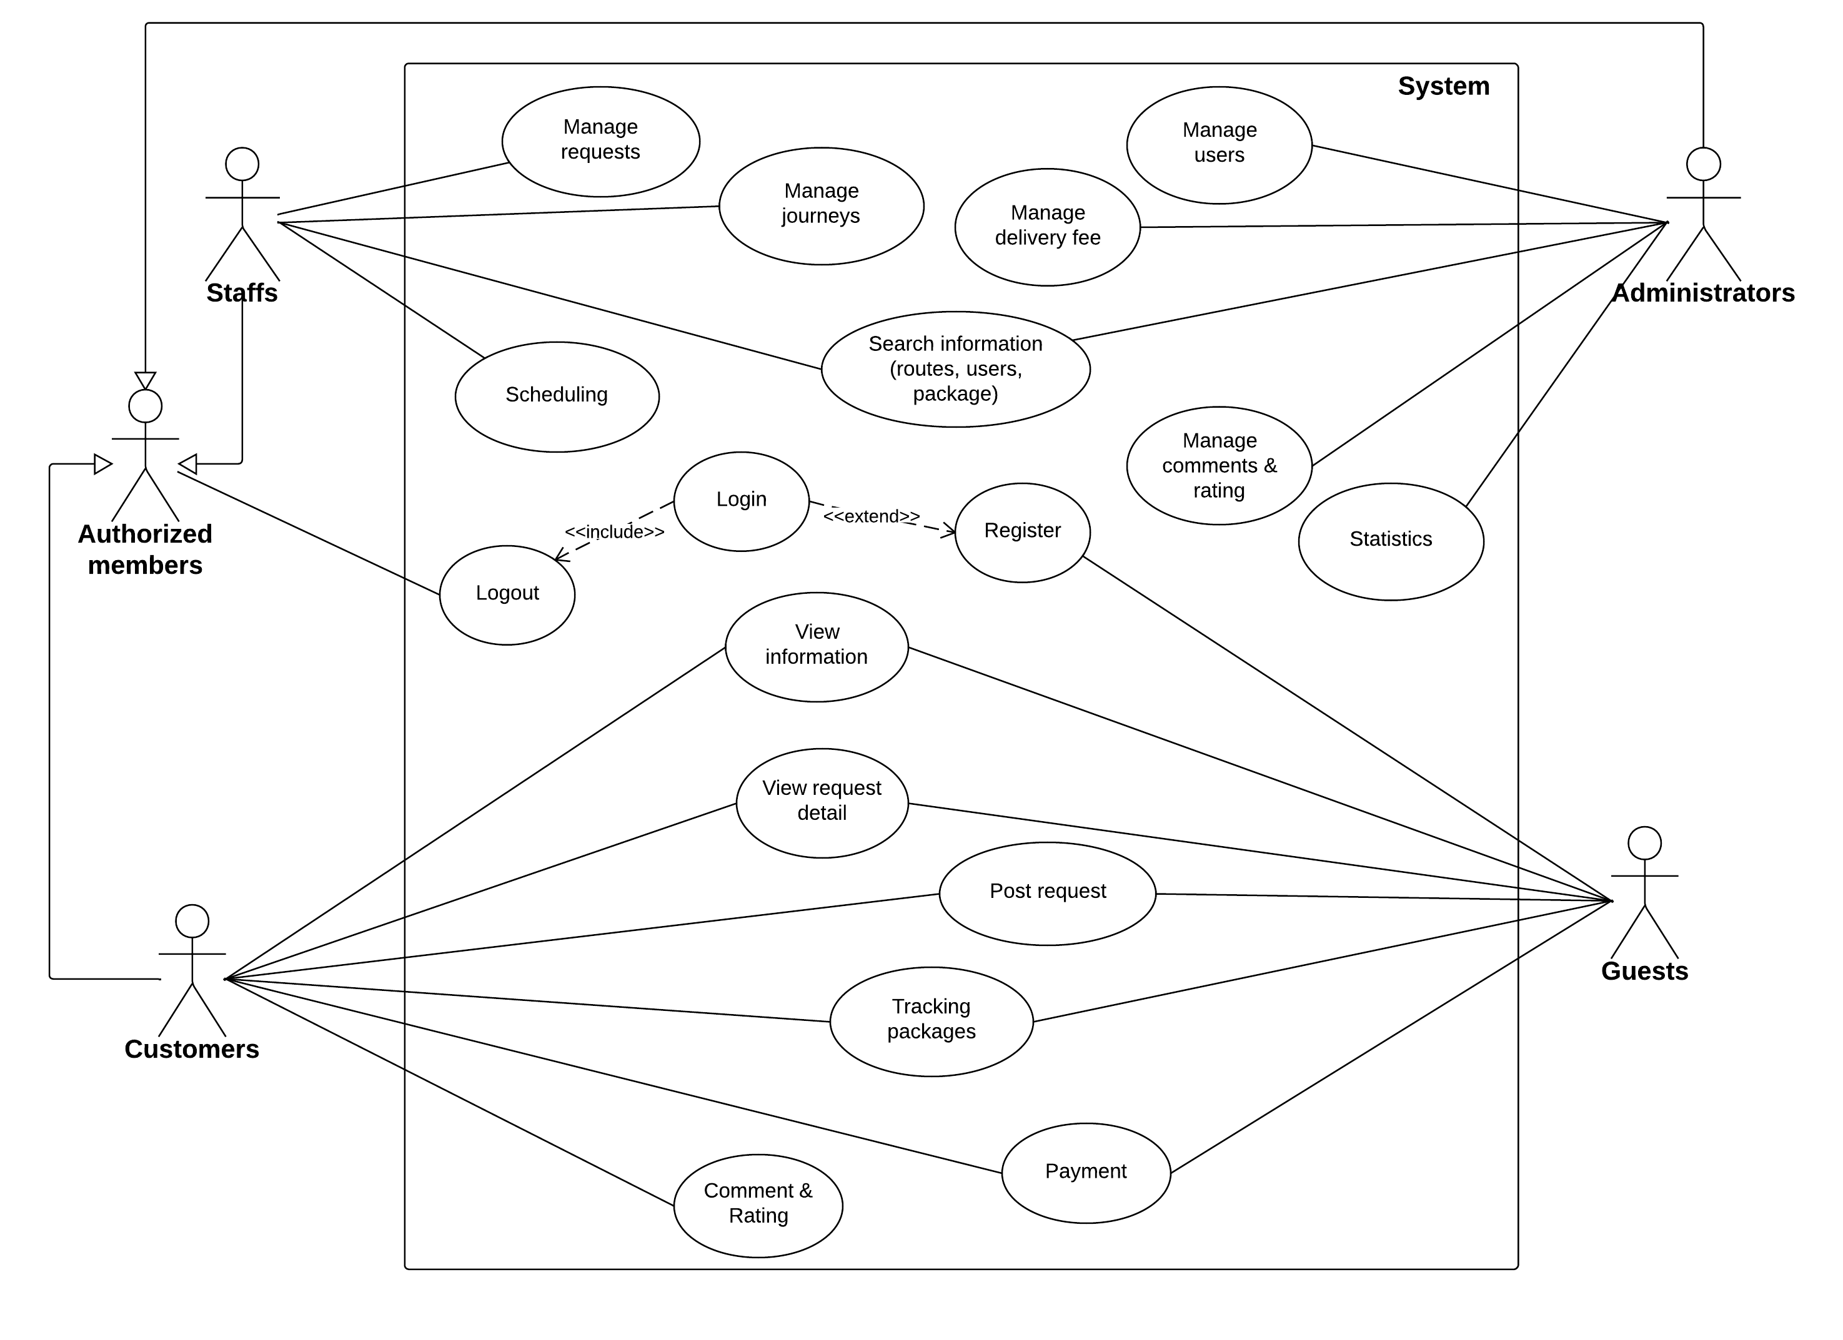

Figure . Overall use case

#### « Guest » Register



|  |  |  |  |  |
| --- | --- | --- | --- | --- |
| **– SPECIFICATION** | | | | |
| **Use-case No.** | UC001 | **Use-case Version** | | 1.0 |
| **Use-case Name** | Register | | | |
| **Author** | Nguyễn Tấn Đức | | | |
| **Date** | 07/02/2014 | **Priority** | Normal | |
| **Actor:** Guest  **Summary:**  This use case help guest to create an account in the i-Deliver system.  **Goal:**  Help guest can have an account in the system. Guest can use this account to log in system and post their request.  **Triggers:**  Guest clicks on “Đăng Kí”.  **Preconditions:**  Guest needs an account to login in to the system in other to have more authorization in the system.  **Post Conditions:**  *On success:* A new account is created in the system. This account is user account type.  *On failure:* Show error message describe invalid fields, ask guest enter again or ask guest register again.  **Main Success Scenario:**   |  |  |  | | --- | --- | --- | | **Step** | **User Action** | **System Response** | | 1. | Guest clicks on “Đăng Kí” |  | | 2. |  | Display “Register” screen with text box for Guest to input all necessary info for creating new account. | | 3. | Guest inputs all required fields. |  | | 4. |  | Validate all input data. Send invalid message (if have). | | 5. | Correct all invalid fields (if have). |  | | 6. | Guest clicks on “Đồng Ý” button. |  | | 7. |  | System creates new account for guest. | | 8. |  | Redirect to Login page. |   **Alternative Scenario:**   |  |  |  |  | | --- | --- | --- | --- | | **No** | **Step** | **User Action** | **System Response** | | 1. | 1. | Clicks on the button “Hủy bỏ”. |  | | 2. |  | Redirect home page. |   **Exceptions:**  N/A  **Relationships:**  N/A  **Business Rules:**   |  |  | | --- | --- | | **No** | **Business Rule Description** | | 1. | Guest must enter all required fields before submitting. | | 2. | Each registering, guest can create one account in the system. | | 3. | Each account in the system is distinguished by email address which assumes as username. | | 4. | When email fields of the new account are as same as the existing ones, the system will show invalid message. | | | | | |

#### « Customer, Guest » Post request



|  |  |  |  |  |
| --- | --- | --- | --- | --- |
| **– SPECIFICATION** | | | | |
| **Use-case No.** | UC002 | **Use-case Version** | | 1.0 |
| **Use-case Name** | Post request | | | |
| **Author** | Nguyễn Tấn Đức | | | |
| **Date** | 07/02/2014 | **Priority** | Normal | |
| **Actor:** Customer, Guest  **Summary:**  This use case is about allowing customer can post request to delivery their goods in the system.  **Goal:**  Customer can describe about their goods (size, weight, etc.), choose the place where to send the goods and get suggest fee from the system.  **Triggers:**  Customer click on “Gửi yêu cầu” link.  **Preconditions:**  Customer logon with customer role.  Customer post request for delivery goods.  **Post Conditions:**  *On success:* Request for transporting goods will be created.  *On failure:* Show message error.Ask customer request again.  **Main Success Scenario:**   |  |  |  | | --- | --- | --- | | **Step** | **User Action** | **System Response** | | 1. | Customer logon to the system with customer role. |  | | 2. | Customer clicks “Gửi yêu cầu” on menu. |  | | 3. |  | Display “Post request” screen with all textbox for customer to enter all necessary info for delivering goods. | | 4. | Customer enters all required fields. |  | | 5. |  | Validate all input data. Send invalid message (if have). | | 6. | Correct all invalid fields (if have). |  | | 7. | Customer click on” Hoàn tất” button. |  | | 8. |  | System create new request for customer. |   **Alternative Scenario:**   |  |  |  |  | | --- | --- | --- | --- | | **No** | **Step** | **User Action** | **System Response** | | 1. | 1. | Clicks on the button “Hủy bỏ”. |  | | 2. |  | Redirect home page. |   **Exceptions:**  N/A  **Relationships:**  Use case “Login”  **Business Rules:**   |  |  | | --- | --- | | **No** | **Business Rule Description** | | 1. | Customer must login to use the system function. | | 2. | Customer must enter all required fields before submitting. | | | | | |

#### « Customer » Cancel request



|  |  |  |  |  |
| --- | --- | --- | --- | --- |
| **– SPECIFICATION** | | | | |
| **Use-case No.** | UC003 | **Use-case Version** | | 1.0 |
| **Use-case Name** | Cancel request | | | |
| **Author** | Nguyễn Thanh Tùng | | | |
| **Date** | 07/02/2014 | **Priority** | Normal | |
| **Actor:** Customer  **Summary:**  This use case is about allowing customer to cancel request for delivery goods.  **Goal:**  Cancel request for delivery goods.  **Triggers:**  N/A  **Preconditions:**  Customer login to the information with their role.  Customer must have previously submitted request.  **Post Conditions:**  *On success:* Request for delivery goods is removed.  *On failure:* N/A  **Main Success Scenario:**   |  |  |  | | --- | --- | --- | | **Step** | **User Action** | **System Response** | | 1. | Click”Quản lí yêu cầu” link in menu bar |  | | 2. |  | Show list of request status on screen(Status of request: “Chờ xác nhận” and “Đã chuyển đi”) | | 3. | Click status “Chờ xác nhận” |  | | 4. |  | Show list of request “Chờ xác nhận” with info each of request | | 5. | Choose the request want to cancel and click “Xoá” button. |  | | 6. |  | Display screen to confirm cancel request. | | 7. | Click “Xác nhận” button |  | | 8. |  | Redirect screen list request “Chờ xác nhận” |   **Alternative Scenario:**   |  |  |  |  | | --- | --- | --- | --- | | **No** | **Step** | **User Action** | **System Response** | | 1. | 1. | Clicks on the button “Hủy bỏ”. |  | | 2. |  | Redirect screen list request “Chờ xác nhận” |   **Exceptions:**  N/A  **Relationships:**  N/A  **Business Rules:**   |  |  | | --- | --- | | **No** | **Business Rule Description** | | 1. | Customer must have previously submitted request. | | | | | |

#### « Customer, Guest » View request detail

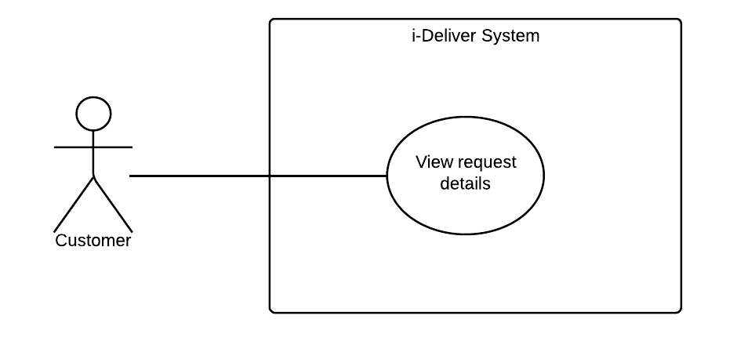

|  |  |  |  |  |
| --- | --- | --- | --- | --- |
| **– SPECIFICATION** | | | | |
| **Use-case No.** | UC006 | **Use-case Version** | | 1.0 |
| **Use-case Name** | View request detail | | | |
| **Author** | Nguyễn Tấn Đức | | | |
| **Date** | 11/02/2014 | **Priority** | Normal | |
| **Actor:** Customer, Guest  **Summary:**  This use case allows customer view all information of their request.  **Goal:**  View information of request.  **Triggers:**  Customer click on a request from list of requests.  **Preconditions:**  Customer must have previously submitted request.  Customer login to the system.  List of request page must be displayed.  **Post Conditions:**  *On success:* Show all information of request.  *On failure:* Show message error.  **Main Success Scenario:**   |  |  |  | | --- | --- | --- | | **Step** | **User Action** | **System Response** | | 1. | Click “Quản lí yêu cầu” link in menu bar |  | | 2. |  | Show list of request status on screen(Status of request: “Chờ xác nhận” and “Đã chuyển đi”) | | 3. | Click status “Chờ xác nhận” |  | | 4. |  | Show list of request “Chờ xác nhận” with info each of request |   **Alternative Scenario:**   |  |  |  |  | | --- | --- | --- | --- | | **No** | **Step** | **User Action** | **System Response** | | 1. | 1. | Click status “Chờ xác nhận” button |  | | 2. |  | Show message “Không tìm thấy kết quả”. |   **Exceptions:**  N/A  **Relationships:**  N/A  **Business Rules:**   |  |  | | --- | --- | | **No** | **Business Rule Description** | | 1. | Customer must have previously submitted request. | | | | | |

#### « Customer, Guest » Tracking package

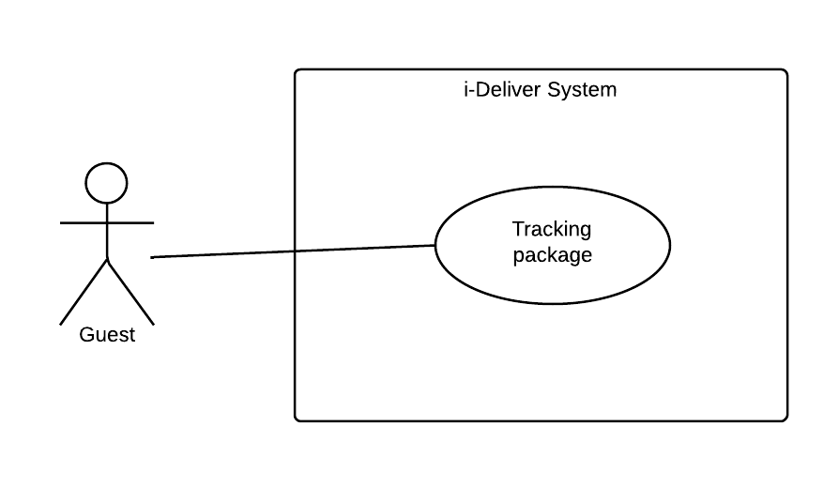

|  |  |  |  |  |
| --- | --- | --- | --- | --- |
| **– SPECIFICATION** | | | | |
| **Use-case No.** | UC007 | **Use-case Version** | | 1.0 |
| **Use-case Name** | Tracking package | | | |
| **Author** | Nguyễn Thanh Tùng | | | |
| **Date** | 11/02/2014 | **Priority** | Normal | |
| **Actor:** Customer, Guest  **Summary:**  This use case allows customer can check amount of time that their package was sent.  **Goal:**  Help customer can track their package.  **Triggers:**  N/A  **Preconditions:**  Customer login to the system.  Customer must have previously submitted request and this request is pending.  **Post Conditions:**  *On success:*  *On failure:*  **Main Success Scenario:**   |  |  |  | | --- | --- | --- | | **Step** | **User Action** | **System Response** | | 1. | Click “Quản lí yêu cầu” link in menu bar |  | | 2. |  | Show list of request status on screen(Status of request: “Chờ xác nhận” and “Đã chuyển đi”) | | 3. | Click status “Đã chuyển đi” button |  | | 4. |  | Show list of request “Đã chuyển đi” | | 5. | Choose request need to tracking |  | | 6. |  | Show result in Google map |   **Alternative Scenario:**   |  |  |  |  | | --- | --- | --- | --- | | **No** | **Step** | **User Action** | **System Response** | | 1. | 1. | Click status “Đã chuyển đi” button |  | | 2. |  | Show message “Không tìm thấy kết quả”. |   **Exceptions:**  N/A  **Relationships:**  N/A  **Business Rules:**  N/A | | | | |

#### « Customer » Payment



|  |  |  |  |  |
| --- | --- | --- | --- | --- |
| **– SPECIFICATION** | | | | |
| **Use-case No.** | UC008 | **Use-case Version** | | <1.0> |
| **Use-case Name** | Payment | | | |
| **Author** | Đào Bảo Long | | | |
| **Date** | 11/02/2014 | **Priority** | Normal | |
| **Actor:** Customer  **Summary:**  This use case allows customer can choose a way to payment (direct or online payment).  **Goal:**  Pay to use the service. Customer can pay directly with staff or paying online through PayPal.  **Triggers:**  Customer click on “Thanh toán” button.  **Preconditions:**  Customer must login to the system.  Customer have unpaid request.  **Post Conditions:**  *On success:*  *On failure:*  **Main Success Scenario:**   |  |  |  | | --- | --- | --- | | **Step** | **User Action** | **System Response** | | 1. | Click “Thanh toán” link in menu bar |  | | 2. |  | Show list of requests required payment. | | 3. | Choose request to payment |  | | 4. |  | Show information of request before payment. | | 5. | Click “Check out with PayPal” button |  | | 6. |  | Redirect PayPal page | | 7. | Customer enters some required fields and click “Pay” button. |  | | 8. |  | Redirect success payment page. |   **Alternative Scenario:**   |  |  |  |  | | --- | --- | --- | --- | | **No** | **Step** | **User Action** | **System Response** | | 1. | 1. | Clicks on the button “Pay”. |  | | 2. |  | Redirect cancel payment page. |   **Exceptions:**  N/A  **Relationships:**  “Post request” use case  **Business Rules:**  N/A | | | | |

#### « Customer » Rating



|  |  |  |  |  |
| --- | --- | --- | --- | --- |
| **RATING – SPECIFICATION** | | | | |
| **Use-case No.** | UC009 | **Use-case Version** | | 1.0 |
| **Use-case Name** | Rating | | | |
| **Author** | Nguyễn Tấn Đức | | | |
| **Date** | 09/02/2014 | **Priority** | Normal | |
| **Actor:** Customer.  **Summary:**  This use case allows customer can make a small feedback to center by rating the service of a specific route. When rating, he/she clicks to the star and the number of marked stars is the level of rating for this route.  **Goal:**  To rate the quality of the service of route of the center.  **Triggers:**  Customer clicks to the stars to rate after he/she used the service of this route.  **Preconditions:**  The customer enters to the page contains the list of route and for each route; there is a rating level corresponding.  **Post Conditions:**  *On success:* The star from the leftmost to the star that user clicked to are all marked. Then, there is a sentence notices the level of customer rated lies beside the list of stars, i.e., “Bạn đã đánh giá 4/5 điểm cho dịch vụ này”.  *On failure:* There is nothing changed and the star is not marked.  **Main Success Scenario:**   |  |  |  | | --- | --- | --- | | **Step** | **User Action** | **System Response** | | 1. | User click to one of five stars corresponding route to select the value that they think it should be. |  | | 2. |  | Display the information that user rated for the route: “Bạn đã đánh giá x/5 điểm cho tuyến đường này” with x is the rating level.  Saves the rating point for the route and updates the overall rating average point and rating average point for the currently rated route. |   **Alternative Scenario:**  N/A  **Exceptions:**   |  |  |  | | --- | --- | --- | | **No** | **User Action** | **System Response** | | 1. | Customer clicks on the star but system encounters an exception when saving the rating point for the route. | Shows the popup to notice about the error “Không thể lưu đánh giá này do hệ thống có vấn đề”. |   **Relationships:**  “Clear rating” use case.  **Business Rules:**   |  |  | | --- | --- | | **No** | **Business Rule Description** | | 1. | This use case only for customer that logged in to the system so when guest rating, the i-Deliver check authentication and don’t perform the rating level. | | 2. | When user re-rates for the route, the old rate level will be updated by new rating. | | 3 | The rating level is the integer in interval [0; 5] inclusively but the average point maybe is a floating point number. | | | | | |

#### « Customer » Comment



|  |  |  |  |  |
| --- | --- | --- | --- | --- |
| **COMMENT – SPECIFICATION** | | | | |
| **Use-case No.** | UC010 | **Use-case Version** | | 1.0 |
| **Use-case Name** | Comment | | | |
| **Author** | Nguyễn Tấn Đức | | | |
| **Date** | 09/02/2014 | **Priority** | Normal | |
| **Actor:** Customer.  **Summary:**  This use case allows customer can make a small feedback to center by comment to the service of a specific route. When comment, he/she type the content of comment to the text box in the comment section of each route. After that, he/she click button “Gửi” or click “Enter” to submit the comment to system and this content will be display on the page of route. As long as submit the comment, he/she can edit or delete their own comment when they want.  **Goal:**  Comment the quality of the service of route of the center.  **Triggers:**  Customer can comment to route after he/she used the service of this route.  **Preconditions:**  The customer enter to the page contains the list of route and for each route, there is text box to input the content of comment corresponding.  **Post Conditions:**  *On success:* The content of comment display on the page of route that customer concerned.  *On failure:* User can input the comment to text box but cannot submit this content to system  **Main Success Scenario:**   |  |  |  | | --- | --- | --- | | **Step** | **User Action** | **System Response** | | 1. | Customer inputs the content of comment to the text box then clicks to button “Gửi”. |  | | 2. |  | Displays the content of comment that user input. Name of button “Gửi” will be changed to “Chỉnh sửa” so when user want to modify their comment, he/she can click to his button, modify and resubmit. |   **Alternative Scenario:**   |  |  |  |  | | --- | --- | --- | --- | | **No** | **Step** | **User Action** | **System Response** | | 1. | 1. | Customer doesn’t input anything to the text box and clicks to button “Gửi” |  | | 2. |  | Displays the popup notice that they want to input the text at least 3 characters, i.e., “Nhận xét của bạn phải có ít nhất 3 kí tự, mời bạn nhập lại”. | | 2. | 1. | Customer inputs the content of comment to the text box and he/she doesn’t click to button “Gửi”, then they click to Back on browse or close the window. |  | | 2. |  | Display the popup notice that they still not submit the comment to system and can be lost it by exit the window. |   **Exceptions:**   |  |  |  | | --- | --- | --- | | **No** | **User Action** | **System Response** | | 1. | Customer inputs the content of comment to the text box then clicks to button “Gửi”. | Shows the popup to notice about the error “Không thể hiện nhận xét này do hệ thống có vấn đề”. | | 2. | After customer submits the comment, he/she want to modify the content, they clicks to button “Chỉnh sửa”. | Shows the popup to notice about the error “Không thể chỉnh sửa nhận xét này do hệ thống có vấn đề”. |   **Relationships:**  “Delete comment” use case.  **Business Rules:**   |  |  | | --- | --- | | **No** | **Business Rule Description** | | 1. | When customer comments to the route, they can modify the content but cannot delete it. The comment is point to quality of the service not for reply the other comment so can be deleting if illegal. | | 2. | The content of comment is at least 3 characters differ to “space” character. | | | | | |

#### « System administrator » Define delivery fee value/calculating formula



|  |  |  |  |  |
| --- | --- | --- | --- | --- |
| **DEFINE DELIVERY FEE VALUE – SPECIFICATION** | | | | |
| **Use-case No.** | UC011 | **Use-case Version** | | 1.0 |
| **Use-case Name** | Define delivery fee value/calculating formula | | | |
| **Author** | Lê Phúc Lữ | | | |
| **Date** | 10/02/2014 | **Priority** | Normal | |
| **Actor:** System administrator (admin).  **Summary:**  This use case allows admin can create the fee of delivery service base on the weight and volume of package. In detail, he/she can define the range of weight including max and min value of package’s weight; then, for each range, define the range of volume that also including max and min value of package’s volume. For a specific range, create the fee for deliver this corresponding package.  **Goal:**  To create the fee for deliver package base on its weight and volume.  **Triggers:**  N/A.  **Preconditions:**  Admin logged in to the system and enter to the fee setting page and he/she doesn’t setting anything about the fee before.  **Post Conditions:**  *On success:* The information of fee value will be inserted successfully.  *On failure:* The information of fee value not inserted or insert incorrectly.  **Main Success Scenario:**   |  |  |  | | --- | --- | --- | | **Step** | **User Action** | **System Response** | | 1. | Admin click “Tạo mới phí mới” link button in menu bar |  | | 2. |  | Display form “Tạo mới phí mới ” on screen | | 3. | Admin enter all fields required. Click “Tạo mới” button. |  | | 4. |  | If some fields wrong, system ask admin enter again. | | 5. | Admin enter all fields required. Click “Tạo mới” button. |  | | 6. |  | New fee is created. Redirect list of fee page. |   **Alternative Scenario:**  N/A  **Exceptions:**   |  |  |  | | --- | --- | --- | | **No** | **User Action** | **System Response** | | 1. |  |  |   **Relationships:**  “Edit fee value” use case.  **Business Rules:**  N/A | | | | |

#### « System administrator » Edit delivery fee value/ calculating formula



|  |  |  |  |  |
| --- | --- | --- | --- | --- |
| **EDIT DELIVERY FEE VALUE – SPECIFICATION** | | | | |
| **Use-case No.** | UC012 | **Use-case Version** | | 1.0 |
| **Use-case Name** | Edit delivery fee value / calculating formula | | | |
| **Author** | Lê Phúc Lữ | | | |
| **Date** | 10/02/2014 | **Priority** | Normal | |
| **Actor:** System administrator (admin).  **Summary:**  This use case allows admin can modify the fee of delivery service base on the weight and volume of package. After he/she define information before, he/she can update the range of weight including max and min value of package’s weight; the range of volume that also including max and min value of package’s volume and also the fee for each range of weight and volume.  **Goal:**  To edit the fee for deliver package base on its weight and volume.  **Triggers:**  Admin define the fee value before.  **Preconditions:**  Admin logged in to the system and enter to the fee setting page.  **Post Conditions:**  *On success:* The information of fee value updated successfully.  *On failure:* The information of fee value not updated or updated incorrectly.  **Main Success Scenario:**   |  |  |  | | --- | --- | --- | | **Step** | **User Action** | **System Response** | | 1. | Click “Danh sách các mức phí” link button in menu bar. |  | | 2. |  | Display list of fees. | | 3. | Choose the fee want to change value and click “Chỉnh sửa” button. |  | | 4. |  | Display form edit fee for admin can change value of fee. | | 5. | Admin change some field value and click “Lưu” button. |  | | 6. |  | Save change new value in database and redirect list of fees page. |   **Alternative Scenario:**  N/A.  **Exceptions:**  N/A  **Relationships:**  “Add fee value” use case.  **Business Rules:**  N/A | | | | |

#### « System administrator » Create new staff account



|  |  |  |  |  |
| --- | --- | --- | --- | --- |
| **CREATE NEW STAFF ACCOUNT – SPECIFICATION** | | | | |
| **Use-case No.** | UC013 | **Use-case Version** | | 1.0 |
| **Use-case Name** | Create new staff account | | | |
| **Author** | Lê Phúc Lữ | | | |
| **Date** | 10/02/2014 | **Priority** | Normal | |
| **Actor:** System administrator (admin)  **Summary:**  The staffs have an important role in the system when they manage almost the action of system. Admin can create new staff account with username and password but without the basic information as the customer (it is no need on the system). The staff role is authorized to access some specific pages to manage.  **Goal:**  Create new staff account.  **Triggers:**  N/A.  **Preconditions:**  Admin logged in to the system and enter to the manage account page.  **Post Conditions:**  *On success:* New account with correct account and password insert successfully.  *On failure:* No new account added or wrong information added.  **Main Success Scenario:**   |  |  |  | | --- | --- | --- | | **Step** | **User Action** | **System Response** | | 1. | Admin click “Tạo tài khoản mới” link button in menu bar |  | | 2. |  | Display form “Tạo tài khoản mới” on screen | | 3. | Admin enter all fields required. Click “Tạo mới” button. |  | | 4. |  | If some fields wrong, system ask admin enter again. | | 5. | Admin enter all fields required. Click “Tạo mới” button. |  | | 6. |  | New account is created. Redirect list of account page. |   **Alternative Scenario:**  N/A  **Exceptions:**  N/A  **Relationships:**  “Add fee value” use case.  **Business Rules:**   |  |  | | --- | --- | | **No** | **Business Rule Description** | | 1. | Login into the system with admin role. | | | | | |

#### « System administrator » Edit account information



|  |  |  |  |  |
| --- | --- | --- | --- | --- |
| **EDIT ACCOUNT INFORMATION – SPECIFICATION** | | | | |
| **Use-case No.** | UC014 | **Use-case Version** | | 1.0 |
| **Use-case Name** | Edit account information | | | |
| **Author** | Lê Phúc Lữ | | | |
| **Date** | 10/02/2014 | **Priority** | Normal | |
| **Actor:** System administrator (admin)  **Summary:**  This use case allows admin can update the information of staff or user account due to some special reason.  **Goal:**  Edit the account (including staff and customer) information.  **Triggers:**  N/A.  **Preconditions:**  Admin logged in to the system and enter to the manage account page.  **Post Conditions:**  *On success:* The updated information is saved successfully.  *On failure:* No new update information are saved or information incorrect.  **Main Success Scenario:**   |  |  |  | | --- | --- | --- | | **Step** | **User Action** | **System Response** | | 1. | Click “Danh sách nhân viên” link button in menu bar. |  | | 2. |  | Display list of accounts. | | 3. | Choose the account want to change information and click “Chỉnh sửa” button. |  | | 4. |  | Display form edit account for admin can change information. | | 5. | Admin change information of account and click “Lưu” button. |  | | 6. |  | Save change in database and redirect list of account page. |   **Alternative Scenario:**  N/A  **Exceptions:**   |  |  |  | | --- | --- | --- | | **No** | **User Action** | **System Response** | | 1. |  |  |   **Relationships:**  N/A  **Business Rules:**   |  |  | | --- | --- | | **No** | **Business Rule Description** | | 1. | User login into the system with admin role. | | | | | |

#### « System administrator » Delete account



|  |  |  |  |  |
| --- | --- | --- | --- | --- |
| **DELETE ACCOUNT – SPECIFICATION** | | | | |
| **Use-case No.** | UC015 | **Use-case Version** | | 1.0 |
| **Use-case Name** | Delete account | | | |
| **Author** | Lê Phúc Lữ | | | |
| **Date** | 10/02/2014 | **Priority** | Normal | |
| **Actor:** System administrator (admin)  **Summary:**  This use case allows admin can delete account of staff or customer. When some staff don’t work for the center anymore so he/she cannot access to the manage page of system. And in the other, if some customer has registered an account at the page for the bad objective, then admin can delete their account.  **Goal:**  Delete the account of staff or customer.  **Triggers:**  N/A.  **Preconditions:**  Admin logged in to the system and enter to the manage account page.  **Post Conditions:**  *On success:* The account delete successfully.  *On failure:* The account still not is deleted.  **Main Success Scenario:**   |  |  |  | | --- | --- | --- | | **Step** | **User Action** | **System Response** | | 1. | Click “Danh sách nhân viên” link button in menu bar. |  | | 2. |  | Display list of accounts. | | 3. | Choose the account want to change information and click “Xoá” button. |  | | 4. |  | Display form confirms to delete account. | | 5. | Admin click “Xác nhận” button |  | | 6. |  | Account will be delete, redirect list of accounts page |   **Alternative Scenario:**   |  |  |  |  | | --- | --- | --- | --- | | **No** | **Step** | **User Action** | **System Response** | | 1. | 1. | Click status “Huỷ” button |  | | 2. |  | Redirect list of accounts page. |   **Exceptions:**  N/A  **Relationships:**  N/A.  **Business Rules:**  N/A | | | | |

#### « System administrator » Statistic



|  |  |  |  |  |
| --- | --- | --- | --- | --- |
| **STATISTIC – SPECIFICATION** | | | | |
| **Use-case No.** | UC017 | **Use-case Version** | | 1.0 |
| **Use-case Name** | Statistic | | | |
| **Author** | Lê Phúc Lữ | | | |
| **Date** | 10/02/2014 | **Priority** | Normal | |
| **Actor:** System administrator (admin)  **Summary:**  This use case allows admin statistic information of system, especially statistic on customer account.  **Goal:**  Statistic the information of account.  **Triggers:**  N/A.  **Preconditions:**  Admin logged in to the system and enter to the statistic page.  **Post Conditions:**  *On success:* The result of statistic information will be displayed.  *On failure:* The statistic information is not displayed.  **Main Success Scenario:**   |  |  |  | | --- | --- | --- | | **Step** | **User Action** | **System Response** | | 1. | Click “Thống kê” button in menu bar. |  | | 2. |  | Display statistic information of account by pie chart. |   **Alternative Scenario:**  N/A  **Exceptions:**  N/A  **Relationships:**  N/A.  **Business Rules:** N/A | | | | |

#### « System administrator » Delete comment



|  |  |  |  |  |
| --- | --- | --- | --- | --- |
| **DELETE COMMENT – SPECIFICATION** | | | | |
| **Use-case No.** | UC018 | **Use-case Version** | | 1.0 |
| **Use-case Name** | Delete comment | | | |
| **Author** | Nguyễn Tấn Đức | | | |
| **Date** | 09/02/2014 | **Priority** | Normal | |
| **Actor:** Admin  **Summary:**  This use case allows admin physical delete the illegal comment for the route, i.e., use the word are not bright meaning, advertise for external service, …  **Goal:**  Delete the specific comment of customer for route.  **Triggers:**  The admin can delete the comment that violates the rule.  **Preconditions:**  Staff enters to the manage feedback page of the system and choose the comment of route for delete.  **Post Conditions:**  *On success:* The comment will be deleted successfully.  *On failure:* The comment won’t be deleted as expected.  **Main Success Scenario:**   |  |  |  | | --- | --- | --- | | **Step** | **User Action** | **System Response** | | 1. | Admin chooses the comment of route and clicks the button “Xóa nhận xét”. |  | | 2. |  | Shows a popup to confirm the action that the staff really wants to delete the comment. “Bạn có thực sự muốn xóa nhận xét này không?” | | 3. | If admin clicks to “Yes” button. |  | | 4. |  | The comment will be deleted. | | 5. | If admin clicks to “No” button. |  | | 6. |  | Closes the popup and doesn’t do anything. |   **Alternative Scenario:**  N/A.  **Exceptions:**   |  |  |  | | --- | --- | --- | | **No** | **User Action** | **System Response** | | 1. | Admin chooses the comment of route and clicks the button “Xóa nhận xét”. When the popup showed, he/she clicks to “Yes” button to confirm. | The comment is not deleted. | | 2. | Admin chooses the list of route that he/she want to reset the rating, then click to button “Clear”. When the popup showed, he/she clicks to “No” button to confirm. | The comment is deleted or the content of it changed. | | 3. | Admin chooses the comment of route and clicks the button “Xóa nhận xét”. | The popup is not showed. |   **Relationships:**  “Comment” usecase.  **Business Rules:**   |  |  | | --- | --- | | **No** | **Business Rule Description** | | 1. | The comment is legal if its content is clear and point to the quality of service, not chat, advertise, … The staff has to read the content of comment carefully to make sure not delete legal comment. | | | | | |

#### « System administrator » Clear rating



|  |  |  |  |  |
| --- | --- | --- | --- | --- |
| **CLEAR RATING – SPECIFICATION** | | | | |
| **Use-case No.** | UC019 | **Use-case Version** | | 1.0 |
| **Use-case Name** | Clear rating | | | |
| **Author** | Nguyễn Tấn Đức | | | |
| **Date** | 09/02/2014 | **Priority** | Normal | |
| **Actor:** Admin  **Summary:**  This use case allows admin clear the rating of the route due to some reasons. After a period run the system, each route maybe receive a lot of rating for the service, so these rating and the average point of rate stand for the quality of a specific period of time. So to make sure the rating is up-to-date, staff have to reset (or clear) the rating for route.  **Goal:**  Clear the rating of customer for the route after a period run the system.  **Triggers:**  Admin can clear the rating after it has been saved or statistic after a long enough period.  **Preconditions:**  Admin enters to the manage feedback page of the system and choose one or multiple route for clear the rating.  **Post Conditions:**  *On success:* The ratings of selected routes will be reset to null.  *On failure:* The ratings of selected routes are not set to null exactly.  **Main Success Scenario:**   |  |  |  | | --- | --- | --- | | **Step** | **User Action** | **System Response** | | 1. | Admin chooses the list of route that he/she want to reset the rating, then click to button “Clear”. |  | | 2. |  | Shows a popup to confirm the action that the staff really wants to clear the rating or not. “Bạn có thực sự muốn reset các đánh giá cũ hay không?” | | 3. | If admin clicks to “Yes” button. |  | | 4. |  | All the rating of user rate for this route, also the average rating will be set to null. | | 5. | If admin clicks to “No” button. |  | | 6. |  | Closes the popup and doesn’t do anything. |   **Alternative Scenario:**  N/A.  **Exceptions:**   |  |  |  | | --- | --- | --- | | **No** | **User Action** | **System Response** | | 1. | Admin chooses the list of route that he/she want to reset the rating, then click to button “Clear”. When the popup showed, he/she clicks to “Yes” button to confirm. | The ratings of selected routes are not set to null exactly. | | 2. | Amin chooses the list of route that he/she want to reset the rating, then click to button “Clear”. When the popup showed, he/she clicks to “No” button to confirm. | Some ratings of selected routes are reset while user don’t expect. | | 3. | Amin chooses the list of route that he/she want to reset the rating, then click to button “Clear”. | The popup is not showed. |   **Relationships:**  “Rating” usecase.  **Business Rules:**   |  |  | | --- | --- | | **No** | **Business Rule Description** | | 1. | The rating of route after clear will become NULL (means there is not any user rate), not become 0. | | | | | |

#### « Staff » Approve request



|  |  |  |  |  |
| --- | --- | --- | --- | --- |
| **– SPECIFICATION** | | | | |
| **Use-case No.** | UC0020 | **Use-case Version** | | 1.0 |
| **Use-case Name** | Approve request | | | |
| **Author** | Nguyễn Thanh Tùng | | | |
| **Date** | 10/2/2014 | **Priority** | High | |
| **Actor:**  *Staffs*  **Summary:**  This use case allows staffs to approve a request from customers or in other words the staffs will change the status of request.  **Goal:**  To confirm a request is valid and that request will be processed.  **Triggers:**  The staffs click on button “Chấp thuận” on the staff page.  **Preconditions:**  The staff page is being displayed.  **Post Conditions:**  *On success:* The request’s status will be changed  *On failure:* An error message is displayed. The content of the error message will be based on the type of failure.  **Main Success Scenario:**   |  |  |  | | --- | --- | --- | | **Step** | **User Action** | **System Response** | | 1. | Click “Tiếp nhận yêu cầu” link button in menu bar.  [See Exception No. 1] |  | | 2. |  | Display list of requests that customer request. | | 3. | Select the request want to approve and click “Xác nhận” button.  [See Exception No. 2] |  | | 4. |  | Request is accepted and system redirect list of requests page. |   **Alternative Scenario:**  N/A  **Exceptions:**   |  |  |  | | --- | --- | --- | | **No** | **User Action** | **System Response** | | 1. | If session equals null | Login modal will show | | 2. | If request not available, and user click on “Xác nhận” | Redirect to error pages. |   **Relationships:**  “Post request” usecase.  **Business Rules:**   |  |  | | --- | --- | | **No** | **Business Rule Description** | | 1. | User login into the system with staff role | | 2. | Only staff at this station has the right to accept requests on this station. | | | | | |

#### « Staff » Reject request



|  |  |  |  |  |
| --- | --- | --- | --- | --- |
| **– SPECIFICATION** | | | | |
| **Use-case No.** | UC0021 | **Use-case Version** | | 1.0 |
| **Use-case Name** | Reject request | | | |
| **Author** | Nguyễn Thanh Tùng | | | |
| **Date** | 10/2/2014 | **Priority** | High | |
| **Actor:**  Staffs  **Summary:**  This use case allows staffs to delete a request from manager page.  **Goal:**  To reject a request because it’s may be not valid or in a period time, don’t have any response from customers.  **Triggers:**  The staffs click on button “Xóa” on the staff pages.  **Preconditions:**  The staff page is being displayed.  **Post Conditions:**  *On success:* The request will be removed.  *On failure:* An error message is displayed. The content of the error message will be based on the type of failure.  **Main Success Scenario:**   |  |  |  | | --- | --- | --- | | **Step** | **User Action** | **System Response** | | 1. | Click on “Xoá” button on staff pages |  | | 2. |  | Popup will show and the content is “Bạn có muốn huỷ bỏ yêu cầu này??” | | 3. | Click on “Yes” button |  | | 4. |  | Pages will reload and request has been removed |   **Alternative Scenario:**  N/A  **Exceptions:**  N/A  **Relationships:**  “Check room prices and availability” use case  **Business Rules:**   |  |  | | --- | --- | | **No** | **Business Rule Description** | | 1. | User must be login to system with role Staff | | 2. | Only staff at this station can do this action | | | | | |

#### « Staff » Assign package



|  |  |  |  |  |
| --- | --- | --- | --- | --- |
| **– SPECIFICATION** | | | | |
| **Use-case No.** | UC022 | **Use-case Version** | | 1.0 |
| **Use-case Name** | Assign package | | | |
| **Author** | Lê Phúc Lữ | | | |
| **Date** | 10/02/2014 | **Priority** | High | |
| **Actor:**  *Staffs*  **Summary:**  This use case allows staffs assign a request to which car, route…follow the content of request, and request will be become a package.  **Goal:**  To transport package according to customer requirements  **Triggers:**  N/A  **Preconditions:**  The request must be approved.  **Post Conditions:**  *On success:* Package will be assigned.  *On failure:* An error message is displayed. The content of the error message will be based on the type of failure.  **Main Success Scenario:**   |  |  |  | | --- | --- | --- | | **Step** | **User Action** | **System Response** | | 1. | Click “Xếp lịch vận chuyển” link button in menu bar. |  | | 2. |  | Display list of request have been paid on screen. | | 3. | Staff can choose one or more requests to assign and click “Xếp lịch”. |  | | 4. |  | Redirect to list of request has been assigned |   **Alternative Scenario:**   |  |  |  |  | | --- | --- | --- | --- | | **No** | **Step** | **User Action** | **System Response** | | 1. | 1. | If request not assign for any trip |  | | 2. |  | Popup will show with the content is reason why the request not assign include: volume, time, trip is not available…. |   **Exceptions:**   |  |  |  | | --- | --- | --- | | **No** | **User Action** | **System Response** | | 1. | User not choose any request but click on “Xếp lịch” button |  | | 2. |  | Redirect to errors pages |   **Relationships:**  **Business Rules:**   |  |  | | --- | --- | | **No** | **Business Rule Description** | | 1. | User must be login to system with role is staff | | 2. | Only the staff at station can be assign | | | | | |

#### « Staff » Update package(s) status



|  |  |  |  |  |
| --- | --- | --- | --- | --- |
| **– SPECIFICATION** | | | | |
| **Use-case No.** | UC023 | **Use-case Version** | | 1.0 |
| **Use-case Name** | Update request status | | | |
| **Author** | Nguyễn Thanh Tùng | | | |
| **Date** | 10/02/2014 | **Priority** | High | |
| **Actor:**  *Staffs*  **Summary:**  The use case allows staffs update status of a package when it’s assigned.  **Goal:**  To notifies to customers about their package through the status of package: on way or waiting.., help their tracking package.  **Triggers:**  Staffs click on button “Xác nhận chuyển đi” or “Xác nhận đến trạm” or “Huỷ hàng” or “Trả hàng” on staff’s page.  **Preconditions:**  .Package must be assigned.  **Post Conditions:**  *On success:* Status of package will be changed.  *On failure:* An error message is displayed. The content of the error message will be based on the type of failure.  **Main Success Scenario:**   |  |  |  | | --- | --- | --- | | **Step** | **User Action** | **System Response** | | 1. | Click on button “Xác nhận chuyển đi” on trip pages |  | | 2. |  | All request in trip will be change status to “Đã chuyển đi” | | 3. | Click on button “Xác nhận đến trạm” |  | | 4. |  | All request has stop station same with station of staff will be change status to “Đã đến đích” | | 5. | Click on button “Huỷ hàng” |  | | 6. |  | Request will be change status to “Đã huỷ” | | 7. | Click on button “Trả hàng” |  | | 8. |  | Request will be change status to “Chờ xếp lịch” |   **Alternative Scenario:**  **N/A**  **Exceptions:**   |  |  |  | | --- | --- | --- | | **No** | **User Action** | **System Response** | | 1. | If don’t have any request available, user click on button | Redirect to errors pages. |   **Relationships:**  **Business Rules:**   |  |  | | --- | --- | | **No** | **Business Rule Description** | | 1. | User must be login to system with role staff | | 2. | Only staff at station can be do this action | | | | | |

#### « Staff » Create a schedule



|  |  |  |  |  |
| --- | --- | --- | --- | --- |
| **CREATE A SCHEDULE – SPECIFICATION** | | | | |
| **Use-case No.** | UC025 | **Use-case Version** | | 1.0 |
| **Use-case Name** | Create new schedule | | | |
| **Author** | Đào Bảo Long | | | |
| **Date** | 10/02/2014 | **Priority** | Normal | |
| **Actor:**  *Staff*  **Summary:**  This use case allows a staff to create a schedule for specify coach and route.  **Goal:**  To manually define a new schedule in the i-Deliver system.  **Triggers:**  The user clicks on the button “Tạo lịch chạy” on the schedule management page.  **Preconditions:**  The user is already logged in with an account of Staff role.  **Post Conditions:**  *On success:* A new schedule was added to system’s database. The user is redirected to schedule list page which is now has a section that describes the currently added schedule.  *On failure:* An error message is displayed. Please refer to the Exception Scenario section the see what the content of the error message is.  **Main Success Scenario:**   |  |  |  | | --- | --- | --- | | **Step** | **User Action** | **System Response** | | 1. | Clicks on the button “Tạo lịch chạy”. |  | | 2. | Fills out the form with relevant values.  [See Exception No. 1, 2, 3, 4] |  | | 3. | Clicks the button “Tạo mới”  [See Alternative No. 1, 2, 3] |  | | 4. |  | Saves the schedule to the database and redirects the user to the schedule list page which now has a new section that describes the newly added schedule. |   **Alternative Scenario:**   |  |  |  |  | | --- | --- | --- | --- | | **No** | **Step** | **User Action** | **System Response** | | 1. | 1. | Clicks on the button “Hủy”. |  | | 2. |  | Shows a popup to ask the user to confirm the action. | | 2. | 1. | The user chooses “OK”. |  | | 2. |  | If the user confirms to go back, redirects the user to the list page, otherwise, just hide the popup. | | 3. | 1. | Clicks on the button “Tạo mới”. |  | | 2. |  | Saves the schedule to the database and redirects the user to the schedule list page. |   **Exceptions:**   |  |  |  | | --- | --- | --- | | **No** | **User Action** | **System Response** | | 1. | Does not select an item in the select list “Tuyến”. | Shows the message “Vui lòng chọn một tuyến” next to the field. | | 2. | Does not select an item in the select list “Xe”. | Shows the message “Vui lòng chọn một xe” next to the field. | | 3. | Leaves the field “Thời gian đi dự kiến” empty. | Shows the message “Vui lòng nhập thời gian” next to the field. | | 4. | Leaves the field “Thời gian đến dự kiến” empty. | Shows the message “Vui lòng nhập thời gian” next to the field. |   **Relationships:**  N/A  **Business Rules:**   |  |  | | --- | --- | | **No** | **Business Rule Description** | | 1. | A new schedule can be created for a route if only that route had specified coaches run on. | | | | | |

#### « Staff » Create a trip



|  |  |  |  |  |
| --- | --- | --- | --- | --- |
| **ADD A TRIP – SPECIFICATION** | | | | |
| **Use-case No.** | UC026 | **Use-case Version** | | 1.0 |
| **Use-case Name** | Create new trip | | | |
| **Author** | Đào Bảo Long | | | |
| **Date** | 10/02/2014 | **Priority** | Normal | |
| **Actor:**  *Staff*  **Summary:**  …  **Goal:**  To manually open a new trip in the i-Deliver system  **Triggers:**  The user clicks on the button “Tạo một chuyến mới” on the trip management page.  **Preconditions:**  The user is already logged in with an account of Staff role.  **Post Conditions:**  *On success:* A new trip was added to system’s database. The user is redirected to trip list page which is now has a section that describes the currently added trip.  *On failure:* An error message is displayed. Please refer to the Exception Scenario section the see what the content of the error message is.  **Main Success Scenario:**   |  |  |  | | --- | --- | --- | | **Step** | **User Action** | **System Response** | | 1. | Clicks on the button “Tạo một chuyến mới”. |  | | 2. | Fills out the form with relevant values.  [See Exception No. 1, 2] |  | | 3. | Clicks the button “Tạo mới”  [See Alternative No. 1, 2, 3] |  | | 4. |  | Saves the trip to the database and redirects the user to the trip list page which now has a new section that describes the newly added trip. |   **Alternative Scenario:**   |  |  |  |  | | --- | --- | --- | --- | | **No** | **Step** | **User Action** | **System Response** | | 1. | 1. | Clicks on the button “Hủy”. |  | | 2. |  | Shows a popup to ask the user to confirm the action. | | 2. | 1. | The user chooses “OK”. |  | | 2. |  | If the user confirms to go back, redirects the user to the list page, otherwise, just hide the popup. | | 3. | 1. | Clicks on the button “Tạo mới”. |  | | 2. |  | Saves the trip to the database and redirects the user to the trip list page. |   **Exceptions:**   |  |  |  | | --- | --- | --- | | **No** | **User Action** | **System Response** | | 1. | Does not select a date in the date picker “Ngày chạy”. | Shows the message “Vui lòng chọn ngày” next to the field. | | 2. | Does not select an item in the select list “Tuyến”. | Shows the message “Vui lòng chọn tuyến” next to the field. |   **Relationships:**  N/A  **Business Rules:**   |  |  | | --- | --- | | **No** | **Business Rule Description** | | 1. | A new trip can be created for a route if only that route had defined schedule. | | 2. | Before create a new trip, user must select a date to review all trip created in that day in order to avoid duplicate. | | 3. | Once time user pick a date to create new trip, the i-Deliver system will create trip for 7 days continuous automatically | | | | | |

#### « Staff » Delete a trip



|  |  |  |  |  |
| --- | --- | --- | --- | --- |
| **DELETE A TRIP – SPECIFICATION** | | | | |
| **Use-case No.** | UC027 | **Use-case Version** | | 1.0 |
| **Use-case Name** | Delete a trip | | | |
| **Author** | Đào Bảo Long | | | |
| **Date** | 10/02/2014 | **Priority** | Normal | |
| **Actor:**  *Staff*  **Summary:**  This use case allows a staff to remove an existing trip from the system.  **Goal:**  To manually remove an existing trip from the system.  **Triggers:**  The staff clicks on the button “Xóa chuyến” on the section that contains the trip to be deleted in the trip management page.  **Preconditions:**  The user is already logged in with an account of Staff role.  The trip management page is being displayed.  The trip to be deleted is being selected.  **Post Conditions:**  *On success:* The selected trip is deleted from the system databse. The row that contains the selected trip is removed from the trip list page.  *On failure:* An error message is displayed. The content of the error message will be specified in the Exception Scenario section based on the type of failure.  **Main Success Scenario:**   |  |  |  | | --- | --- | --- | | **Step** | **User Action** | **System Response** | | 1. | Clicks on the button “Xóa” on the row that contains the trip to be deleted. |  | | 2. |  | Shows a popup to ask the staff to confirm the action. | | 3. | Chooses “OK” to continue to delete the trip.  [See Alternative No. 1] | Marks the selected trip as deleted in the database.  Removes the row that contains the selected trip from the trip list page. |   **Alternative Scenario:**   |  |  |  |  | | --- | --- | --- | --- | | **No** | **Step** | **User Action** | **System Response** | | 1. | 1. | Clicks on the button “Hủy bỏ”. |  | | 2. |  | Hides the popup message box. |   **Exceptions:**  N/A  **Relationships:**  “Add a trip” use case  **Business Rules:**   |  |  | | --- | --- | | **No** | **Business Rule Description** | | 1. | Staff will be notified by requests list which assigned to selected trip before delete that trip. | | 2. | All of requests has assigned to selected trip will be re-assigned | | | | | |

#### « Staff » Add a station



|  |  |  |  |  |
| --- | --- | --- | --- | --- |
| **ADD A STATION – SPECIFICATION** | | | | |
| **Use-case No.** | UC028 | **Use-case Version** | | 1.0 |
| **Use-case Name** | Add new station | | | |
| **Author** | Nguyễn Thanh Tùng | | | |
| **Date** | 10/02/2014 | **Priority** | Normal | |
| **Actor:**  *Staff*  **Summary:**  …  **Goal:**  To manually open a new station in the i-Deliver system  **Triggers:**  The user clicks on the button “Thêm một trạm mới” on the station management page.  **Preconditions:**  The user is already logged in with an account of Staff role.  **Post Conditions:**  *On success:* A new station was added to system’s database. The user is redirected to trip station page which is now has a section that describes the currently added station.  *On failure:* An error message is displayed. Please refer to the Exception Scenario section the see what the content of the error message is.  **Main Success Scenario:**   |  |  |  | | --- | --- | --- | | **Step** | **User Action** | **System Response** | | 1. | Clicks on the button “Tạo trạm chuyến mới”. |  | | 2. | Fills out the form with relevant values. |  | | 3. | Clicks the button “Tạo mới”.  [See Alternative No. 1, 2, 3] |  | | 4. |  | Saves the stations to the database and redirects the user to the station list page which now has a new section that describes the newly added station. |   **Alternative Scenario:**   |  |  |  |  | | --- | --- | --- | --- | | **No** | **Step** | **User Action** | **System Response** | | 1. | 1. | Clicks on the button “Tạo mới”. |  | | 2. |  | Shows a popup to ask the user to confirm the action. | | 2. | 1. | The user chooses “OK”. |  | | 2. |  | If the user confirms to go back, redirects the user to the list page, otherwise, just hide the popup. | | 3. | 1. | Clicks on the button “Tạo mới”. |  | | 2. |  | Saves the station to the database and redirects the user to the station list page. |   **Exceptions:**   |  |  |  | | --- | --- | --- | | **No** | **User Action** | **System Response** | | 1. | Leaves the field “Tên trạm” empty. | Shows the message “Vui lòng nhập tên trạm” next to the field. | | 2. | Leaves the field “Địa chỉ” empty. | Shows the message “Vui lòng nhập địa chỉ trạm” next to the field. | | 3. | Does not select an item in the select list “Tỉnh thành”. | Shows the message “Vui lòng chọn tỉnh, thành phố” next to the select list. | | 4. | Fills the field “Số điện thoại” with a value that cannot be recognized as a phone number. | Shows the message “Vui lòng nhập số điện thoại hợp lệ” next to the field. | | 5. | Leaves the field “Địa chỉ” empty. | Shows the message “Vui lòng nhập địa chỉ” next to the field. |   **Relationships:**  N/A  **Business Rules:**  N/A | | | | |

#### « Staff » Edit station information



|  |  |  |  |  |
| --- | --- | --- | --- | --- |
| **EDIT STATION INFORMATION – SPECIFICATION** | | | | |
| **Use-case No.** | UC029 | **Use-case Version** | | 1.0 |
| **Use-case Name** | Edit station information | | | |
| **Author** | Nguyễn Thanh Tùng | | | |
| **Date** | 10/02/2014 | **Priority** | Normal | |
| **Actor:**  *Staff*  **Summary:**  This use case allows a staff to view and manually change information about an existing station in the database.  **Goal:**  To manually edit information of a station in the system.  **Triggers:**  The user clicks on the button “Thông tin trạm” on station management page.  **Preconditions:**  The user is already logged in with an account of Staff role.  The station management page is being displayed.  **Post Conditions:**  *On success:* The information of selected station is updated in the system. The user is redirect to the station management page where information is currently updated.  *On failure:* An error message is displayed. The content of the error message will be specified in the Exception Scenario section based on the type of failure.  **Main Success Scenario:**   |  |  |  | | --- | --- | --- | | **Step** | **User Action** | **System Response** | | 1. | Clicks on the button “Chỉnh sửa thông tin trạm”. |  | | 2. | Fills out the form with relevant values. |  | | 3. | Clicks the button “Lưu thay đổi”.  [See Alternative No. 1, 2, 3] |  | | 4. |  | Saves new station information to the database and redirects the staff to the station list page. |   **Alternative Scenario:**   |  |  |  |  | | --- | --- | --- | --- | | **No** | **Step** | **User Action** | **System Response** | | 1. | 1. | Clicks on the button “Quay về trang quản lý”. |  | | 2. |  | Shows a popup to ask the user to confirm the action. | | 2. | 1. | The user chooses “OK”. |  | | 2. |  | If the user confirms to go back, redirects the user to the list page, otherwise, just hide the popup. | | 3. | 1. | Clicks on the button “Lưu thay đổi”. |  | | 2. |  | Saves new station information to the database and redirects the staff to the station list page. |   **Exceptions:**  N/A  **Relationships:**  “Add a station” use case  **Business Rules:**  N/A | | | | |

#### « Staff » Add a route



|  |  |  |  |  |
| --- | --- | --- | --- | --- |
| **ADD A ROUTE – SPECIFICATION** | | | | |
| **Use-case No.** | UC030 | **Use-case Version** | | 1.0 |
| **Use-case Name** | Add new route | | | |
| **Author** | Nguyễn Tấn Đức | | | |
| **Date** | 10/02/2014 | **Priority** | Normal | |
| **Actor:**  *Staff*  **Summary:**  …  **Goal:**  To manually open a new route in the i-Deliver system  **Triggers:**  The user clicks on the button “Thêm một tuyến mới” on the routes management page.  **Preconditions:**  The user is already logged in with an account of Staff role.  **Post Conditions:**  *On success:* A new route was added to system’s database. The user is redirected to route station page which is now has a section that describes the currently added station.  *On failure:* An error message is displayed. Please refer to the Exception Scenario section the see what the content of the error message is.  **Main Success Scenario:**   |  |  |  | | --- | --- | --- | | **Step** | **User Action** | **System Response** | | 1. | Clicks on the button “Tạo một tuyến mới”. |  | | 2. | Fills out the form with relevant values. |  | | 3. | Clicks the button “Tạo mới”.  [See Alternative No. 1, 2, 3] |  | | 4. |  | Saves the routes to the database and redirects the user to the route list page which now has a new section that describes the newly added route. |   **Alternative Scenario:**   |  |  |  |  | | --- | --- | --- | --- | | **No** | **Step** | **User Action** | **System Response** | | 1. | 1. | Clicks on the button “Quay về trang quản lý”. |  | | 2. |  | Shows a popup to ask the user to confirm the action. | | 2. | 1. | The user chooses “OK”. |  | | 2. |  | If the user confirms to go back, redirects the user to the list page, otherwise, just hide the popup. | | 3. | 1. | Clicks on the button “Tạo mới”. |  | | 2. |  | Saves the route to the database and redirects the user to the route list page. |   **Exceptions:**  N/A  **Relationships:**  “…” use case  **Business Rules:**  N/A | | | | |

#### « Staff » Delete a route



|  |  |  |  |  |
| --- | --- | --- | --- | --- |
| **DELETE A ROUTE – SPECIFICATION** | | | | |
| **Use-case No.** | UC032 | **Use-case Version** | | 1.0 |
| **Use-case Name** | Delete a route | | | |
| **Author** | Nguyễn Tấn Đức | | | |
| **Date** | 10/02/2014 | **Priority** | Normal | |
| **Actor:**  *Staff*  **Summary:**  This use case allows a staff to remove an existing route from the system.  **Goal:**  To manually remove an existing route from the system.  **Triggers:**  The staff clicks on the button “Xóa tuyến” on the section that contains the route to be deleted in the route management page.  **Preconditions:**  The user is already logged in with an account of Staff role.  The route management page is being displayed.  The route to be deleted is being selected.  **Post Conditions:**  *On success:* The selected route is deleted from the system databse. The row that contains the selected route is removed from the route list page.  *On failure:* An error message is displayed. The content of the error message will be specified in the Exception Scenario section based on the type of failure.  **Main Success Scenario:**   |  |  |  | | --- | --- | --- | | **Step** | **User Action** | **System Response** | | 1. | Clicks on the button “Xóa” on the row that contains the trip to be deleted. |  | | 2. |  | [See Exception No. 1]  Shows a popup to ask the staff to confirm the action. | | 3. | Chooses “OK” to continue to delete the route.  [See Alternative No. 1] | Marks the selected route as deleted in the database.  Removes the row that contains the selected route from the route page.  [See Exception No. 2, 3] |   **Alternative Scenario:**   |  |  |  |  | | --- | --- | --- | --- | | **No** | **Step** | **User Action** | **System Response** | | 1. | 1. | Clicks on the button “Hủy bỏ”. |  | | 2. |  | Hides the popup message box. |   **Exceptions:**  N/A  **Relationships:**  “Add a route” use case  **Business Rules:**  N/A | | | | |

#### « Staff » Add new coach



|  |  |  |  |  |
| --- | --- | --- | --- | --- |
| **ADD A COACH – SPECIFICATION** | | | | |
| **Use-case No.** | UC033 | **Use-case Version** | | 1.0 |
| **Use-case Name** | Add new coach | | | |
| **Author** | Lê Phúc Lữ | | | |
| **Date** | 10/02/2014 | **Priority** | Normal | |
| **Actor:**  *Staff*  **Summary:**  …  **Goal:**  To manually add a new coach to the i-Deliver system  **Triggers:**  The user clicks on the button “Thêm một xe mới” on the coach management page.  **Preconditions:**  The user is already logged in with an account of Staff role.  **Post Conditions:**  *On success:* A new coach was added to system’s database. The user is redirected to coach station page which is now has a section that describes the currently added coach.  *On failure:* An error message is displayed. Please refer to the Exception Scenario section the see what the content of the error message is.  **Main Success Scenario:**   |  |  |  | | --- | --- | --- | | **Step** | **User Action** | **System Response** | | 1. | Clicks on the button “Thêm một xe mới”. |  | | 2. | Fills out the form with relevant values. |  | | 3. | Clicks the button “Tạo mới”.  [See Alternative No. 1, 2] |  | | 4. |  | Saves the coach s to the database and redirects the user to the coach list page which now has a new section that describes the newly added coach. |   **Alternative Scenario:**   |  |  |  |  | | --- | --- | --- | --- | | **No** | **Step** | **User Action** | **System Response** | | 1. | 1. | Clicks on the button “Quay về trang quản lý”. |  | | 2. |  | Shows a popup to ask the user to confirm the action. | | 2. | 1. | The user chooses “OK”. |  | | 2. |  | If the user confirms to go back, redirects the user to the list page, otherwise, just hide the popup. | | 3. | 1. | Clicks on the button “Tạo mới”. |  | | 2. |  | Saves the coach to the database and redirects the user to the coach list page. |   **Exceptions:**  N/A  **Relationships:**  N/A  **Business Rules:**  N/A | | | | |

#### « Staff » Delete a coach



|  |  |  |  |  |
| --- | --- | --- | --- | --- |
| **DELETE A COACH – SPECIFICATION** | | | | |
| **Use-case No.** | UC035 | **Use-case Version** | | 1.0 |
| **Use-case Name** | Delete a coach | | | |
| **Author** | Lê Phúc Lữ | | | |
| **Date** | 10/02/2014 | **Priority** | Normal | |
| **Actor:**  *Staff*  **Summary:**  This use case allows a staff to remove an existing coach from the system.  **Goal:**  To manually remove an existing coach from the system.  **Triggers:**  The staff clicks on the button “Xóa xe này” on the section that contains the coach to be deleted in the coach management page.  **Preconditions:**  The user is already logged in with an account of Staff role.  The coach management page is being displayed.  The coach to be deleted is being selected.  **Post Conditions:**  *On success:* The selected coach is deleted from the system databse. The row that contains the selected coach is removed from the coach list page.  *On failure:* An error message is displayed. The content of the error message will be specified in the Exception Scenario section based on the type of failure.  **Main Success Scenario:**   |  |  |  | | --- | --- | --- | | **Step** | **User Action** | **System Response** | | 1. | Clicks on the button “Xóa” on the row that contains the trip to be deleted. |  | | 2. |  | Shows a popup to ask the staff to confirm the action. | | 3. | Chooses “OK” to continue to delete the coach.  [See Alternative No. 1] | Marks the selected coach as deleted in the database.  Removes the row that contains the selected coach from the coach list page. |   **Alternative Scenario:**   |  |  |  |  | | --- | --- | --- | --- | | **No** | **Step** | **User Action** | **System Response** | | 1. | 1. | Clicks on the button “Hủy bỏ”. |  | | 2. |  | Hides the popup message box. |   **Exceptions:**  N/A  **Relationships:**  “Add a coach” use case  **Business Rules:**   |  |  | | --- | --- | | **No** | **Business Rule Description** | | 1. | Packages assigned to selected coach must be update and re-assigned. | | | | | |

### Non-Functional Requirements



#### Reliability

Information about journeys are provided by staffs in such a way that preserves the most accurate and up-to-date data.

#### Availability

N/A

#### Security

Authentication is required when the user utilizes certain functions in the system. Passwords must be encrypted so the even they are unrecognizable to even system admins and database admins. The system should also require authorization when the user tries to access an unauthorized function.

#### Maintainability

In the architecture design of the system, the responsibilities of all components should be clear and do no overlap each other.

The communications with a web service provider should be packaged in a single module independent from the rest of the system. The module should support plug-and-play, so that, when the web service provider change the structure of the web service results, or when the system must work with another web service provider, minimal changes to the rest of the system are required.

#### Portability

On the client side, the website should be accessible to anyone with a personal computer that connects to the Internet and has a browser.

#### Performance

N/A

## Entity Relationship Diagram

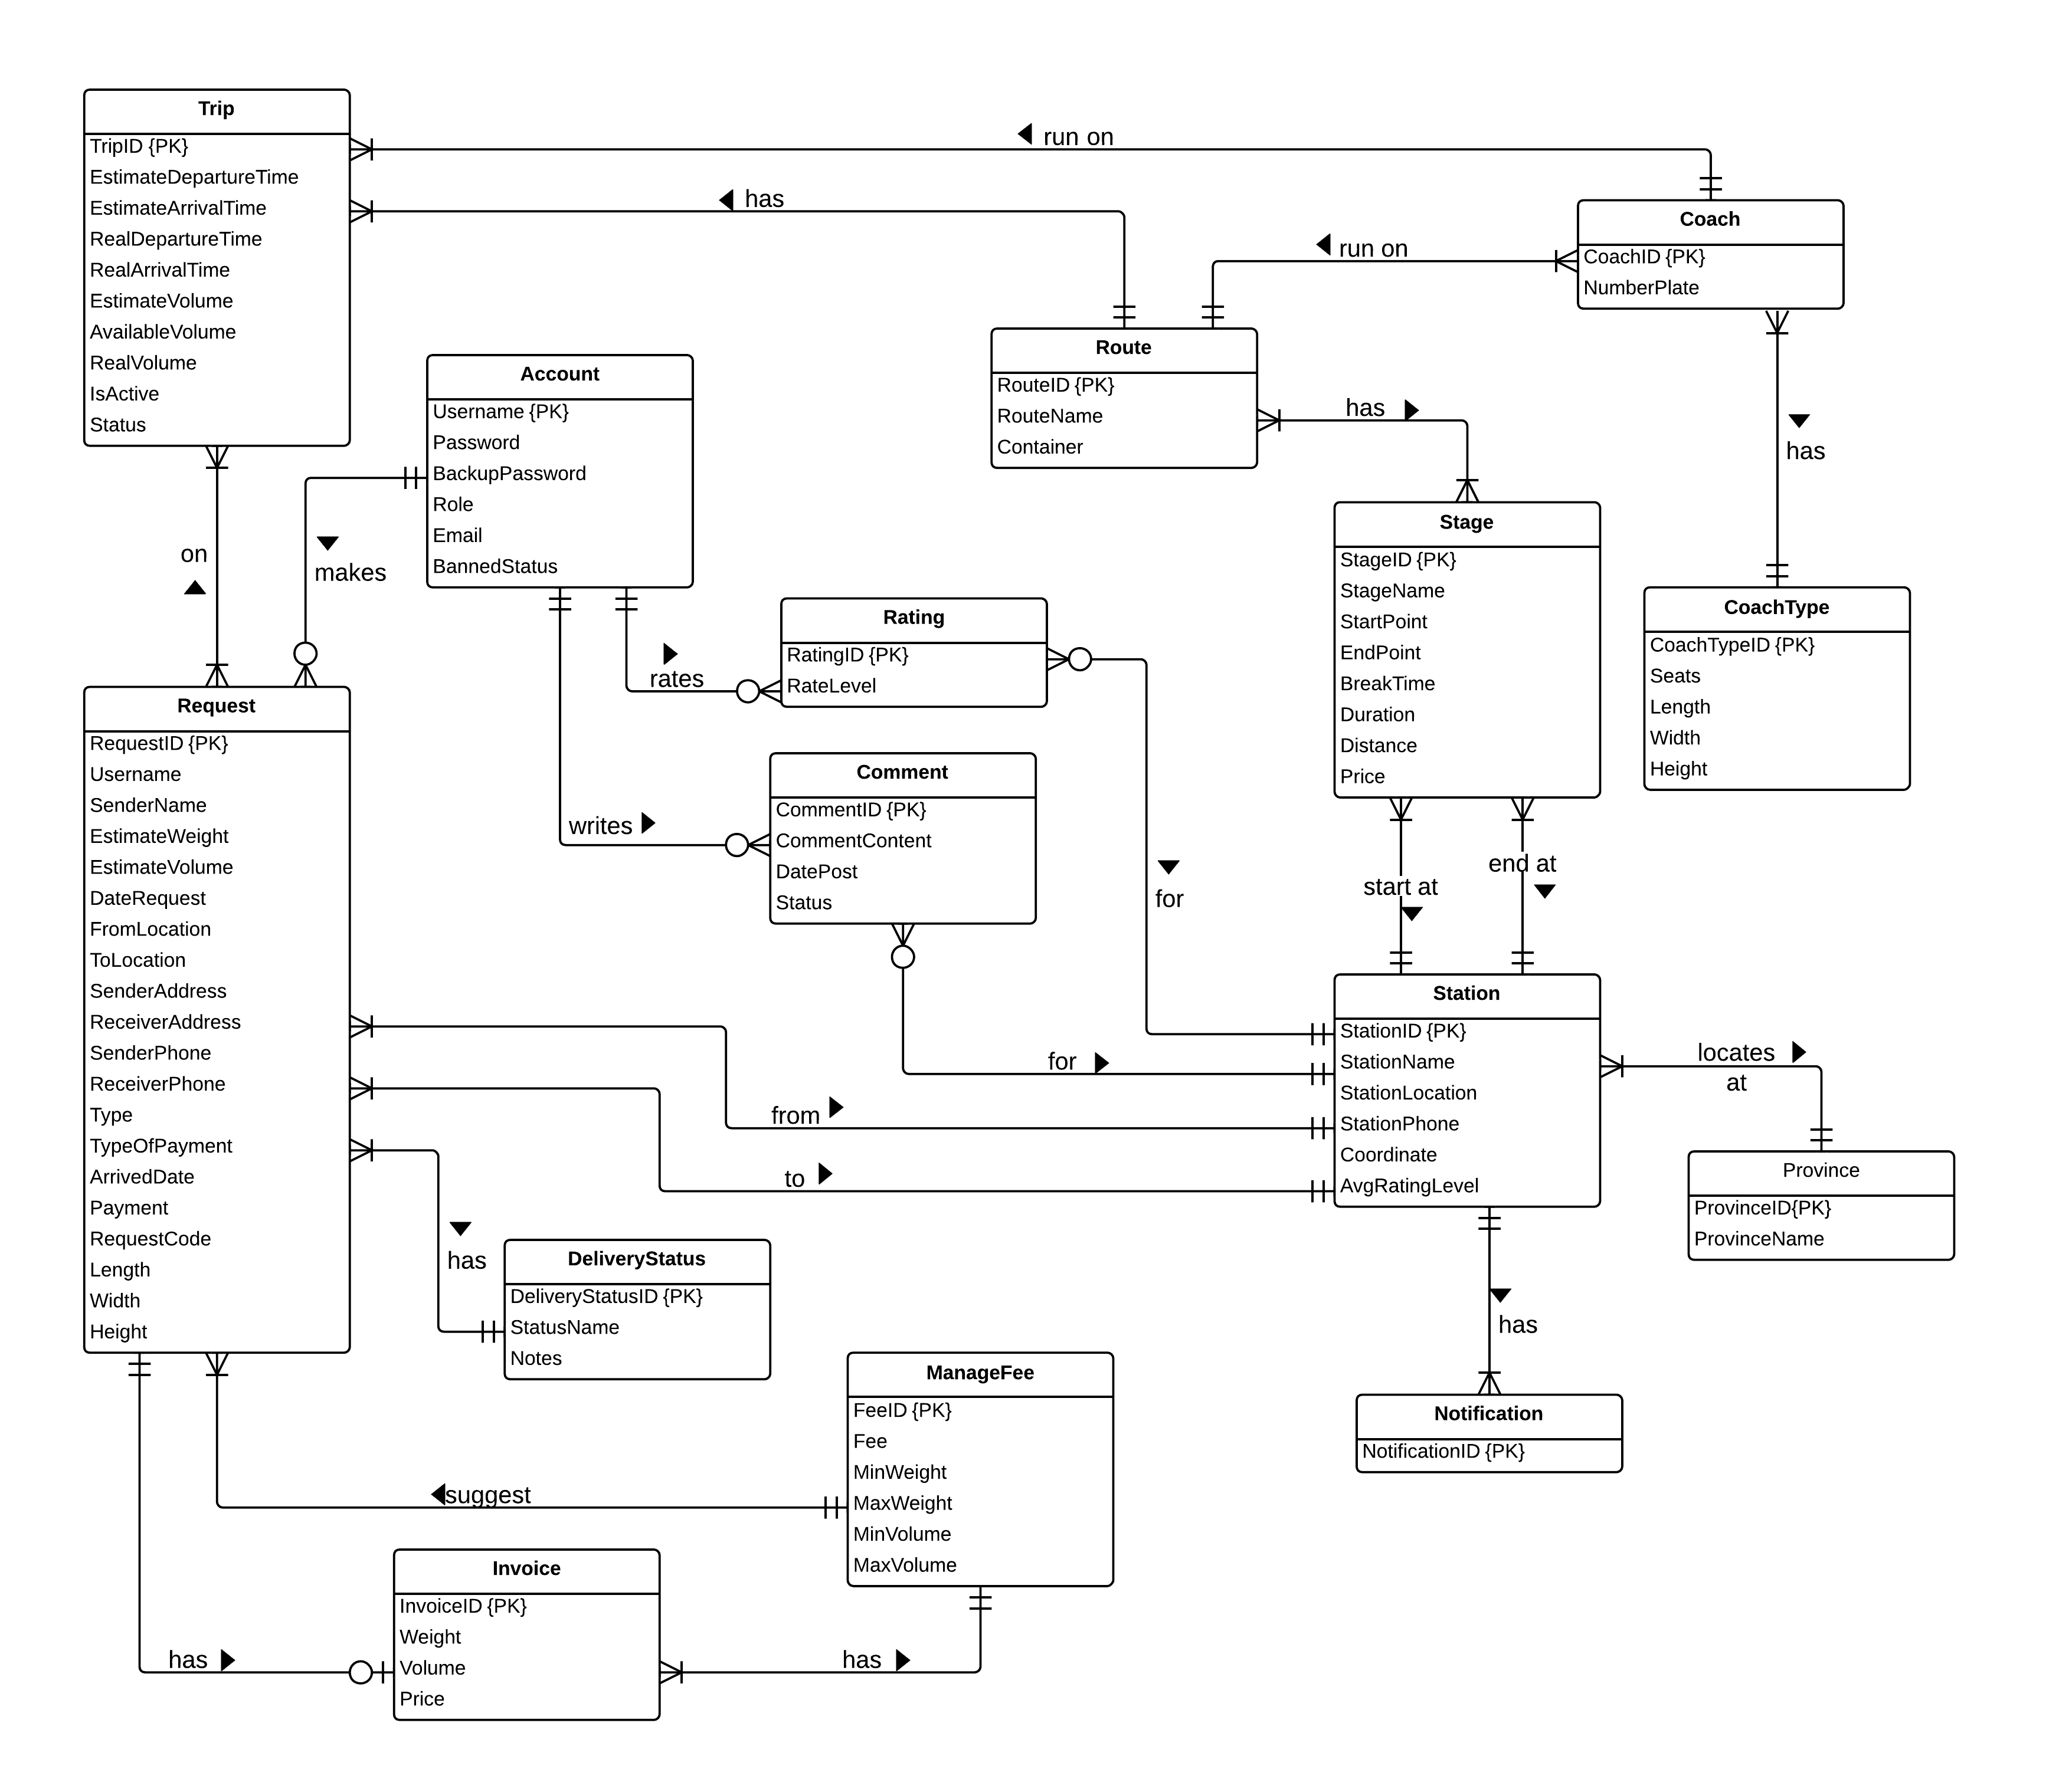

Diagram . Entity relationship diagram

# Software Design Description (SDD)



## Design Overview

The SDD describes the system architectural design and the detailed designs, including the user interfaces, of the system.

The components should communicate through interfaces. The detailed implementation of each component should be transparent to other components. The passive MVC III pattern is the preferable architecture for the website.

The detailed designs of the system should adopt the basic principles of software design, including “high cohesion, low coupling” and “open to extension, closed to modification” principles.

Each of the following sections is summarized below:

* Section 4.2: Gives a specification of the system architecture design, describing the overall architecture of the system and subsystems.
* Section 4.3: Specifies all the components that should be included in the system, and the communications between them.
* Section 4.4: Describes the class and package diagrams, as well as their descriptions in details, to provide a static view of the system.
* Section 4.4: Describes the sequence diagrams for the use cases specified in the SRS, to provide a dynamic view of the system.
* Section 4.5: Describes the user interfaces, to specify what will be seen by the users of the system.
* Section 4.5: Describes the Database Design, including the relations and the relationships between them.

## System Architectural Design

The MVC III (Model – View – Controller) pattern is used as the overall system architecture, because it specifies a clear distinction between the responsibilities of the components and is appropriate for developing web applications.

3. Exchange data

4. Results

**CONTROLLER**

* Intercepts user input;
* Coordinates the view and model;
* Handles communication between the model and data layer.

**VIEW**

* Binds to the model;
* Renders the UIs (HTML, CSS, JavaScript);
* Allows navigating between controllers.

**MODEL**

* Communicates with data source;
* Exposes functionalities, business logics, and data validation.

Database   
Server

Application Server

1. Request

8. Response

5. Select views

7. Changes made

2. Invoke methods

6. Query states

Method invocations

Change notifications

Figure . Model-View-Controller Architecture

## Component Diagram



Diagram . Component Diagram

The i-Deliver system includes the following major components:

* **Entity Framework 5.0:** An object-relational mapper that enables working with relational data persistence using domain-specific objects;
* **Data Repository:** A data store that provides data access functionality, using the Entity Framework to communicates with the database;
* **Business Logic:** A module that uses interfaces exposed by the Data Repository to encapsulate important businesses of in the i-Deliver system;
* **Ninject Dependency Injection 3.0:** A lightweight dependency injection framework for .NET applications which helps split the application into a collection of loosely-coupled, highly-cohesive pieces, and then glue them back together in a flexible manner.
* **Website:** A web-application that helps exposes all the functionalities to end-users.
* **Algorithms Processing Module:** A module that uses Interface and DataRepository to execute the business of system by processing throught some relative entities and find out the needed connections between them that satisfying the given contraint.

From the point of view of the MVC-III pattern, the components Entity Framework 5.0, Data Repository, Business Logic, and Ninject Dependency Injection 3.0 all belong to the Model part. The Controller and the View parts are wrapped in the component Website.

## Detailed Description of Components



### Entities Classes

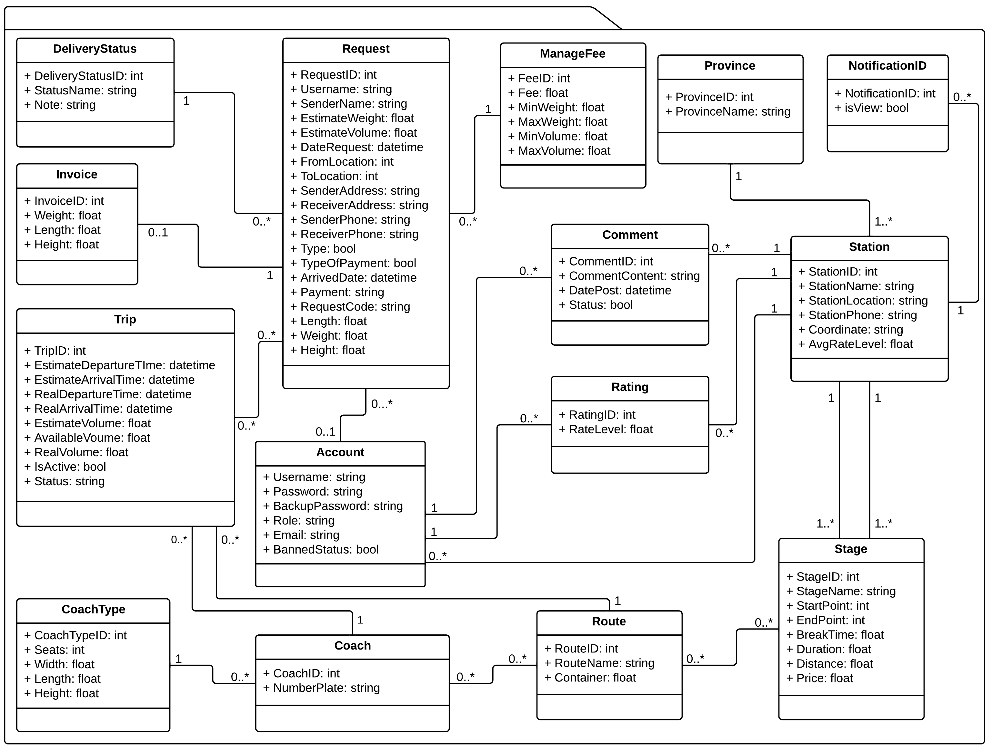

Diagram . Entities Class Diagram

### Algorithm Processing Classes

#### Class diagram



Diagram . Algorithm Processing Class Diagram

#### Algorithms description

##### Introduction

Scheduling problem is very popular in real life and appears in a lot of scopes, such as: education, human resource, transport, etc. For most of the scheduling problems, it has been shown that they are NP – complete problem, and they cannot be solved in polynomial time using a deterministic algorithm or find out the optimize solution within considered space in short time.

Our problem points to a type of this problem, which is scheduling the vehicles to deliver some package from a specific location to another location. The detail description of the problem:

At the transport center using coaches, they want to do an addition task for each coach as deliver the package that some customer sends to center along to each trip. Customers post request to the system to ask for transport the package with some specific information as:

* The time that user post request to the center.
* Volume of request (in dm3).
* Weight of request (in kilograms).
* Begin and end location of request.

The center has some resource as follow:

* Some stations with given address, exact coordinate with longitude and latitude.
* Some stages and each stage connect exactly two stations.
* Some routes and each route include one or multiple stages with the given order.
* Some coach with specific capacity (about volume can serve).
* Some schedule infers that which coach travels on which route and the coach start at what specific time of day.
* Some trip and each trip is an instant of schedule in a specific day.

The problem turns out is one type of scheduling problem: arrange resource for satisfying the given constraint. For detail, we want to assign each request for some trips such that:

- The total volume of requests assigned to trip not more than this coach’ volume.

- The time of delivery for each request not more than 5 days and the time for deliver each request as min as possible.

- In the list of trips, the departure time of each trip not earlier than the time for right previous trip depart to the middle station and the delta time between two point times (arrival time of previous trip and depart time of current trip) is 45 minutes.

- The way of deliver is straight forward, not go backward.

##### Detail solution

We name the begin station of request is  and the end station of request is 

1. **Step 1:**

First, build an indirect and single graph  in which:

*  is the set of stations of the system.
*  is the set of stage connects two stations.

List all data from database and sort the list of request base on 3 criterions:

* The time of user post request (like the principles: first come, first served of queue).
* The volume of request (follow the greedy rules: to gain the most, first try to process the biggest one).
* The weight of request (the higher weight of request, the more money system can get).

1. **Step 2:**

Using Breath First Search algorithm to find some way connect  and . The original of this algorithm is just finding one satisfied solution and that solution travels on the smallest number of edges of graph. We extend it a little bit to find not only one solution but also multiple solutions. The maximum number of solutions allowed is  (to avoid the loop in graph with thick graph situation that leads to the number can be up to ).

In some cases, the direction of the partial of way is not always forward so we should reject the inappropriate way (the path in graph usually fallen into that case). To check the way not go backward, we use the mathematical idea as:

The point  with longitude and latitude are  respectively, we have the coordinate of its in space is  with  and  is the radius of Earth (we can assume that Earth is a quite sphere).

The angle of two vectors  is

.

with  is the dot product of two vectors and we can find this value easily by the found coordinate as above.

Assume that we have the list of stages:



with  is the number of stages. So we iterate through the list of stages to check whether two consecutive stages form an obtuse angle with value bigger than the allow angle (in this case, we choose  as the upper value). If all pairs of consecutive stages are satisfy the condition, we accept this way, otherwise, we reject it and find another way.

1. **Step 3:**

For each found way, try to perform 3 greedy ideas as following:

* Check one trip:
* If the is such route, find list of trip travel on that route: this can be obtained by iterate through the list of route.
* If this trip satisfies the condition, take it as the good solution immediately (because it is easy to deliver and manage a package when it is only in one trip than multiple trips).
* Check multiple trip:
* Check to find some routes connect the consecutive stages of each list of found way list and the package hasn’t been get off the coach at the middle way, this can be obtained by brute-force way as following:
* Cut the list of stages into 2 parts and find route for each part. If all well, save the current solution to list.
* Cut the list of stages into 3 parts and perform action the same as above.
* Cut the list of stages into 4 parts and perform action the same as above.
* For each list of found route, find trip and check condition to find some solution and add them to the list.
* Sort the solution bases on 2 criteria: the duration and the distance. Then choose the first of list mean the best solution for this case and stop the finding method.
* Check middle trips:
* Check to find some trips travel on some routes and the package can be gets on and gets off each trip at the middle of its journey, this can be done by the brute-force way as above that try to cut the list of into 1, 2, 3 or 4 (not consider more) parts and find the route.
* For each found list, we check the time that previous trip will comes to the break station that earlier than the next trip 45 minutes or more. If all are well, save the current list as one of solution in this case.
* Sort the solution bases on 2 criteria: the duration and the distance. Then choose the first of list mean the best solution for this case and stop the finding method.

Notes that the condition including some criterions:

- The total request assigned to trip not more than available volume of trip.

- If the list of trip contains more than one trip, the departure time of each trip is 45 minutes later than the arrival time of previous trip on the list.

##### Pros and cons of algorithm

|  |  |
| --- | --- |
| **Pros** | **Cons** |
| Use greedy method for almost steps of algorithm so it is fast to find out the solution and meet the local optimize of the given optimization problem. | The step of algorithm are separately performed so in some case, it cannot meet the absolute optimize solution (it occurs in some tricky or special case). |
| Some list of needed data listed for the first request also can be used for next requests. | Data list all from database so when the system works in a long time, the amount of item can be very large so reducing the time of action. |
| It is easy to see the correctness of this solution and because all condition are check step by step so if a solution is found, it also meet all constraint. | Some steps of algorithm can be implemented better to reduce the complexity but still not have done. |

The complexity of algorithm is  with  are the number of trip, route, stage and requests, respectively.

##### References

[1] <http://www.codeproject.com/Questions/164691/Retrieve-all-simple-paths-in-a-graph>

[2] <http://math.stackexchange.com/questions/441182/how-to-check-if-three-coordinates-form-a-line>

#### IRouteChooser



**Properties:** N/A

**Operations**

|  |  |  |
| --- | --- | --- |
| **Signature:** int ChooseOneRouteSolution(int StartStation, int EndStation)  **Description:** return one suitable route to deliver from the start station to the end station, if the route not exists, return -1. | | |
| **Parameter** | **Type** | **Description** |
| StartStation | int | The ID of the start station of the request |
| EndStation | int | The ID of the end station of the request |

|  |  |  |
| --- | --- | --- |
| **Signature:** List <int> ChooseMultipleRouteSolution(int StartStation, int EndStation)  **Description:** return the list of suitable route to deliver from the start station to the end station. | | |
| **Parameter** | **Type** | **Description** |
| StartStation | int | The ID of the start station of the request |
| EndStation | int | The ID of the end station of the request |

|  |  |  |
| --- | --- | --- |
| **Signature:** List<int> SuggestRoute(int StartStation, int EndStation)  **Description:** Suggest for staff the best suitable route or list of routes base on the input start and end station of request. | | |
| **Parameter** | **Type** | **Description** |
| StartStation | int | The ID of the start station of the request |
| EndStation | int | The ID of the end station of the request |

|  |  |  |
| --- | --- | --- |
| **Signature:** bool RouteChosenSave (List<int> RouteList)  **Description:** Retrieves the list of route and save them to the table with exactly indicate order. | | |
| **Parameter** | **Type** | **Description** |
| RouteList | List<int> | List of route that staff choose or system suggest |

|  |  |  |
| --- | --- | --- |
| **Signature:** float EstimateTimeDeliver (List<int> RouteList)  **Description:** Find the estimate time to deliver the package base on the input route list and their relative information. | | |
| **Parameter** | **Type** | **Description** |
| RouteList | List<int> | List of route that staff choose or system suggest |

#### IAssigning



**Properties:** N/A

**Operations**

|  |  |  |
| --- | --- | --- |
| **Signature:** float FindRemaingVolume (int TripID)  **Description:** Return the remaining volume that the coach on input trip can be serving. | | |
| **Parameter** | **Type** | **Description** |
| TripID | int | The ID of trip that staff wants to estimate. |

|  |  |  |
| --- | --- | --- |
| **Signature:** List <int> AssigningPackage (int RequestID)  **Description:** Automatically find the list of trip suitable for deliver the package. | | |
| **Parameter** | **Type** | **Description** |
| RequestID | int | The ID of request that staff processing. |

### Data Repository Classes

#### Class diagram

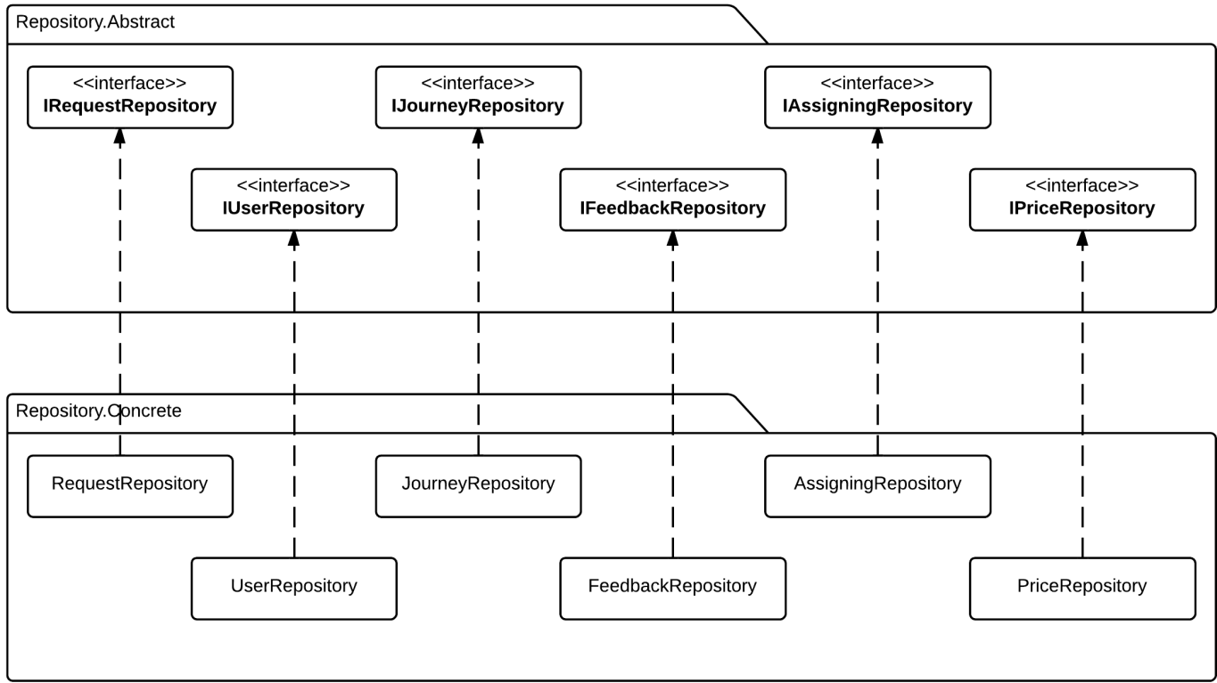

Diagram . Data Repository Class Diagram

#### IRequestRepository Interface



Properties: N/A

Operations:

|  |  |  |
| --- | --- | --- |
| Signature: IEnumerable<Request> Get Requests()  Description: Retrieves all the requests from the database | | |
| N/A | N/A | N/A |

|  |  |  |
| --- | --- | --- |
| Signature: Request GetRequestById(int requestId)  Description: Retrieves a request from the database given its id | | |
| Parameter | **Type** | **Description** |
| *requestId* | int | Id of the request to be retrieved |

|  |  |  |
| --- | --- | --- |
| Signature: IEnumerable<Request> GetRequestByStatus(int status)  Description: Retrieves all the request from the database given its status | | |
| Parameter | **Type** | **Description** |
| *Status* | Int | Status of the request to be retrieved |

|  |  |  |
| --- | --- | --- |
| Signature: bool postRequest(Request request)  Description: post new delivery request to system and save to database | | |
| Parameter | **Type** | **Description** |
| *request* | Request | New request to be saved |

|  |  |  |
| --- | --- | --- |
| Signature: bool updateRequest(int requestId)  Description: Update existing request to the database given its id | | |
| Parameter | **Type** | **Description** |
| *requestId* | int | Id of the request to be updated |

|  |  |  |
| --- | --- | --- |
| Signature: bool cancelRequest(int requestId)  Description: Cancel/Remove existing request from the database given its id | | |
| Parameter | **Type** | **Description** |
| *requestId* | int | Id of the request to be updated |

|  |  |  |
| --- | --- | --- |
| Signature: IEnumerable<Request> serchRequest(string query)  Description: Retrieves all the request from the database given by query string | | |
| Parameter | **Type** | **Description** |
| *query* | String | Query string to find matching request |

#### IUserRepository Interface



Properties: N/A

|  |  |  |
| --- | --- | --- |
| Signature: User GetUserByUsername(String username)  Description: Retrieves a user given its username from the database | | |
| Parameter | **Type** | **Description** |
| *username* | String | Username of user to be retrieved |

|  |  |  |
| --- | --- | --- |
| Signature: User GetUserByRole(String role)  Description: Retrieves a user given its role from the database | | |
| Parameter | **Type** | **Description** |
| *role* | String | Role of user to be retrieved |

|  |  |  |
| --- | --- | --- |
| Signature: bool addUser(User user)  Description: Add new user to the database | | |
| Parameter | **Type** | **Description** |
| *user* | UserProfile | The user to be saved |

|  |  |  |
| --- | --- | --- |
| Signature: bool updateUser(int username)  Description: Update/Save user information to the database | | |
| Parameter | **Type** | **Description** |
| *username* | String | Username of user to be updated |

|  |  |  |
| --- | --- | --- |
| Signature: bool GrantAccess(String username, int roleId)  Description: Grants the selected role the user with the user id | | |
| Parameter | **Type** | **Description** |
| *username* | String | Username of the user to be granted access |
| *roleId* | Role | Role that will be granted to the user |

|  |  |  |
| --- | --- | --- |
| Signature: bool DeactivateUser(String username)  Description: Marks the user as deactivated in the database | | |
| Parameter | **Type** | **Description** |
| *username* | String | Username of the user to be marked as deactivated |

#### IJourneyRepository Interface



**Properties:** N/A

**Operations**

|  |  |  |
| --- | --- | --- |
| Signature: IEnumerable<Station> GetStations()  Description: Retrieves all the stations from the database | | |
| Parameter | **Type** | **Description** |
| N/A | N/A | N/A |

|  |  |  |
| --- | --- | --- |
| Signature: Station GetStationByStationId(int stationId)  Description: Retrieves the station given its station id from the database | | |
| Parameter | **Type** | **Description** |
| *stationId* | int | Id of the station to be retrieved |

|  |  |  |
| --- | --- | --- |
| Signature: Station AddStation(Station station)  Description: Add new station to the database | | |
| Parameter | **Type** | **Description** |
| *station* | Station | The new station to be added to database |

|  |  |  |
| --- | --- | --- |
| Signature: bool UpdateStation(int stationId)  Description: Update station information from given its id from the database | | |
| Parameter | **Type** | **Description** |
| *stationId* | int | Id of the station to be updated |

|  |  |  |
| --- | --- | --- |
| Signature: bool DeleteStation(int stationId)  Description: Delete the station given its it from the database | | |
| Parameter | **Type** | **Description** |
| *stationId* | int | Id of the station to be deleted |

|  |  |  |
| --- | --- | --- |
| Signature: IEnumerable<Trip> GetTrips()  Description: Retrieves all the trips from the database | | |
| Parameter | **Type** | **Description** |
| N/A | N/A | N/A |

|  |  |  |
| --- | --- | --- |
| Signature: Station GetTripByTripId(int tripId)  Description: Retrieves the station given its station id from the database | | |
| Parameter | **Type** | **Description** |
| *tripId* | int | Id of the trip to be retrieved |

|  |  |  |
| --- | --- | --- |
| Signature: Station AddTrip(Trip trip)  Description: Add new trip to the database | | |
| Parameter | **Type** | **Description** |
| *trip* | Trip | The new trip to be added to database |

|  |  |  |
| --- | --- | --- |
| Signature: bool UpdateTrip(int tripId)  Description: Update trip information from given its id from the database | | |
| Parameter | **Type** | **Description** |
| *tripId* | int | Id of the trip to be updated |

|  |  |  |
| --- | --- | --- |
| Signature: bool DeleteTrip(int tripId)  Description: Delete the trip given its it from the database | | |
| Parameter | **Type** | **Description** |
| *tripId* | int | Id of the trip to be deleted |

#### IAssigningRepository Interface



**Properties:** N/A

**Operations**

|  |  |  |
| --- | --- | --- |
| Signature: bool approveRequest(int requestId)  Description: Approve pending requests | | |
| Parameter | **Type** | **Description** |
| *requestId* | int | Id of the request to be approved |

|  |  |  |
| --- | --- | --- |
| Signature: bool rejectRequest(int requestId)  Description: Reject pending requests | | |
| Parameter | **Type** | **Description** |
| *requestId* | int | Id of the request to be rejected |

|  |  |  |
| --- | --- | --- |
| Signature: bool assignPackage(int requestId, int coachId, int tripId)  Description: Assign approved package for specified coach | | |
| Parameter | **Type** | **Description** |
| *requestId* | int | Id of the package to be assigned |
| *coachId* | int | Id of the coach to assign package |
| *tripId* | Int | Id of the trip to assign package |

|  |  |  |
| --- | --- | --- |
| Signature: bool updateLateRequest(int requestId)  Description: Update and re-assign for late arrive package | | |
| Parameter | **Type** | **Description** |
| *requestId* | int | Id of the request to be update and re-assigned |

|  |  |  |
| --- | --- | --- |
| Signature: bool updatePackageStatus(int requestId)  Description: Update package status when it departed, arrived, delivered or expired | | |
| Parameter | **Type** | **Description** |
| *requestId* | int | Id of the request to be update and re-assigned |

#### IFeedbackRepository Interface



**Properties:** N/A

**Operations**

|  |  |  |
| --- | --- | --- |
| Signature: IEnumerable<Comment> GetComments()  Description: Retrieves all the comments from the database | | |
| Parameter | **Type** | **Description** |
| N/A | N/A | N/A |

|  |  |  |
| --- | --- | --- |
| Signature: IEnumerable<RatingCriterion> GetRatingByStationId(int stationId)  Description: Retrieves all the rating that belong to a given station from the database | | |
| Parameter | **Type** | **Description** |
| *stationId* | int | Id of the station that has the rating to be retrieved |

|  |  |  |
| --- | --- | --- |
| Signature: bool postComment(Comment comment)  Description: Post new comment and save to database | | |
| Parameter | **Type** | **Description** |
| *comment* | Comment | The new comment to be saved to database |

|  |  |  |
| --- | --- | --- |
| Signature: bool saveRating(Rating rating)  Description: Save station rating to database | | |
| Parameter | **Type** | **Description** |
| *rating* | Rating | The new station rating to be saved to database |

|  |  |  |
| --- | --- | --- |
| Signature: bool deleteComment(int commentId)  Description: Marks a comment as deleted in the database | | |
| Parameter | **Type** | **Description** |
| *commentId* | int | Id of the comment to be deleted |

|  |  |  |
| --- | --- | --- |
| Signature: bool clearRating(int ratingId)  Description: Marks a station rating as deleted in the database | | |
| Parameter | **Type** | **Description** |
| *ratingId* | Int | Id of the rating to be deleted |

#### IPriceRepository Interface



**Properties:** N/A

**Operations**

|  |  |  |
| --- | --- | --- |
| Signature: IEnumerable<Price> GetPriceByWeight(float weight)  Description: Get delivery price/fee based on package weight | | |
| Parameter | **Type** | **Description** |
| *weight* | float | Weight of delivered package |

|  |  |  |
| --- | --- | --- |
| Signature: IEnumerable<Price> GetPriceByVolume(float volume)  Description: Get delivery price/fee based on package volume | | |
| Parameter | **Type** | **Description** |
| *volume* | float | Volume of delivered package |

|  |  |  |
| --- | --- | --- |
| Signature: bool addPriceNorm(Price price)  Description: Add new price/fee norm to database | | |
| Parameter | **Type** | **Description** |
| *price* | Price | New price norm to be added to database |

|  |  |  |
| --- | --- | --- |
| Signature: bool updatePriceNorm(priceId: int)  Description: Update a price norm to the database | | |
| Parameter | **Type** | **Description** |
| *priceId* | int | The price norm to be saved |

|  |  |  |
| --- | --- | --- |
| Signature: bool updatePriceNorm(priceId: int)  Description: Delete/Remove a price norm from the database | | |
| Parameter | **Type** | **Description** |
| *priceId* | int | The price norm to be deleted |

### Business Logic Classes

#### Class diagram



Diagram . Business Logic Class Diagram

#### IAcount Interface



**Properties:** N/A

**Operations**

|  |  |  |
| --- | --- | --- |
| Signature: bool LogIn(Account model, string returnUrl)  Description: Login account to system | | |
| Parameter | **Type** | **Description** |
| *model* | Account | The data of account model |
| *returnUrl* | string | The url of redirect |

|  |  |  |
| --- | --- | --- |
| Signature: bool Register(Account model)  Description: Create a new account for user | | |
| Parameter | **Type** | **Description** |
| *model* | Account | The data of account model |
|  |  |  |

#### IAssigning Interface



**Properties**

|  |  |  |  |
| --- | --- | --- | --- |
| Property name | Type | Visibility | Description |
| *stages* | List<Stage> | public | A list of all stage in the stage list |

**Operations**

|  |  |  |
| --- | --- | --- |
| Signature: void ListAssign(int stationID)  Description: List requests has been assigned at the station of staff | | |
| Parameter | **Type** | **Description** |
| *stationID* | int | Id of stationID of staff |

|  |  |  |
| --- | --- | --- |
| Signature: void ListTrip(int requestId)  Description: List trip that have requestId | | |
| Parameter | **Type** | **Description** |
| *requestId* | int | Id of the request |

|  |  |  |
| --- | --- | --- |
| Signature: void FindStageFromRoute(int routeID)  Description: Find the stage from the route | | |
| Parameter | **Type** | **Description** |
| *routeID* | int | Id of the route |

|  |  |  |
| --- | --- | --- |
| Signature: void Accept(List<Request> requestId)  Description: Accept request that on the ways | | |
| Parameter | **Type** | **Description** |
| requestId | List<Request> | Id of the request |

|  |  |  |
| --- | --- | --- |
| Signature: bool CheckRequestLate(List<Trip> requestId)  Description: Saves the booking list to the database | | |
| Parameter | **Type** | **Description** |
| *requestId* | int | Id of list request to check |

|  |  |  |
| --- | --- | --- |
| Signature: void RequestPeding(int stationId)  Description: List request pending at the staff station | | |
| Parameter | **Type** | **Description** |
| *stationId* | int | Id of the station |

|  |  |  |
| --- | --- | --- |
| Signature: void ListTripPending(int requestId)  Description: List trip pending | | |
| Parameter | **Type** | **Description** |
| *requestId* | int | Id of the request |

|  |  |  |
| --- | --- | --- |
| Signature: bool UpdateStatus(int tripId, int requestId)  Description: Update the status of request | | |
| Parameter | **Type** | **Description** |
| *requestId* | int | Id of the request |
| *tripId* | int | Id of the trip |

|  |  |  |
| --- | --- | --- |
| Signature: void ListRequestForTrip(int tripid)  Description: List request for trip | | |
| Parameter | **Type** | **Description** |
| *tripid* | int | Id of the trip |

|  |  |  |
| --- | --- | --- |
| Signature: bool UpdateArrive(int requestId)  Description: Update request arrived | | |
| Parameter | **Type** | **Description** |
| *requestId* | int | Id of the request |

|  |  |  |
| --- | --- | --- |
| Signature: void DeliveredRequest(int stationID)  Description: List request have status is delivered | | |
| Parameter | **Type** | **Description** |
| *stationID* | int | Id of the station |

|  |  |  |
| --- | --- | --- |
| Signature: void ExpiredRequest(int stationID)  Description: List request have status is expired | | |
| Parameter | **Type** | **Description** |
| *stationID* | int | Id of the station |

|  |  |  |
| --- | --- | --- |
| Signature: void ArrivedRequest(int stationID)  Description: List request have status is arrived | | |
| Parameter | **Type** | **Description** |
| *requestId* | int | Id of the request |

#### IStage Interface



**Properties:** N/A

**Operations**

|  |  |  |
| --- | --- | --- |
| Signature: bool Create(Stage stage)  Description: Create new stage | | |
| Parameter | **Type** | **Description** |
| *stage* | Stage | Stage data model |

|  |  |  |
| --- | --- | --- |
| Signature: bool Delete(int stageId)  Description: Delete stage | | |
| Parameter | **Type** | **Description** |
| *stageId* | Int | Id of the stage to delete |
| Signature: bool Edit(Stage stage)  Description: Edit stage | | |
| Parameter | **Type** | **Description** |
| *stage* | Stage | Stage data model |

#### ITrip Interface



**Properties:** N/A

**Operations**

|  |  |  |
| --- | --- | --- |
| Signature: bool Create(List<Schedule> schedules, DateTime date)  Description: Adds a new trip to database | | |
| Parameter | **Type** | **Description** |
| *Schedules* | List<Schedule> | List of the schedule |
| *date* | DateTime |  |

|  |  |  |
| --- | --- | --- |
| Signature: bool Edit(Trip trip)  Description: Update existing trip | | |
| Parameter | **Type** | **Description** |
| *trip* | Trip | Trip to edit |

|  |  |  |
| --- | --- | --- |
| Signature: bool Delete(int tripId)  Description: Delete trip from database | | |
| Parameter | **Type** | **Description** |
| *tripId* | int | Id of trip to delete |

#### ICustomer Interface



**Properties:** N/A

**Operations**

|  |  |  |
| --- | --- | --- |
| Signature: void getInvoice(int requestId) : void)  Description: List invoice | | |
| Parameter | **Type** | **Description** |
| *requestId* | Int | Id of the request to get the invoice |

|  |  |  |
| --- | --- | --- |
| Signature: void ListRequestCustomer(string username)  Description: List of request customer | | |
| Parameter | **Type** | **Description** |
| *username* | string | Username of customer to list the request |

#### IFee Interface



**Properties:** N/A

**Operations**

|  |  |  |
| --- | --- | --- |
| Signature: bool Create(ManageFee manageFee)  Description: Add new fee to manage | | |
| Parameter | **Type** | **Description** |
| *manageFee* | ManageFee | ManageFee model need to create new data |

|  |  |  |
| --- | --- | --- |
| Signature: bool Edit(ManageFee fee)  Description: Edit fee from manage | | |
| Parameter | **Type** | **Description** |
| *fee* | ManageFee | ManageFee model need to edit data |

|  |  |  |
| --- | --- | --- |
| Signature: bool Delete(int feeId)  Description: Removes the fee from manage | | |
| Parameter | **Type** | **Description** |
| *feeId* | int | Id of the fee need to removes |

#### IFeedback Interface



**Properties:** N/A

**Operations**

|  |  |  |
| --- | --- | --- |
| Signature: bool Comment(String Username, String Comment, Int32 StationID)  Description: Add new comment of customer | | |
| Parameter | **Type** | **Description** |
| *Username* | String | Username of customer to comment |
| *Comment* | String | Content of comment |
| *StationID* | Int | Id of the station to comment |

|  |  |  |
| --- | --- | --- |
| Signature: bool Rating(String Username, float Rating, Int32 StationID)  Description: Add rating of customer for station | | |
| Parameter | **Type** | **Description** |
| *Username* | String | Username of customer to rating |
| *Rating* | Float | Point rating of customer |
| *StationID* | Int | Id of station to rating |

|  |  |  |
| --- | --- | --- |
| Signature: void ListComment(int station)  Description: List all the comment of station | | |
| Parameter | **Type** | **Description** |
| *station* | int | Id of the station to list the comment |

#### IHome Interface



**Properties:** N/A

**Operations**

|  |  |  |
| --- | --- | --- |
| Signature: float CalculateFee(float minVolume, float maxVolume)  Description: CalculateFee from customer input | | |
| Parameter | **Type** | **Description** |
| *minVolume* | float | Min of the volume to calculate |
| *maxVolume* | float | Max of the volume to calculate |

|  |  |  |
| --- | --- | --- |
| Signature: bool PostRequest(string Username, int DeliveryStatusID, int FeeID, string EstimateVolume, string EstimateWeight, DateTime DateRequest, int FromLocation, int ToLocation, string SenderName, string SenderAddress, string SenderPhone, string ReceiverName, string ReceiverAddress, string ReceiverPhone, bit Type, string TypeOfPayment, bit Payment, string RequestCode, float Weight, float Width, float Height)  Description: Insert new request of customer | | |
| Parameter | **Type** | **Description** |
| *Username* | String | Username of customer to post new request |
| *DeliveryStatusID* | Int | Id of the delivery to know status of request |
| *FeeID* | Int | Id of the fee when customer post request |
| *EstimateVolume* | String | The estimate volume customer input |
| *EstimateWeight* | String | The estimate weight customer input |
| *DateRequest* | DateTime | Date that customer post request |
| *FromLocation* | Int | Id of the station that customer sent package |
| *ToLocation* | Int | Id of the station that customer receiver package |
| *SenderName* | String | Name of sender who post request |
| *SenderAddress* | String | Address of sender who post request |
| *SenderPhone* | String | Phone of sender who post request |
| *ReceiverName* | String | Name of receiver who will receiver package |
| *ReceiverAddress* | String | Address of receiver who will receiver package |
| *ReceiverPhone* | String | Phone of receiver who will receiver package |
| *Type* | Bit | Status of request, return or delete |
| *TypeOfPayment* | String | Type of payment when customer post request |
| *Payment* | Bit | Status of payment when customer post request |
| *RequestCode* | String | Random code for request when customer post request |
| *Width* | Float | Width of package request |
| *Height* | Float | Height of package request |
| *Length* | Float | Length of package request |

|  |  |  |
| --- | --- | --- |
| Signature: float GetRoutePrice(string RouteName)  Description: Get the price of route to calculate total fee | | |
| Parameter | **Type** | **Description** |
| *RouteName* | String | Name of the route to calculate fee |

|  |  |  |
| --- | --- | --- |
| Signature: bool checkPackage(double length, double width, double height)  Description: Check package is valid or not | | |
| Parameter | **Type** | **Description** |
| *length* | Double | Length of the package to check |
| *width* | Double | Width of the package to check |
| *height* | Double | Height of the package to check |

|  |  |  |
| --- | --- | --- |
| Signature: float getVolume(float volume)  Description: Get min volume, max volume when customer input length, width, height | | |
| Parameter | **Type** | **Description** |
| *volume* | float | Volume that calculate base on length, width, height when customer input request |

|  |  |  |
| --- | --- | --- |
| Signature: void ListStatusCustomer(string Username)  Description: List all status of customer to view request that they has been posted | | |
| Parameter | **Type** | **Description** |
| *Username* | String | Username of customer to list request follow the status |

#### IPaypal Interface



**Properties:** N/A

**Operations**

|  |  |  |
| --- | --- | --- |
| Signature: void InforOfRequest(string item_name, string amount)  Description: View infor of request on paypal page | | |
| Parameter | **Type** | **Description** |
| *item_name* | String | Name of request |
| *amount* | String | Amount of request |

#### IRequest Interface



|  |  |  |
| --- | --- | --- |
| Signature: void ListRequest(int stationId)  Description: List all request of station | | |
| Parameter | **Type** | **Description** |
| *stationId* | Int | Id of station to list request |

|  |  |  |
| --- | --- | --- |
| Signature: void AutoSet(List<int> requestIDs)  Description: Auto set request status to 'Đã hết hạn - 8' if delivery date was late 2 days | | |
| Parameter | **Type** | **Description** |
| *requestIDs* | List<int> | List of request that need to check late |

|  |  |  |
| --- | --- | --- |
| Signature: bool Return(int listRequest)  Description: Prepare late delivery request for returning | | |
| Parameter | **Type** | **Description** |
| *listRequest* | Int | Id of request need to returning |

|  |  |  |
| --- | --- | --- |
| Signature: bool AcceptRequest(int stationID)  Description: The place to receiver new request and the station of staff | | |
| Parameter | **Type** | **Description** |
| *stationID* | Int | Id of the station to view new request |

|  |  |  |
| --- | --- | --- |
| Signature: bool InsertInvoice(int RequestID, float Weight, float Volume, float Price)  Description: Create invoice for request | | |
| Parameter | **Type** | **Description** |
| *RequestID* | Int | Id of request to create invoice |
| *Weight* | Float | Weight of request to create invoice |
| *Volume* | Float | Volume of request to create invoice |
| *Price* | Float | Price of request to create invoice |

|  |  |  |
| --- | --- | --- |
| Signature: bool CreatePDF(int invoiceID)  Description: Create PDF for invoice | | |
| Parameter | **Type** | **Description** |
| *invoiceID* | Int | Id of the station to view new request |

|  |  |  |
| --- | --- | --- |
| Signature: float CalculatePrice(float weight, float volume, int FromLocation, int ToLocation)  Description: Create invoice for request | | |
| Parameter | **Type** | **Description** |
| *RequestID* | Int | Id of request to create invoice |
| *Weight* | Float | Weight of request to create invoice |
| *Volume* | Float | Volume of request to create invoice |
| *Price* | Float | Price of request to create invoice |

#### ISMS Interface



**Properties:** N/A

**Operations**

|  |  |  |
| --- | --- | --- |
| Signature: void Send(List<Request> phone)  Description: Send notification to customer | | |
| Parameter | **Type** | **Description** |
| *phone* | List<Request> | List of phone customer need to send SMS |

#### IStaff Interface



**Properties:** N/A

**Operations**

|  |  |  |
| --- | --- | --- |
| Signature: bool Create(Account account)  Description: Create new account for staff | | |
| Parameter | **Type** | **Description** |
| *account* | Account | Account model to create |

|  |  |  |
| --- | --- | --- |
| Signature: bool Edit(Account account)  Description: Edit account information for staff | | |
| Parameter | **Type** | **Description** |
| *account* | Account | Account model to edit |

|  |  |  |
| --- | --- | --- |
| Signature: bool Delete(int staffID)  Description: Remove staff | | |
| Parameter | **Type** | **Description** |
| *staffID* | Int | Id of staff to remove |

#### IStation Interface



**Properties:** N/A

**Operations**

|  |  |  |
| --- | --- | --- |
| Signature: bool Create(Station station)  Description: Create new station | | |
| Parameter | **Type** | **Description** |
| *station* | Station | Station model that need to create |

|  |  |  |
| --- | --- | --- |
| Signature: bool Edit(Station station)  Description: Edit station information | | |
| Parameter | **Type** | **Description** |
| *station* | Station | Station model that need to edit |

|  |  |  |
| --- | --- | --- |
| Signature: bool Delete(int stationID)  Description: Remove station | | |
| Parameter | **Type** | **Description** |
| *stationID* | Int | Id of the station to remove |



## Behavioral Diagrams



### State Machine Diagram: Request Status Transition



Diagram . State machine diagram: Request status transition

### State Machine Diagram: Package Status Transition



Diagram . State machine diagram: Package status transition

### Sequence Diagram: Send Delivery Requests

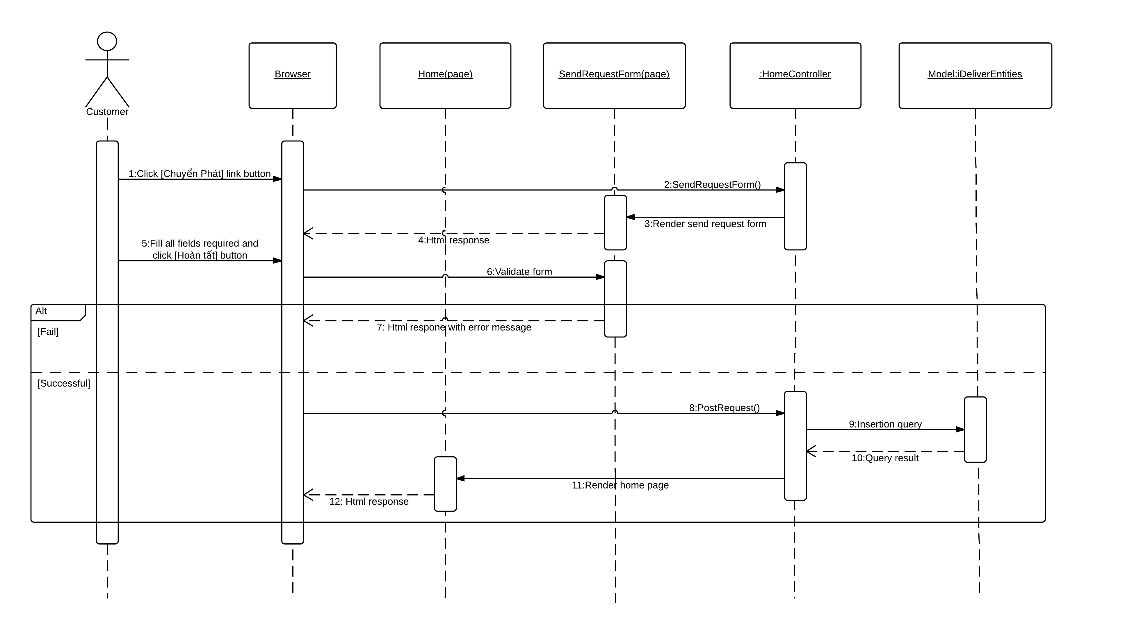

Diagram . Sequence diagram: Send delivery request

### Sequence Diagram: Tracking



Diagram . Sequence diagram: Tracking package

### Sequence Diagram: Payment

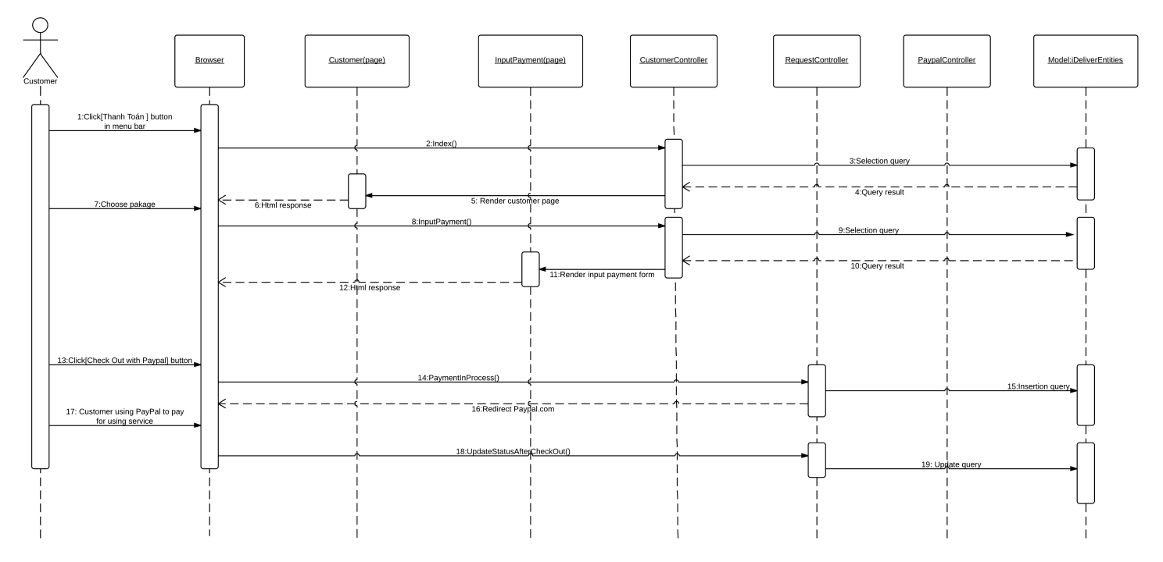

Diagram . Sequence diagram: Payment

### Sequence Diagram: Feedback

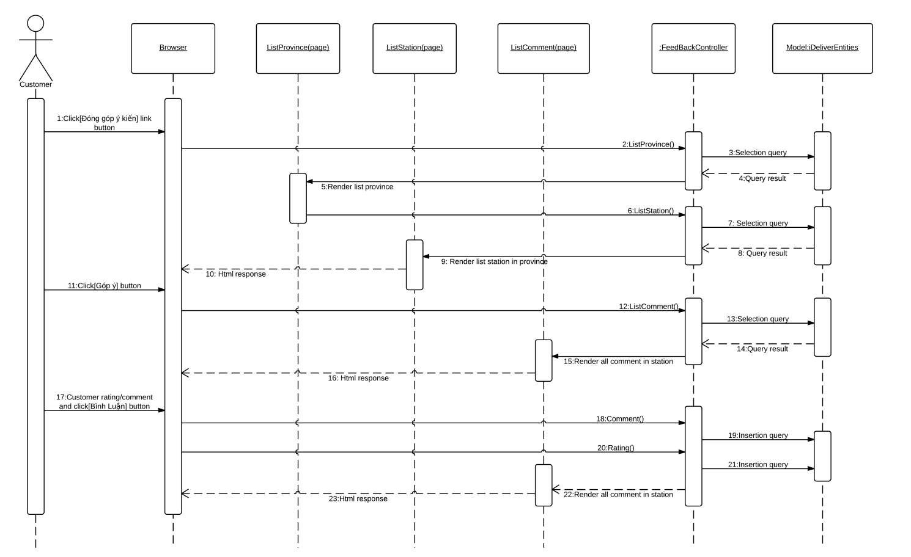

Diagram . Sequence diagram: Feedback

### Sequence Diagram: Approve Requests



Diagram . Sequence diagram: Approve Requests

### Sequence Diagram: Assign Package



Diagram . Sequence diagram: Assign packages

### Sequence Diagram: Package in-transit



Diagram . Sequence diagram: Packages in-transit

### Sequence Diagram: Package arrived



Diagram . Sequence diagram: Package arrived

### Sequence Diagram: Package delivered



Diagram . Sequence diagram: Package delivered

### Sequence Diagram: Package return

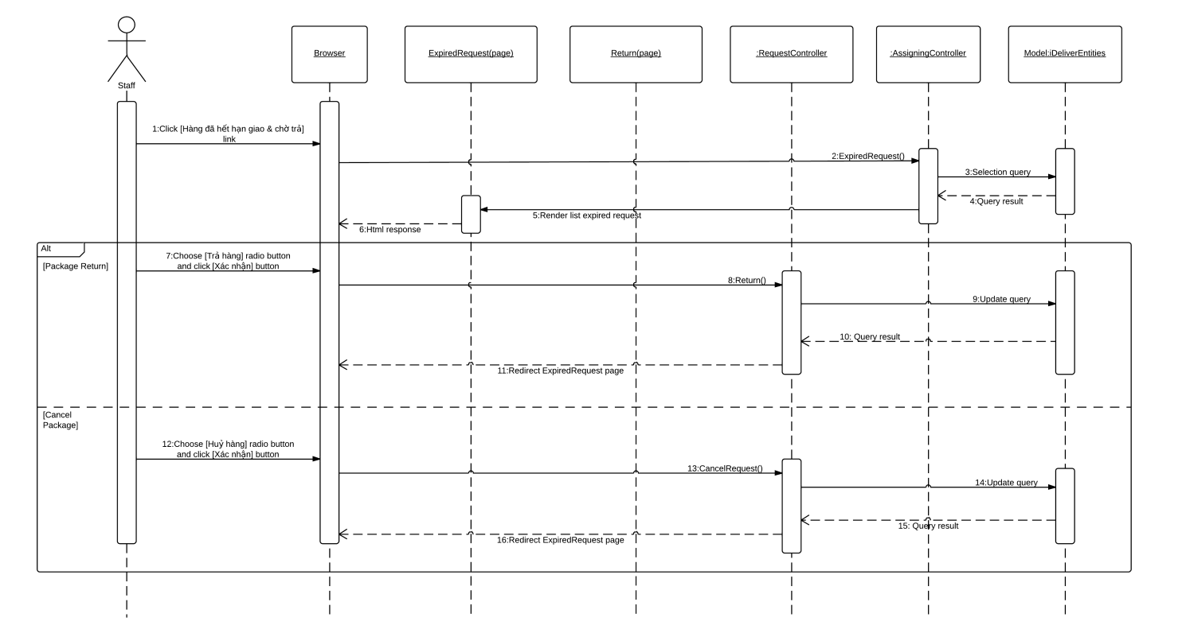

Diagram . Sequence diagram: Package return

### Sequence Diagram: Manage late payment requests

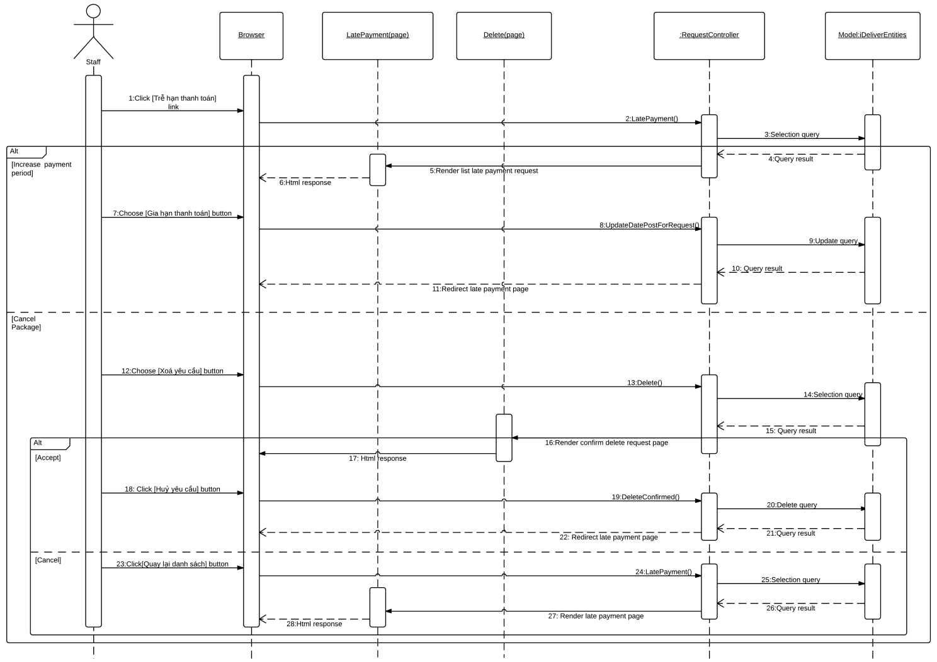

Diagram . Sequence diagram: Manage late payment requests

### Sequence Diagram: Create schedule

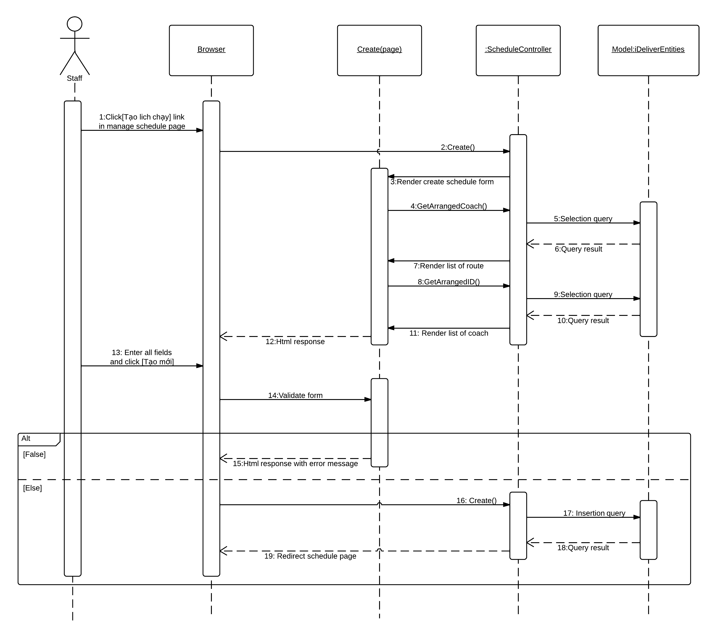

Diagram . Sequence diagram: Create schedule

### Sequence Diagram: Create trip

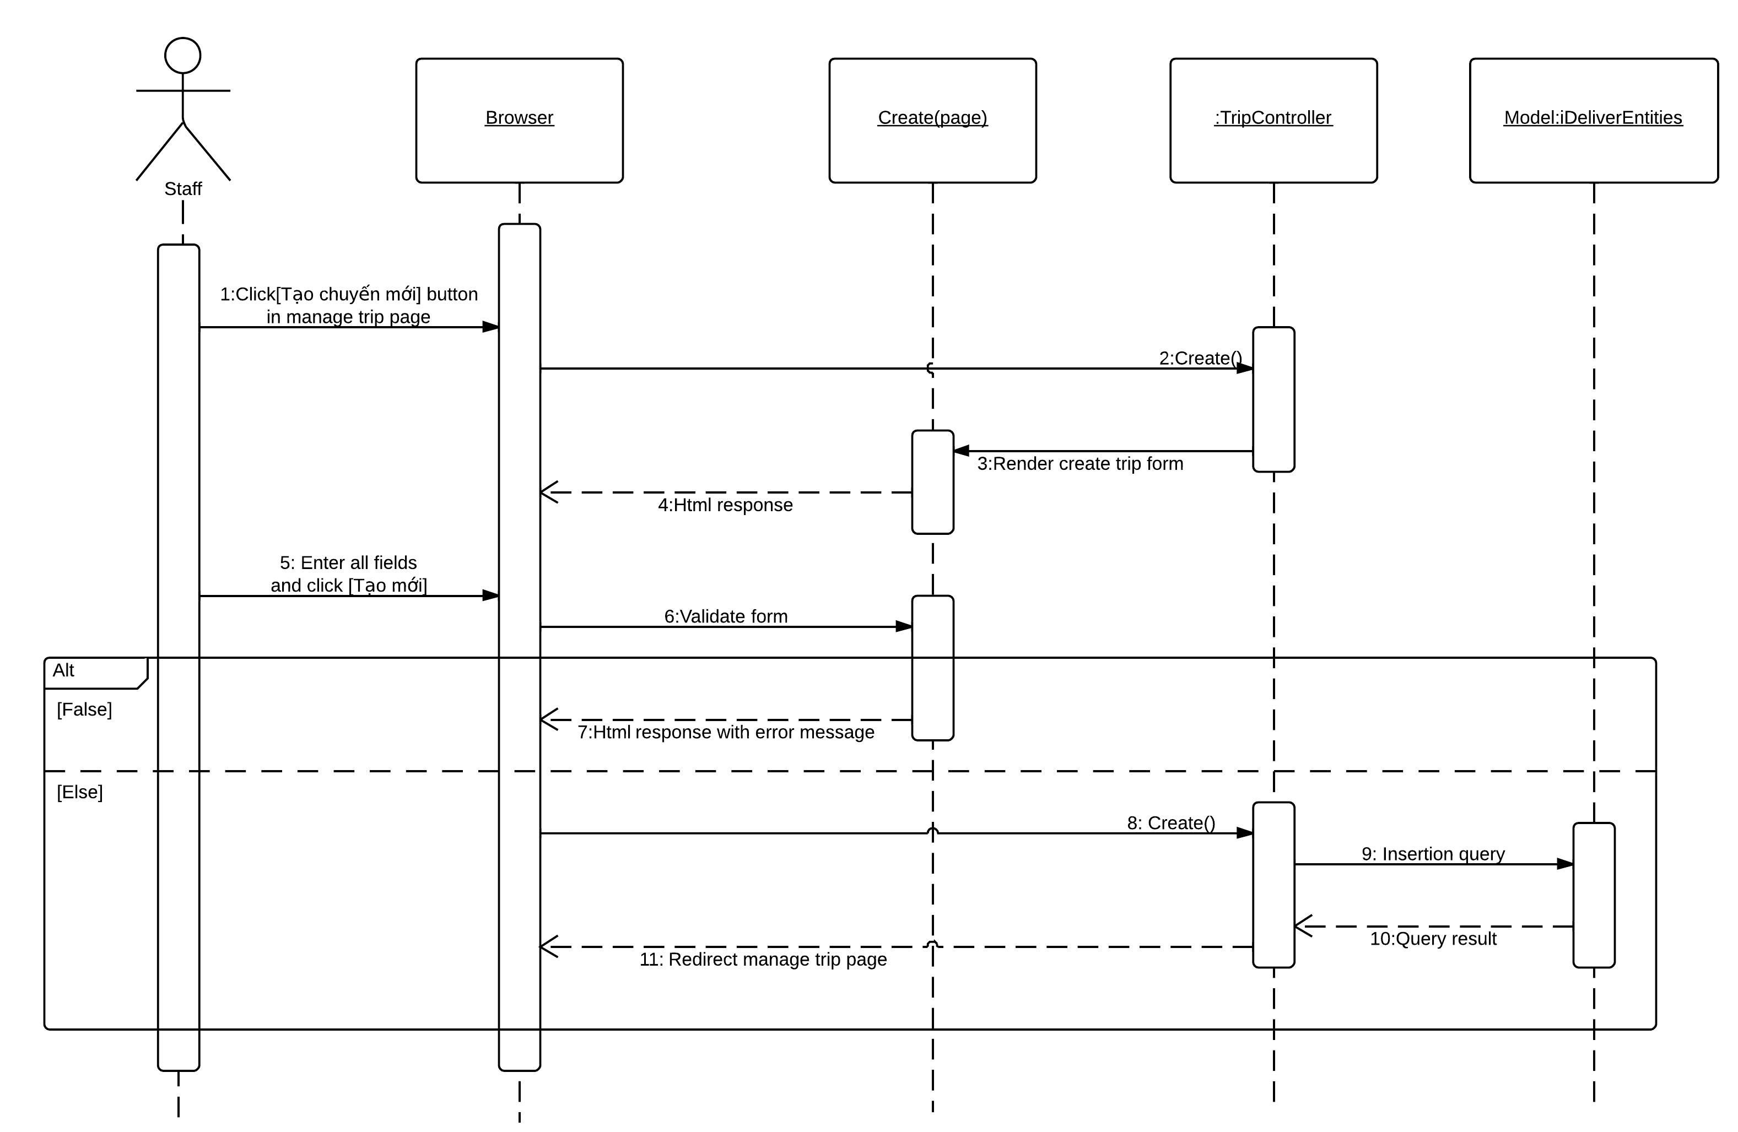

Diagram . Sequence diagram: Create trip

### Sequence Diagram: Create staff account

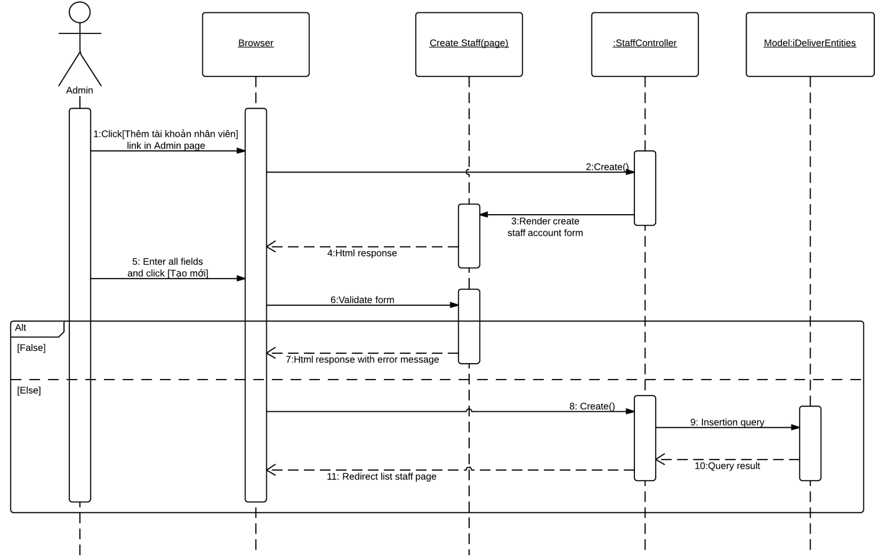

Diagram . Sequence diagram: Create staff account

## User Interface Design

Below are some important screen designs for the i-Deliver systems.



### Home Page



8

7

6

5

4

3

2

1

Figure . Home page

|  |  |  |  |  |  |  |
| --- | --- | --- | --- | --- | --- | --- |
| No. | Element | Description | Read Only | Mandatory | Control Type | Data type |
| 1. | “Trang chủ” link | A link to the home page of the i-Deliver website | N/A | N/A | Link | N/A |
| 2. | “Chuyển phát” link | A link to send delivery request page | N/A | N/A | Link | N/A |
| 3. | “Bảng giá” link | A link to the price/fee page | N/A | N/A | Button | N/A |
| 4. | “Đăng nhập” button | A button that displays the log in popup | N/A | N/A | Button | N/A |
| 5. | “Đăng ký” button | A button that displays the register popup | N/A | N/A | Button | N/A |
| 6. | “Danh sách trạm” section | Provinces and stations located in that province | N/A | N/A | N/A | Text |
| 7. | “Bản đồ trạm và hành trình” maps | The marker indicate station location on Google maps | N/A | N/A | N/A | Image |
| 8. | “Trạm được đánh giá cao” section | List of high level rating stations | N/A | N/A | N/A | Text |

### Send Delivery Request Page



10

7

11

9

8

6

5

4

3

2

1

Figure . Send delivery request page

|  |  |  |  |  |  |  |
| --- | --- | --- | --- | --- | --- | --- |
| No. | Element | Description | Read Only | Mandatory | Control Type | Data type |
| 1. | “Tên người gửi” textbox | Full name of the sender | No | Yes | Textbox | Text |
| 2. | “Địa chỉ người gửi” textbox | Address of the sender | No | Yes | Textbox | Text |
| 3. | “Số điện thoại người gửi” textbox | Phone number of the sender | No | Yes | Textbox | Text |
| 4. | “Tên người nhận” textbox | Full name of the receiver | No | Yes | Textbox | Text |
| 5. | “Địa chỉ người nhận” textbox | Address of the receiver | No | Yes | Textbox | Text |
| 6. | “Số điện thoại người nhận” textbox | Phone number of the receiver | No | Yes | Textbox | Text |
| 7. | “Khối lượng ước tính” dropdown list | Estimate weight of package | Yes | Yes | Textbox | Text |
| 8. | “Dài”, “Rộng”, “Cao” textbox | Length, width and height of the package | No | Yes | Textbox | Text |
| 9. | “Thể tích ước tính” dropdown list | Estimate volume of package | Yes | Yes | Textbox | Text |
| 10. | “Phương thức thanh toán” dropdown list | Type of payment for delivery request | Yes | Yes | Textbox | Text |
| 11. | “Hoàn tất” button | A button to submit delivery request | N/A | N/A | Button | N/A |

### Online Payment Page



Figure . Select new request to make a payment



Figure . Make an online payment via Paypal

### Approve Request Page



3

2

1

Figure . Approve request page

|  |  |  |  |  |  |  |
| --- | --- | --- | --- | --- | --- | --- |
| No. | Element | Description | Read Only | Mandatory | Control Type | Data type |
| 1. | “Tìm kiếm” textbox | Request information to search | N/A | N/A | Textbox | Text |
| 2. | Request information section | All of requests waiting for approved | N/A | N/A | N/A | Text |
| 3. | “Nhập hóa đơn” button | A button to input invoice for paid request | N/A | N/A | Button | N/A |

### Assign Package Page



Figure . Assign packages page

### Tracking Page



Figure . Tracking package page

### Update Package Status Page



Figure . Confirm package departed



Figure . Confirm package arrived



Figure . Confirm package delivered



Figure . Prepare package to return



Figure . Extend due-date for late payment requests

### Create Trip Page



4

3

1

2

Figure . Create trip page

|  |  |  |  |  |  |  |
| --- | --- | --- | --- | --- | --- | --- |
| No. | Element | Description | Read Only | Mandatory | Control Type | Data type |
| 1. | “Ngày chạy” dropdown list | Specific date for trip | N/A | Yes | Textbox | Text |
| 2. | “Tuyến” dropdown list | Specific route for trip | N/A | Yes | Textbox | Text |
| 3. | Schedules checkbox | Defined schedules for selected route | N/A | Yes | Checkbox | Text |
| 4. | “Tạo mới” button | A button to submit create trip command | N/A | N/A | Button | N/A |

### Feedback and Review Page



3

2

1

4

Figure . Feedback and review page

|  |  |  |  |  |  |  |
| --- | --- | --- | --- | --- | --- | --- |
| No. | Element | Description | Read Only | Mandatory | Control Type | Data type |
| 1. | “Trạm: …” | Station name to review/feedback | N/A | N/A | N/A | Text |
| 2. | Stars rating bar | Drag able stars bar for rating | N/A | Yes | Adjustable bar | Image |
| 3. | “Ý kiến của bạn” textbox | Textbox for comment | N/A | Yes | Textbox | Text |
| 4. | “Bình luận” button | A button to submit review/feedback | N/A | N/A | Button | N/A |

### Manage Fee Page



3

2

1

Figure . Manage fee page

|  |  |  |  |  |  |  |
| --- | --- | --- | --- | --- | --- | --- |
| No. | Element | Description | Read Only | Mandatory | Control Type | Data type |
| 1. | “Tạo mức phí mới” link | A link to define new fee value | N/A | N/A | Link | Text |
| 2. | Fee, min to max weight and min to max volume | Fee correlative to weight and volume | N/A | N/A | N/A | Text |
| 3. | “Thao tác” links section | Links to edit, detail and delete page of each fee level | N/A | N/A | Link | Text |



## Database Design

### Logical database design

From the ERD specified in the SRS section, logical database design includes the following relations:

|  |  |  |
| --- | --- | --- |
| **Index** | **Table Name** | **Description** |
| 1 | Account | List of user that registered to the system with valid username and password. |
| 2 | UserInfo | Detail information of each user. |
| 3 | Coach | List of all coach the center has. |
| 4 | CoachType | List of type of coach base on the number of seat that the coach has. |
| 5 | Route | List of route that center can deliver to, including the route name. |
| 6 | Trip | Information of trip of each coach the center has every day. |
| 7 | Station | The list of all stations the center has. |
| 8 | Schedule | The schedule of coach for run on the specific route during a day. |
| 9 | Request | Information of each request that user posted to the system. |
| 10 | DeliveryStatus | Status of the request of base on the action of user and staff. |
| 11 | Invoice | Detail of invoice corresponding to the approve request. |
| 12 | ManageFee | The fee of service base on the range of volume and range of weight. |
| 13 | Comment | Content of comment of user posted for each station. |
| 14 | Rating | Rating level that user rate for each station. |
| 15 | Assigning | Table of mapping between coach and request. |
| 16 | Stage | The partial of the way of route, each stage contains the start and end station and addition information of this stage. |
| 17 | RouteStage | Mapping between route and stage |
| 18 | Notification | Check whether user has seen the notification or not yet. |
| 19 | Province | List of provinces that the system has some station in there. |



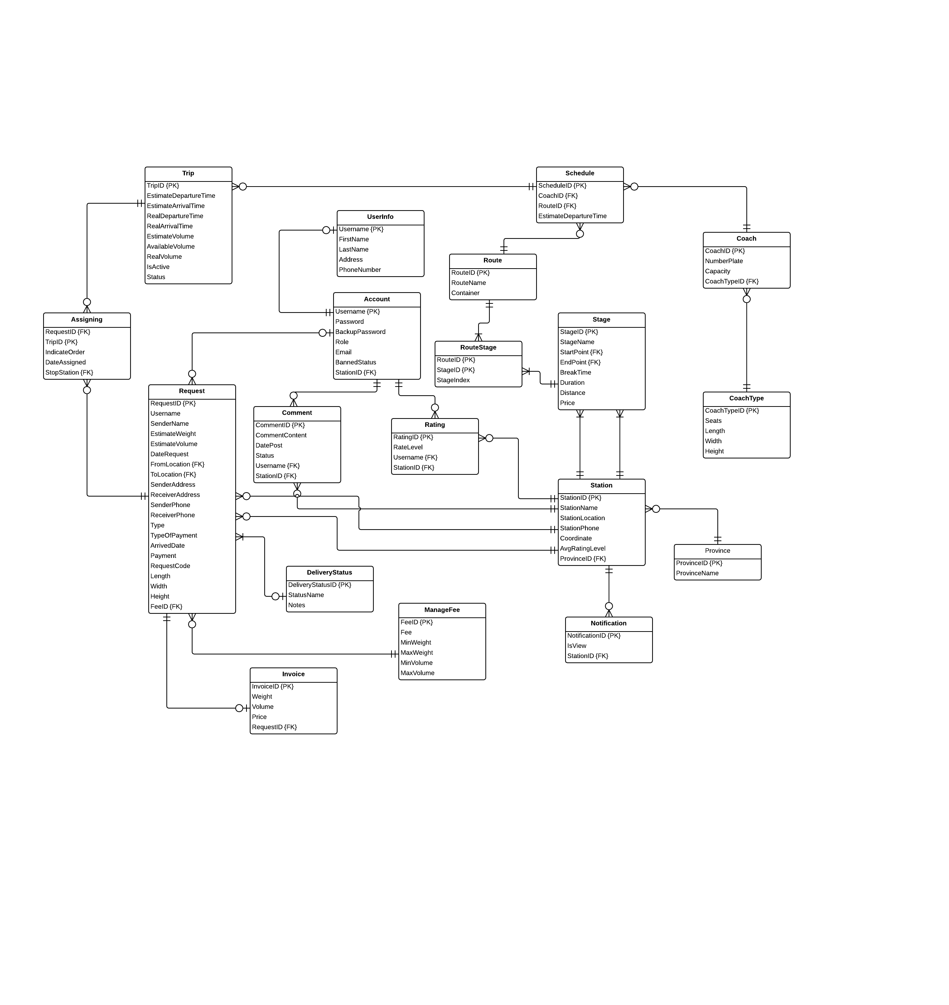

Figure . Logical database design

The details of each relation are specified below

#### User

|  |  |  |  |  |  |
| --- | --- | --- | --- | --- | --- |
| **Column Name** | **Type** | **Allow Null** | **Default Value** | **P/F Key** | **Description** |
| Username | int |  | - | PK | Username of user |
| Password | nvarchar(50) |  | - |  | Password of user |
| BackupPassword | nvarchar(50) |  | - |  | Backup password for user |
| Role | nvarchar(50) |  | - |  | Role of user in the system:  customer, admin or staff |
| Email | nvarchar(50) |  | - |  | Email of user |
| Phone | nvarchar(50) |  | - |  | Phone of user |
| BannedStatus | bit |  | - |  | User is banned or not |
| StationID | int |  | 11 | FK | The station of the staff belong to (just for staff account) |

Unique: Username.

Foreign key: StationID.

#### UserInfo

|  |  |  |  |  |  |
| --- | --- | --- | --- | --- | --- |
| **Column Name** | **Type** | **Allow Null** | **Default Value** | **P/F Key** | **Description** |
| Username | nvarchar(50) |  | - | FK | Username of user registered to the system or the staff |
| Firstname | nvarchar(50) |  | - |  | Firstname of user registered to the system or the staff |
| Lastname | nvarchar(50) |  | - |  | Lastname of user registered to the system or the staff |
| Address | nvarchar(500) |  | - |  | Address of user registered to the system or the staff |

Unique: Username.

Foreign key: N/A.

#### Coach

|  |  |  |  |  |  |
| --- | --- | --- | --- | --- | --- |
| **Column Name** | **Type** | **Allow Null** | **Default Value** | **P/F Key** | **Description** |
| CoachID | int |  | Auto generated | PK | Uniquely identifies of the coach |
| NumberPlate | nvarchar(50) |  | - |  | Number plate of coach |
| CoachTypeID | int |  | - | FK | The type of coach |

Unique: CoachID, NumberPlate.

Foreign key: CoachTypeID (table CoachType).

#### CoachType

|  |  |  |  |  |  |
| --- | --- | --- | --- | --- | --- |
| **Column Name** | **Type** | **Allow Null** | **Default Value** | **P/F Key** | **Description** |
| CoachTypeID | int |  | Auto generated | PK | Uniquely identifies of the coach |
| Seats | int |  | - |  | The number of seats of the coach, that define the type of coach |
| Capacity | float |  |  |  | The percentage of the cabin that coach can be serving. |

Unique: Seats.

Foreign key: N/A.

#### Route

|  |  |  |  |  |  |
| --- | --- | --- | --- | --- | --- |
| **Column Name** | **Type** | **Allow Null** | **Default Value** | **P/F Key** | **Description** |
| RouteID | int |  | Auto generated | PK | Uniquely identifies a route |
| RouteName | nvarchar(50) |  | - |  | The name of route |

Unique: RouteID.

Foreign key: StartPoint (table Station), EndPoint (table Station).

#### Trip

|  |  |  |  |  |  |
| --- | --- | --- | --- | --- | --- |
| **Column Name** | **Type** | **Allow Null** | **Default Value** | **P/F Key** | **Description** |
| TripID | int |  | Auto generated | PK | Uniquely identifies a route |
| EstimateDepartureTime | time |  | - |  | The estimate time for the trip departures in each day |
| RealDepartureTime | time |  | - |  | The real time that the trip departures in a specific day |
| EstimateArrivalTime | time |  | - |  | The estimate time for the trip departures in each day |
| RealArrivalTime | float |  |  |  | The real time for the trip arrival to the station in a specific day |
| AvailableVolume | float |  |  |  | The volume that the coach on this trip can deliver |
| Date | date |  |  |  | The date that trip start. |
| RouteID |  |  |  | FK | The route that the trip traveling on |
| CoachID |  |  |  | FK | The coach of this trip. |

Unique: RouteID.

Foreign key: RouteID (table Route), CoachID (table Coach).

#### Station

|  |  |  |  |  |  |
| --- | --- | --- | --- | --- | --- |
| **Column Name** | **Type** | **Allow Null** | **Default Value** | **P/F Key** | **Description** |
| StationID | int |  | Auto generated | PK | Uniquely identifies a route |
| StationName | nvarchar(50) |  | - |  | The name of the station |
| StationLocation | nvarchar(50 |  | - |  | The address of location |
| BreakTime | float |  | - |  | The default break time that for each trip come to this station |
| StationPhone | nvarchar(50) |  | - |  | The telephone number of this station |
| Description | nvarchar(500) |  | - |  | The description for this station |
| Longitude | float |  | - |  | The longitude of the station location |
| Latitude | float |  | - |  | The latitude of the station location |
| Province | nvarchar |  | - |  | The province of the station location |

Unique: StationID.

Foreign key: N/A.

#### Schedule

|  |  |  |  |  |  |
| --- | --- | --- | --- | --- | --- |
| **Column Name** | **Type** | **Allow Null** | **Default Value** | **P/F Key** | **Description** |
| ScheduleID | int |  | Auto generated | PK | Uniquely identifies the volume |
| CoachID | Int |  | - |  | Uniquely identifies the coach used to scheduling |
| RouteID | Int |  | - |  | Uniquely identifies the route to be scheduled |
| EstimateDepartureTime | time |  | - |  | The minimum volume the coach can be deliver on the route |
| EstimateArrivalTime | time |  | - | FK | The route in this volume define |

Unique: N/A.

Foreign key: CoachID (table Coach), RouteID (table Route).

#### Request

|  |  |  |  |  |  |
| --- | --- | --- | --- | --- | --- |
| **Column Name** | **Type** | **Allow Null** | **Default Value** | **P/F Key** | **Description** |
| ScheduleID | int |  | Auto generated | PK | Uniquely identifies the volume |
| ArrangeID | float |  | - |  | The maximum volume the coach can be deliver on the route |
| EstimateDepartureTime | time |  | - |  | The minimum volume the coach can be deliver on the route |
| EstimateArrivalTime | time |  | - | FK | The route in this volume define |

Unique: N/A.

Foreign key: ArrangeID (table CoachArrangement).

#### DeliveryStatus

|  |  |  |  |  |  |
| --- | --- | --- | --- | --- | --- |
| **Column Name** | **Type** | **Allow Null** | **Default Value** | **P/F Key** | **Description** |
| DeliveryStatusID | Int |  | Auto generated | PK | Uniquely identifies the delivery status |
| StatusName | nvarchar(50) |  | - |  | The name of delivery status of the package |
| Note | nvarchar(500) | X | - |  | Some more description for the status |

Unique: DeliveryStatusID.

Foreign key: N/A.

#### Invoice

|  |  |  |  |  |  |
| --- | --- | --- | --- | --- | --- |
| **Column Name** | **Type** | **Allow Null** | **Default Value** | **P/F Key** | **Description** |
| InvoiceID | Int |  | Auto generated | PK | Uniquely identifies an invoice |
| Weight | float | X | - |  | Weight of package |
| Volume | int | X | - |  | Volume of package |
| Price | float |  | - |  | Price of delivery service |
| RequestID | int |  | - | FK | The request that the invoice point to |

Unique: InvoiceID.

Foreign key: RequestID (table Request).

#### ManageFee

|  |  |  |  |  |  |
| --- | --- | --- | --- | --- | --- |
| **Column Name** | **Type** | **Allow Null** | **Default Value** | **P/F Key** | **Description** |
| FeeID | int |  | Auto generated | PK | Uniquely identifies a fee rule |
| Fee | float |  | - |  | The fee of this weight and volume range |
| MinWeight | float |  | - |  | The minimum weight of the weight range |
| MaxWeight | float |  | - |  | The maximum weight of the weight range |
| MinVolume | float |  | - |  | The minimum volume of the volume range |
| MaxVolume | float |  | - |  | The maximum volume of the volume range |

Unique: FeeID.

Foreign key: N/A.

#### Comment

|  |  |  |  |  |  |
| --- | --- | --- | --- | --- | --- |
| **Column Name** | **Type** | **Allow Null** | **Default Value** | **P/F Key** | **Description** |
| CommentID | int |  | Auto generated | PK | Uniquely identifies the comment |
| Username | nvarchar(50) |  | - | FK | The user post comment |
| CommentContent | nvarchar(4000) |  | - |  | Content of comment |
| DatePost | date |  | - |  | Date that user post the comment |
| Status | bit |  | - |  | Approve or reject the comment |
| StationID | int |  | - | FK | The station that customer comment for |

Unique: CommentID.

Foreign key: Username (table User), StationID (table Station).

#### Rating

|  |  |  |  |  |  |
| --- | --- | --- | --- | --- | --- |
| **Column Name** | **Type** | **Allow Null** | **Default Value** | **P/F Key** | **Description** |
| RatingID | int |  | Auto generated | PK | Uniquely identifies the rating |
| Username | nvarchar(50) |  | - | FK | The user post comment |
| RateLevel | int |  | - |  | The level of rate: from 1 to 5 |
| StationID | int |  | - | FK | The station that user rating for |

Unique: RatingID.

Foreign key: Username (table User), StationID (table Station).

#### Assigning

|  |  |  |  |  |  |
| --- | --- | --- | --- | --- | --- |
| **Column Name** | **Type** | **Allow Null** | **Default Value** | **P/F Key** | **Description** |
| CoachID | int |  | - | PK | The ID of coach for the specific request |
| RequestID | int |  | - | The ID of request |
| IndicateOrder | int |  | - |  | The indicated order of the assigning the package of this request |

Unique: (CoachID, RequestID).

Foreign key: N/A.

#### Stage

|  |  |  |  |  |  |
| --- | --- | --- | --- | --- | --- |
| **Column Name** | **Type** | **Allow Null** | **Default Value** | **P/F Key** | **Description** |
| CoachID | int |  | - | PK | The ID of coach |
| StartPoint | int |  | - | FK | The start position (station) of the stage |
| EndPoint | int |  | - | FK | The end position (station) of the stage |
| Duration | float |  | - |  | The estimate duration (in hours) for moving on this route |
| Distance | float |  | - |  | The estimate distance (in km) between start and end location |
| Container | float |  | - |  | The percentage of coach that allow to travel on the stage |
| Price | float |  | - |  | The fee for travel on the stage |

Unique: N/A.

Foreign key: StartPoint, EndPoint.

#### RouteStage

|  |  |  |  |  |  |
| --- | --- | --- | --- | --- | --- |
| **Column Name** | **Type** | **Allow Null** | **Default Value** | **P/F Key** | **Description** |
| RouteID | int |  | - | PK | The ID of route |
| StageID | int |  | - | The ID of stage |
| StageIndex | int |  | - |  | The index of stage in the list stage of the route |

Unique: N/A.

Foreign key: N/A.

#### Notification

|  |  |  |  |  |  |
| --- | --- | --- | --- | --- | --- |
| **Column Name** | **Type** | **Allow Null** | **Default Value** | **P/F Key** | **Description** |
| ID | int |  | **-** | PK | The index of notification |
| Username | Int |  | - |  | Username of user |
| StationID | int |  | - |  | The ID of station the user mange’s |
| isView | bit |  | - |  | Status of notification, it is seen by user or not. |

Unique: N/A.

Foreign key: StationID, Username.

#### Province

|  |  |  |  |  |  |
| --- | --- | --- | --- | --- | --- |
| **Column Name** | **Type** | **Allow Null** | **Default Value** | **P/F Key** | **Description** |
| ProvinceID | int |  | **-** | PK | The index of province |
| ProvinceName | nvarchar(50) |  | - |  | Name of province |

Unique: N/A.

Foreign key: N/A.

### Physical database design



Diagram . Physical database design

# Software Test Document



## Introduction



### System Overview

From the perspective of a user, the i-Deliver system operates in the following order

### Test Approach

The system will be tested following the normal testing approach for a software project, including for major stages: Unit testing, Integration testing, System testing, and Acceptance testing.

Firstly, each member will be responsible for *unit testing* all the modules he or she developed. The other team members will later approve of the modules developed by verifying that they comply with the detailed designs.

Secondly, the team leader will perform *integration testing* for the whole application with the assistance of the other team members.

Next, all of the team members will conduct *system testing* to make sure that the system is consistent with the requirements initially specified.

Finally, the supervisor of the project will be accountable for a*cceptance testing*, with the assistance of all team members.

## Test Plan



### Features to be tested

The following features will be system-tested and the results are specified in this test document. The order of the tested features is listed in the system main flow.

|  |  |  |  |
| --- | --- | --- | --- |
| No. | Feature | Description | Assigned |
| 1. | Send new package delivery request | Test if the customers can post new package delivery request easily | TungNT |
| 2. | Online payment | Test if the dashboard page for staffs and administrators is displayed correctly | LongDB |
| 3. | Tracking packages | Test if the customers can track delivery status of packages | TungNT |
| 4. | Feedback and review | Test if the customers can write reviews for stations | DucNT |
| 5. | Approve package delivery request | Test if the staffs can approve package delivery request issued by a customer | TungNT |
| 6. | Assign packages |  |  |
| 7. | Prepare for packages return | Test if the customers can search routes information. | TungNT |
| 8. | Create a trip |  |  |
| 9. | Create a schedule | Test if a packages can be returned if it can’t be delivered to receiver | LongDB |
| 10. | Monitor price/fee | Test if the delivery fee can be easily and accurately monitored | LuLP |

### Features not to be tested

The following features will not be tested.

* For guests and travelers: Change password, Update account information, View past requests.
* For staffs and system admins: Add a coach, Edit a coach, Delete a coach, Add a coach type, Edit a coach type, Delete a coach type, Add a station, Edit a station, Delete a station, Add a route, Edit a route, Delete a route, Add a schedule, Edit a schedule, Delete a schedule, Add a stage, Edit a stage, Delete a stage, Delete a comment, Clear station rating.
* For system administrators: Manage staff accounts

## System Test Cases



### Send new delivery request

|  |  |  |  |  |  |  |  |
| --- | --- | --- | --- | --- | --- | --- | --- |
| Test case ID | Test Case Description | Test Case Procedure | Expected Output | Inter-Test Case Dependence | Result | Test Date | Note |
|  | **Main Steps: 1.** Log in the system with Customer role  **2.** Click on the “Chuyển phát” link in the menu bar  **3.** Provide the necessary information about the receiver and packages  **4.** Click the “Hoàn tất” button | | | | | | |
| [SR-1] | Try to post a request with erroneous input | * Make one or more validation errors when entering the information for the request. * Click the “Hoàn tất” button. | The corresponding message will be shown next to the fields that have errorneous input. |  | Passed | 10/04/14 |  |
| [SR-2] | Post a request with validated input | * Fill in all fields with validated input; * Click the “Hoàn tất” button. | The request is saved into the database. A delivery request is issued waiting for a Staff to approve of it. The customer is redirected to the request management page. |  | Passed | 10/04/14 |  |

### 

### Online payment

|  |  |  |  |  |  |  |  |
| --- | --- | --- | --- | --- | --- | --- | --- |
| Test case ID | Test Case Description | Test Case Procedure | Expected Output | Inter-Test Case Dependence | Result | Test Date | Note |
|  | **Main Steps: 1.** Clicks on the “Thanh toán” link in the menu bar.  **2.** Select request need to pay on request list, user is redirected to new page with payment information.  **3.** Clicks on “Check out with PayPal” button to direct to Paypal payment gate. | | | | | | |
| [OP-1] | Payment was successful | * User complete payment information at Paypal site; | The user completed payment information with validate credit card;  Paypal returns successful payment. |  | Passed | 10/04/14 |  |
| [OP-2] | Payment was not completed | * User complete payment information at Paypal site; | The user completed payment information with invalidate credit card;  Paypal cannot charge money and return unsuccessful payment result. |  | Passed | 10/04/14 |  |
| [OP-3] | User cancelled payment action | * User click on “Hủy bỏ” button | The user cancelled payment action then they is redirected to request list page |  | Passed | 10/04/14 |  |

### 

### Tracking package

|  |  |  |  |  |  |  |  |
| --- | --- | --- | --- | --- | --- | --- | --- |
| Test case ID | Test Case Description | Test Case Procedure | Expected Output | Inter-Test Case Dependence | Result | Test Date | Note |
|  | **Main Steps: 1.** Log in the system with Customer role.  **2.** Click “Quản lý yêu cầu” link on the left menu bar of Customer main page.  **3.** Click on “Đã chuyển đi” tab on requests section below Google maps. | | | | | | |
| [TP-1] | Track package successfully | * Click on “Theo dõi” button at the end of each request record. | The corresponding route of request will display on above Google maps where passed road is highlighted with pink, on-route road is highlighted with black and left distance with red. |  | Passed | 13/04/13 |  |
| [TP-2] | Track package unsuccessfully | * Click on “Theo dõi” button at the end of each request record. | The Internet connection has problems so Google maps cannot render route of package. |  | Passed | 13/04/13 |  |
| [TP-3] | Track package unsuccessfully | * Requests list have no record to tracking | The logged in account has unapproved requests, late payment requests or no posted request |  | Passed | 13/04/13 |  |

### 

### Feedback and review

|  |  |  |  |  |  |  |  |
| --- | --- | --- | --- | --- | --- | --- | --- |
| Test case ID | Test Case Description | Test Case Procedure | Expected Output | Inter-Test Case Dependence | Result | Test Date | Note |
|  | **Main Steps: 1.** Log in the system with Customer role.  **2.** Click “Đóng góp ý kiến” link on the left menu bar of Customer main page.  **3.** Click on “Góp ý” button of each station in stations section. | | | | | | |
| [FR-1] | Rating and write a review successfully | * Rating for station services by checking the number of stars on rating bar. * Fill the content of of the review (more than 50 characters in length) in the “Ý kiến của bạn” text area. * Click the “Hoàn tất” button. | The rating and review is saved and is added at the top of the review list. |  | Passed | 12/04/14 |  |
| [FR-2] | Fail to validate the review content | * Rating for station services by checking the number of stars on rating bar. * Leave the box “Ý kiến của bạn” empty. * Click the “Hoàn tất” button. | The message “Bình luận phải có độ dài ít nhất 50 kí tự” is displayed.  The rating is not saved to database for selected station |  | Passed | 12/04/14 |  |

### 

### Approve delivery requests

|  |  |  |  |  |  |  |  |
| --- | --- | --- | --- | --- | --- | --- | --- |
| Test case ID | Test Case Description | Test Case Procedure | Expected Output | Inter-Test Case Dependence | Result | Test Date | Note |
|  | **Main Steps: 1.** Log in with account granted Staff role.  **2.** Click on the “Quản lý yêu cầu vận chuyển” link in the menu bar if the log in form does not redirect you to this page.  **3.** Click on the “Tiếp nhận yêu cầu” link in the menu bar  All of new requests which waiting for approved is on the view. | | | | | | |
| [AD-1] | Approve requests successfully with validated input | * Click on “Nhập hóa đơn” button at the end of each row on the requests table. * Fills in all fields with validated input. * Click on “Xác nhận” button | The selected request status is updated in database with corresponding invoice.  The staff is redirected to assign packages page. |  | Passed | 11/04/14 |  |
| [AD-2] | Try to approve a request with erroneous input | * Click on “Nhập hóa đơn” button at the end of each row on the requests table. * Make one or more validation errors when entering the information for the invoice. * Click on “Xác nhận” button | The corresponding message will be shown next to the fields that have errorneous input. |  | Passed | 11/04/14 |  |
| [AD-3] | Approve requests unsuccessfully with validated input | * Click on “Nhập hóa đơn” button at the end of each row on the requests table. * Fills in all fields with validated input. * Click on “Hủy bỏ” button | Nothing has changed in database.  The current page still keeps on. |  | Passed | 11/04/14 |  |

### 

### Assign packages

|  |  |  |  |  |  |  |  |
| --- | --- | --- | --- | --- | --- | --- | --- |
| Test case ID | Test Case Description | Test Case Procedure | Expected Output | Inter-Test Case Dependence | Result | Test Date | Note |
|  | **Main Steps: 1.** Log in with account granted Staff role.  **2.** Click on the “Quản lý yêu cầu vận chuyển” link in the menu bar if the log in form does not redirect you to this page.  **3.** Click on the “Xếp lịch vận chuyển” link in the menu bar  All of approved requests which waiting for assigned is on the view. | | | | | | |
| [AP-1] | Assign packages successfully with validated input | * Check box at the end of each row to select which package to assign or check box on the top to select all packages * Click on “Xếp lịch” button to assign selected package(s) | * The current page is redirected to a new page with a list of assigned package(s) and detail of trip that package was assigned to |  | Passed | 11/04/14 |  |
| [AP-2] | Assign packages unsuccessfully | * Check box at the end of each row to select which package to assign or check box on the top to select all packages * Click on “Xếp lịch” button to assign selected package(s) | The current page is redirected to a new page with nothing because assign procedure does not meet condition (trips/schedules is not available) |  | Passed | 11/04/14 |  |
| [AP-3] | Assign packages unsuccessfully | * Click on “Xếp lịch” button without select package to assign | The current page is redirected to a new page with nothing because none of packages were selected. |  | Passed | 11/04/14 |  |

### 

### Prepare for packages return

|  |  |  |  |  |  |  |  |
| --- | --- | --- | --- | --- | --- | --- | --- |
| Test case ID | Test Case Description | Test Case Procedure | Expected Output | Inter-Test Case Dependence | Result | Test Date | Note |
|  | **Main Steps: 1.** Log in to the system with System Admin role.  **2.** Click on the “Hàng đã đến trạm” link in the left menu bar.  All of requests have arrived in end-station but late for delivery now waiting for return or cancel. | | | | | | |
| [PR-1] | Successfully prepare for packages return | * Click on “Trả hàng” button at the end of each row on the packages table. * A popup dialog is displayed with confirm message “Bạn muốn gửi trả lại món hàng này?” * Click on “Xác nhận” button of confirm popup dialog. | The package has selected for return is updated in database.  The staff is redirected to requests waiting for assign page. |  | Passed | 11/04/14 |  |
| [PR-2] | Fail to prepare for packages return | * Click on “Trả hàng” button at the end of each row on the packages table. * A popup dialog is displayed with confirm message “Bạn muốn gửi trả lại món hàng này?” * Click on “Hủy bỏ” button of confirm popup dialog. | Nothing has changed in database.  The current page still keeps on. |  | Passed | 11/04/14 |  |

### Create the trip

|  |  |  |  |  |  |  |  |
| --- | --- | --- | --- | --- | --- | --- | --- |
| Test case ID | Test Case Description | Test Case Procedure | Expected Output | Inter-Test Case Dependence | Result | Test Date | Note |
|  | **Main Steps: 1.** Log in the system with Staff role.  **2.** Click on the “Quản lý chuyến xe” link in the left menu bar | | | | | | |
| [CT-1] | Create trip successfully with validated input | * Select a date by date picker * Select which route to create trip by click on dropdown list under date picker. * Check box at the start of each row in the schedules table to choose schedule for trip or check box on top header of schedules table to select all displayed schedules. * Click on “Tạo chuyến mới” button | The trip is saved to database.  The current page is redirected to trip list page with new trip records on the top of list. |  | Passed | 11/04/14 |  |
| [CT-2] | Try to create a trip with erroneous input | * Make one or more validation errors when click the “Tạo chuyến mới” button without select date or route or schedule | The corresponding message will be shown next to the fields that have errorneous input. |  | Passed | 11/04/14 |  |
| [CT-3] | Create trip unsuccessfully | * Select a date by date picker * Select which route to create trip by click on dropdown list under date picker. * Check box at the start of each row in the schedules table to choose schedule for trip or check box on top header of schedules table to select all displayed schedules. * Click on “Hủy bỏ” button | The trip is not saved to database.  The current page is back to trip list page. |  | Passed | 11/04/14 |  |

### Create schedules

|  |  |  |  |  |  |  |  |
| --- | --- | --- | --- | --- | --- | --- | --- |
| Test case ID | Test Case Description | Test Case Procedure | Expected Output | Inter-Test Case Dependence | Result | Test Date | Note |
|  | **Main Steps: 1.** Log in the system with Staff role.  **2.** Click on the “Quản lý lịch trình” link in the left menu bar | | | | | | |
| [CT-1] | Create schedule successfully with validated input | * Select a route from dropdown list * Select a coach from dropdown list * Fills in textbox of “Giờ đi dự kiến” and “Giờ đến dự kiến” with valid timespan value * Click on “Tạo mới” button | The schedule is saved to database.  The current page is redirected to schedule list page with new schedule records on the top of list. |  | Passed | 11/04/14 |  |
| [CT-2] | Try to create a schedule with erroneous input | * Make one or more validation errors when click the “Tạo mới” button without select route/coach or both | The corresponding message will be shown next to the fields that have errorneous input. |  | Passed | 11/04/14 |  |
| [CT-3] | Try to create a schedule with erroneous input | * Make one or more validation errors when click the “Tạo mới” button without fills in “Giờ đi dự kiến” or “Giờ đi dự kiến” textbox | The corresponding message will be shown next to the fields that have errorneous input. |  | Passed | 11/04/14 |  |
| [CT-4] | Create schedule unsuccessfully | * Select a route from dropdown list * Select a coach from dropdown list * Fills in textbox of “Giờ đi dự kiến” and “Giờ đến dự kiến” with valid timespan value * Click on “Hủy bỏ” button | The current page is back to schedules list page. |  | Passed | 11/04/14 |  |

### Monitor price/fee

|  |  |  |  |  |  |  |  |
| --- | --- | --- | --- | --- | --- | --- | --- |
| Test case ID | Test Case Description | Test Case Procedure | Expected Output | Inter-Test Case Dependence | Result | Test Date | Note |
|  | **Main Steps: 1.** Go the the “Hủy đặt phòng” link.  **2.** Choose a booking you have made or enter your booking code in the “Mã xác nhận” box.  **3.** Click the “Gửi yêu cầu hủy phòng” button. | | | | | | |
| [RR-1] | Successfully request for a refund | * Fill the generated code of booking that has been approved, not expired and not refunded before in the “Mã xác nhận” box. * Click the “Gửi yêu cầu hủy phòng” button. | The message “Bạn đã gởi yêu cầu thành công, chúng tôi sẽ xử lí và thông báo trong email cho bạn trong thời gian sớm nhất. Vui lòng kiểm tra e-mail để xác nhận.” is displayed. |  | Passed | 19/11/2013 |  |
| [RR-2] | Fail to request for a refund | * Fill the generated code of a booking that has been refunded before or expired in the “Mã xác nhận” box. * Click the “Gửi yêu cầu hủy phòng” button. | The message “Thông tin bạn nhập không chính xác, đã tồn tại hoặc đã quá hạn. Vui lòng thử lại.” is displayed. |  | Passed | 19/11/2013 |  |
| [RR-3] | Fail to request for a refund | * Leave the “Mã xác nhận” textbox empty. * Click the “Gửi yêu cầu hủy phòng” button. | The message box “Mã xác nhận phải là kí tự chữ hoặc số có 6 kí tự” is displayed. |  | Passed | 19/11/2013 |  |

### Monitor price/fee

|  |  |  |  |  |  |  |  |
| --- | --- | --- | --- | --- | --- | --- | --- |
| Test case ID | Test Case Description | Test Case Procedure | Expected Output | Inter-Test Case Dependence | Result | Test Date | Note |
|  | **Main Steps: 1.** Log in to the system with System Admin role.  **2.** Clicks on the “Phí vận chuyển” link in the menu bar.  **3.** Change price/fee, weight and volume value to updates it information. | | | | | | |
| [MP-1] | Modify/update price, volume or weight with validated input | * Fills in all textboxes with of valid price, volume or weight values. * Click the “Hoàn tất” button. | Modified/updated information is saved to database.  The system admin is redirected to list of fee levels page. |  | Passed | 24/11/2013 |  |
| [MP-2] | Try to modify/update price, volume or weight with erroneous input | * Make one or more validation errors when entering the information for price, volume or weight. * Click the “Hoàn tất” button. | The corresponding message will be shown next to the fields that have errorneous input. |  | Passed | 10/04/14 |  |

### Create staff account

|  |  |  |  |  |  |  |  |
| --- | --- | --- | --- | --- | --- | --- | --- |
| Test case ID | Test Case Description | Test Case Procedure | Expected Output | Inter-Test Case Dependence | Result | Test Date | Note |
|  | **Main Steps: 1.** Log in the system with System Admin role.  **2.** Click on the “Quản lý nhân viên” link in the left menu bar | | | | | | |
| [CT-1] | Create staff account successfully with validated input | * Fill in all fields with validated input; * Click the “Tạo mới” button. | The new staff account is saved to database.  The system admin is redirected to staff accounts list page with new account records on the top of list. |  | Passed | 11/04/14 |  |
| [CT-2] | Try to create staff account with erroneous input | * Make one or more validation errors when click the “Tạo mới” button without fill in all fields or fill in all fields with erroneous input | The corresponding message will be shown next to the fields that have errorneous input. |  | Passed | 11/04/14 |  |
| [CT-3] | Create staff account unsuccessfully | * Fill in all fields with validated input; * Click the “Hủy bỏ” button. | Nothing has changed in database.  The current page is back to staff accounts list page. |  | Passed | 11/04/14 |  |

## 

## Checklists



### Checklist of Validation

|  |  |  |  |  |
| --- | --- | --- | --- | --- |
| Question | | Yes | No | N/A |
| 1 | Does a failure of validation on every field cause a sensible user error message? | 🗹 |  |  |
| 2 | Is the user required to fix entries which have failed validation tests? | 🗹 |  |  |
| 3 | Have any fields got multiple validation rules and if so are all rules being applied? | 🗹 |  |  |
| 4 | If the user enters an invalid value and clicks on the OK button (i.e. does not TAB off the field) is the invalid entry identified and highlighted correctly with an error message? |  | 🗹 |  |
| 5 | Is validation consistently applied at screen level unless specifically required at field level? |  | 🗹 |  |
| 6 | For all numeric fields check whether negative numbers can and should be able to be entered. | 🗹 |  |  |
| 7 | For all numeric fields check the minimum and maximum values and also some mid-range values allowable? | 🗹 |  |  |
| 8 | For all character/alphanumeric fields check the field to ensure that there is a character limit specified and that this limit is exactly correct for the specified database size? |  | 🗹 |  |
| 9 | Do all mandatory fields require user input? | 🗹 |  |  |
| 10 | If any of the database columns don’t allow null values then the corresponding screen fields must be mandatory. (If any field which initially was mandatory has become optional then check whether null values are allowed in this field.) | 🗹 |  |  |

### Submission Checklist

|  |  |  |  |  |
| --- | --- | --- | --- | --- |
| Question | | Yes | No | N/A |
| TABLES AND FIGURES | | | | |
| 1 | Does every table column, including the stub column, have a heading? | 🗹 |  |  |
| 2 | Are all tables referred to in text? |  | 🗹 |  |
| 3 | Are the elements in the figures large enough to remain legible after the figure has been reduced to the width of a journal column or page? |  | 🗹 |  |
| 4 | Is lettering in a figure no smaller than 8 points and no larger than 14 points? |  | 🗹 |  |
| 5 | Are the figures being submitted in a file format acceptable to the publisher? |  | 🗹 |  |
| 6 | Has the figure been prepared at a resolution sufficient to produce a high-quality image? |  | 🗹 |  |
| 7 | Are all figures numbered consecutively with Arabic numerals? | 🗹 |  |  |
| 8 | Are all figures and tables mentioned in the text and numbered in the order in which they are mentioned? | 🗹 |  |  |
| REFERENCES | | | | |
| 1 | Are references cited both in text and in the reference list? |  | 🗹 |  |
| 2 | Do the text citations and reference list entries agree both in spelling and in date? |  | 🗹 |  |
| 3 | Are journal titles in the reference list spelled out fully? | 🗹 |  |  |
| 4 | Are the references (both in the parenthetical text citations and in the reference list) ordered alphabetically by the authors’ surnames? |  | 🗹 |  |
| 5 | Are inclusive page numbers for all articles or chapters in books provided in the reference list? |  | 🗹 |  |
| 6 | Are references to studies included in your meta-analysis preceded by an asterisk? |  | 🗹 |  |
| FORMAT | | | | |
| 1 | Have you checked the journal’s website for instructions to authors regarding specific formatting requirements for submission? | 🗹 |  |  |
| 2 | Is the entire manuscript—including quotations, references, author note, content footnotes, and figure captions—double-spaced? Is the manuscript neatly prepared? |  | 🗹 |  |
| 3 | Are the margins at least 1 in. (2.54 cm)? |  | 🗹 |  |
| 4 | Are the title pages, abstracts, references, appendices, content footnotes, tables, and figures on separate pages (with only one table or figure per page)? Are the figure captions on the same page as the figures? Are manuscript elements ordered in sequence, with the text pages between the abstract and the references? | 🗹 |  |  |
| 5 | Are all pages numbered in sequence, starting with the title page? | 🗹 |  |  |
| PARAGRAPHS AND HEADINGS | | | | |
| 1 | Is each paragraph longer than a single sentence but not longer than one manuscript page? | 🗹 |  |  |
| 2 | Do the levels of headings accurately reflect the organization of the paper? | 🗹 |  |  |
| 3 | Do all headings of the same level appear in the same format? | 🗹 |  |  |

# Software User’s Manual



## Installation Guide

### Prerequisites

Before we install the application and throw it into operation, the preconditions about the environment and tools specified below must be satisfied.

Firstly, system requirements for the i-Deliver application to run on top of are specified below:

* Personal computers for the minimum configuration: 2 Gb of RAM, 50Gb of hard disk, Core 2 Duo 2.0 Ghz;
* Microsoft Windows 7 or higher.
* At least 100MB for the application resources and another 100MB for data storage.

Secondly, these tools must be installed in advance and run without errors:

* IIS Express 7.0 or higher
* SQL Server 2008 or higher,
* .NET Framework 4.5,
* WebDeploy 3.5

### Installation procedures

**Step** 1. Prepare the deployment package

Firstly, you need to publish your application and you’ll get folder to add to IIS



Figure . i-Deliver web application release folder

**Step** 2. **Create the database**

Open the file “iDeliver.sql” in the folder “Document” of the deployment package by Microsoft SQL Server Management Studio (MSSQL).



Figure . Create i-Deliver database using SQL Query

**Step 3. Install the application**



Figure . Add new web application

Expand the Sites folder and then right click on Default Web Site. Select “Add Application…” to open Add Application window. In the “Add application” window, fill the field “Alias” with the name of the website.



Click the “…” button to browse to the folder that contains the deployment package. Select the “Website” folder in the “iDeliver” folder, in the “Application” folder and click OK.

Verify that the iDeliver Website has been added to “Default Web Site” of IIS Express by right-clicking the website’s name, choosing “Manage Application” and then “Browse”.

**Step 4. Configure database connection string**

Folder of the deployment package, find and open the file Web.config using Notepad or any other text editor.



Figure . Configure database connection string

In the connectionStrings tag, change the Data Source of the connection strings to the SQLServer instance where you installed the database. Also, update the password to access the SQLServer instance in the connection strings.

Now go to **http://localhost/aspnet_client/iDeliver** and enjoy the website**.**



Figure . Run i-Deliver website

## User’s Guide



### Guides for Customer



#### Log in to the system

This function allows a user with a registered account to log in to the i-Deliver system.



1

4

4

3

2

Screen . Login screen

|  |  |
| --- | --- |
| Step | Instruction |
| 1. | Click the “Đăng nhập” button on the menu bar of the “Trang chủ” page. |
| 2. | Fill the registered account in the “Tên đăng nhập” field |
| 3. | Fill the password in the “Mật khẩu” field |
| 4. | Click the “Đăng nhập” button to log in to the system. You will be redirected to the page you are viewing |

#### Log out of the system

This function allows the user to log out of the system after he or she finishes browsing the website.



1

Screen . Logout screen

|  |  |
| --- | --- |
| Step | Instruction |
| 1. | Click the “Đăng xuất” link on top right of page you are viewing. You will be redirected to the page you are viewing if this page allows guests to access or the “Trang chủ” page otherwise. |

#### Register an account with Customer role

This function allows the user to register a new account with Customer role in the i-Deliver system.



2

1

Screen . Register screen

|  |  |
| --- | --- |
| Step | Instruction |
| 1. | Fill in the fields “Tên đăng nhập”, “Mật khẩu”, “Email” “Điện thoạiwith your username, password, email address, phone number.  Your input will be validated as you type. Please make sure that all the values that you provide are validated. |
| 5. | Click the button “Đăng ký” to proceed to register your account with Customer role.  If registered successfully, you will be redirected to the “Thông tin cá nhân” page to input profile information with the newly created account. |

#### Send a delivery request

This function allows the user to send a delivery request to the i-Deliver system.



1

Screen . Customer screen



3

2

Screen . Send delivery request screen

|  |  |
| --- | --- |
| Step | Instruction |
| 1. | Click “Chuyển phát” link on the menu bar when you logged in with Customer role |
| 2. | Fill in all fields.  Your input will be validated as you type. Please make sure that all the values that you provide are validated. |
| 3. | Click the button “Hoàn tất”.  You will be redirected to payment page. |

#### View station details and review

This function allows the customer to view details of station information, review, and rate the station.



1

Screen . Station information screen



2

Screen . Customer main screen



3

Screen . Station list for review screen



**4**

**6**

**5**

Screen . Review screen

|  |  |
| --- | --- |
| Step | Instruction |
| 1. | Click on “Chi tiết” button in the result list of stations sections. A popup wil be displayed to show route/stage information. |
| 2. | On Customer’s main screen, click “Đóng góp ý kiến” link to direct to stations list for review page |
| 3. | On stations list for review page, click on “Góp ý” button to show review popup dialog |
| 4. | Rate the station about station services by checking the number of stars on rating bar. |
| 5. | Fill your review about the station in the box “Ý kiến của bạn”. The content of the review can be your opinion on the station services, your personal experience, and what needs to be improved. |
| 6. | Press the button “Bình luận” in order to submit a review for the station. |

#### Online payment

This function allows the customer make a payment online via PayPal.

**2**

**1**

Screen . Request view before make a payment screen



**4**

**3**

Screen . Invoice review before checkout screen

|  |  |
| --- | --- |
| Step | Instruction |
| 1. | Click “Thanh toán” link on the left menu bar when you logged in with Customer role. |
| 2. | With the list of request are showed on the body of page, click on the box of request you want to pay. The website will redirect to the new page. |
| 3. | Click button “Hủy bỏ” if you don’t want to page anymore and the website will redirect to the previous page. |
| 4 | Click Check out with “PayPal” and |

#### Tracking package(s)

This function allow customer view the delivery status of assigned request with 3 types: not depart, departed and ongoing.



**1**

**2**

Screen . Tracking package screen

|  |  |
| --- | --- |
| Step | Instruction |
| 1. | On the index page of customer, click to the button “Theo dõi” to tracking the delivery status of request |
| 2. | See the pop up with estimate time deliver, end station and map. |

### Guides for Staffs and System Admins



#### Approve pending requests

This function allows the staff to view all pending requests, input invoice for each request by click “Nhập hóa đơn” button then approve it after confirm payment for request by click “Xác nhận thanh toán” button.



**3**

**2**

**1**

Screen . Requests review screen



**5**

**4**

Screen . Input invoice screen



**6**

**7**

Screen 15. Print invoice screen

|  |  |
| --- | --- |
| Section | Description |
| 1. | Click to button “Tiếp nhận yêu cầu” on the left menu after user logged in to the system with account staff. |
| 2. | See the list of request on the body page with some information: sender name, receiver name, phone of receiver, date post, from location and date arrive. |
| 3. | Click to button “Nhập hóa đơn” for show the pop up for input information of invoice. |
| 4. | Input the exact value of weight and volume of the request after customer bring to center. |
| 5. | Click to button “Xác nhận” to save the information of invoice. |
| 6. | Click to button “Xác nhận thanh toán” on the left menu. |
| 7. | Click to button “In hóa đơn” to print the invoice as the PDF format for each request. |

#### Create a trip

This function allows the staff to create new trip and save to the system database.



**2**

**1**

Screen . Trip list screen



**3**

4

Screen . Create trip screen

|  |  |
| --- | --- |
| Step | Instruction |
| 1. | Click the “Chuyến” link on the menu bar when already logged in with Staff role account. |
| 2. | Click on “Tạo chuyến mới” button to display a popup dialog. |
| 3. | Provide necessary information for new trip.   * Choose a date from date picker “Ngày chạy”; * Choose a route from “Tuyến” dropdown list; * Check box to select defined schedule(s) of selected route   Your input will be validated as you type. |
| 4. | Click the “Tạo mới” button. The system saves the new trip, close popup dialog and return to trip list page. |

#### Assign package(s)

This function allow staff account can choose one or multiple request that send at the current station and schedule them by assigning each of them to some trip to deliver them to their final destination.****

**1**

**2**

**3**

Screen . Assign package(s) screen

|  |  |
| --- | --- |
| Step | Instruction |
| 1. | Click to button “Xếp lịch vận chuyển” on the left menu after user logged in to the system with account staff. |
| 2. | See the list of request on the body page with some information: sender name, receiver name, phone of receiver, date post, from location and date arrive. Choose one or more request you want to schedule. |
| 3. | Click to button “Xếp lịch” to run automatically function of the system to schedule for each of them for delivery. The assigning information are list of trip with the specific indicate order. |

#### Confirm package(s) departed from start-station

This function allow staff to change status of the trip that also change status of all request assigned to that trip to “ Đã chuyến đi” mean the package departed from its start station.



**2**

**3**

**5**

**1**

**4**

Screen . Confirm departed package(s) screen



**4**

Screen 19. List request assigned to trip screen



**7**

**6**

Screen 20. List departed trip screen

|  |  |
| --- | --- |
| Step | Instruction |
| 1. | Click to button “Chuyến” on the left menu of page when user logs in with the account “Staff” of the some station. |
| 2. | Click to button “Chuyến xe vừa tạo” and assume that staff have created some trip from this station and assigned some request to one of those trips. |
| 3. | Click to button “Quản lý” to view the list of request assigned to that trip. |
| 4. | View the information of list requests were assgined to that trip, each of them including Request Code, Date Post, From Station and To Station. |
| 5. | Clik to button “Xác nhận chuyển đi” to confirm that trip departs from the start station. After that action, the station of trip will be changed to “Đang chạy” and the real departure time set as the time staff clicks button. |
| 6. | Click to button “Chuyến đã khởi hành” on the menu bar to view the list of trip have departed from that station. |
| 7. | Click to button “Hàng trên chuyến” to view the list request again. |

#### Confirm package(s) arrived in end-station

This function allow staff to change status of the trip that also change status of all request assigned to that trip and have the destination station the same to the current station to “ Đã đến đích” mean the package arrived in its end station.****

**3**

**4**

**2**

**1**

Screen . List trip from the other station screen

|  |  |
| --- | --- |
| Step | Instruction |
| 1. | Click to button “Chuyến” on the left menu of page when user logs in with the account “Staff” of the some station. |
| 2. | Click to button “Xe đến từ trạm khác” to view the list of trip travel cross that station. |
| 3. | Click to button “Hàng trên chuyến” to view the list of request assigned to each trip, the information is the same to the information show on the previous list request. |
| 4. | Click to button “Xác nhận đến trạm” to confirm the corresponding trip arrived to the station and the status of that trip change to “Đã đến đích” and all request with the destination is the same to this station will be changed status to “Đã đến đích”. |

#### Confirm package(s) delivered

This function allows manage the package at the end station. Each package are sent to the receiver should be changed status to “Đã giao hàng” by click the button “Xác nhận giao hàng” on screen.



**3**

**2**

**1**

Screen 22. List request that delivered to end station screen



**4**

**5**

Screen . List request that delivered to customer screen

|  |  |
| --- | --- |
| Step | Instruction |
| 1. | Click to button “Hàng đã đến trạm” on the left menu after user logged in to the system with account staff. |
| 2. | See the list of request on the body page with some information: sender name, receiver name, phone of receiver, date post, from location and date arrive. Choose which request you want to change status. |
| 3. | Click to button “Xác nhận giao hàng” to change status of request to “Đã giao hàng” mean the request are sent to the receiver. |
| 4. | Click to button “Hàng đã được giao” on the left menu. |
| 5. | View the list of delivered requests on the body page. |

#### Prepare package(s) for return

This function allows manage the package at the end station. Each package is not sent to the receiver and overdue the time of delivery, staff will consider return that package to the sender or cancel this package.



2

3

1

Screen . List late deliver request screen

|  |  |
| --- | --- |
| Step | Instruction |
| 1. | Click to button “Hàng đã hết hạn & chờ giao” on the left menu after user logged in to the system with account staff. |
| 2. | See the list of request on the body page with some information: sender name, receiver name, phone of receiver, date post, from location and date arrive. Choose which request you want to change status. |
| 3. | If you choose the radio button “Trả hàng” and click to button “Xác nhận”, the package will consider as the new request and will return to sender.  If you choose the radio button “Hủy hàng” and click to button “Xác nhận”, the package will be cancelled. |

#### Extend due-date for online payment

This function allow staff to extend the due date of request that post to the system but after 24 hours, the customer still not pay for this request.****

1

32

2

Screen . List late payment requests screen

|  |  |
| --- | --- |
| Step | Instruction |
| 1. | Click to button “Trễ hạn thanh toán” on the left menu after user logged in to the system with account staff. |
| 2. | See the list of request on the body page with some information: sender name, receiver name, phone of receiver, date post, from location and date arrive. For each request, choose which action you want to perform. |
| 3. | If you click to the green button, the corresponding package will be extended the due day to 24 hour more.  If you click to the orange button, the corresponding package will be cancelled. |

#### Statistics

This function allows a system admin to view statistic of routes.



1

2

Screen . Statistic screen

|  |  |
| --- | --- |
| Step | Instruction |
| 1. | Click “Thống kê” link on menu bar when already logged in which System admin role account |
| 2. | Revenues of each route will display on pie chart. |

#### Add a fee

This function allows a system admin to add a new fee for delivery service.



1

3

2

Screen . Add a fee screen

|  |  |
| --- | --- |
| Step | Instruction |
| 1. | Click “Tạo mức phí mới” link on menu bar when already logged in which System admin role account |
| 2. | Fills in all fields with validated input.  Your input will be validated as you type. |
| 3. | Click the “Tạo mới” button. The fee will be saved to database. |

#### Monitor fees

This function allows a system admin to monitor the fees/prices of delivery service (includes edit, view detail and delete defined fee level).



5

4

3

1

2

Screen . Monitor fees screen

|  |  |
| --- | --- |
| Section | Description |
| 1. | Click “Danh sách các mức phí” link on menu bar when already logged in which System admin role account |
| 2. | A view of fees list will be display with monitoring actions. |
| 3. | Click “pen” icon to edit correlative fee record. |
| 4. | Click “i” icon to view fee detail. |
| 5. | Click “recycle bin” icon to delete correlative fee record. |

# Appendix

## Reference

<http://en.wikipedia.org/wiki/Model-view-controller>

<http://www.visual-paradigm.com/product/vpuml/tutorials/>

<http://www.packtpub.com/mastering-ninject-for-dependency-injection/book>

<http://en.wikipedia.org/wiki/Waterfall_model>

<http://www.asp.net/mvc/tutorials/mvc-4>

<http://msdn.microsoft.com/en-us/library/vstudio/ff926074.aspx>

<http://www.csharpfriends.com/articles/getarticle.aspx?articleid=336>

<http://www.uml-diagrams.org/>

<http://en.wikipedia.org/wiki/Database_design>